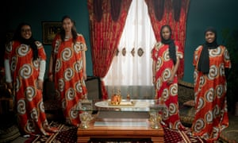 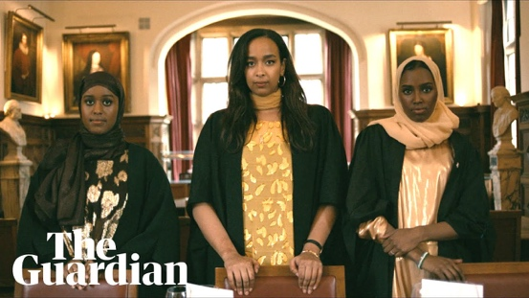 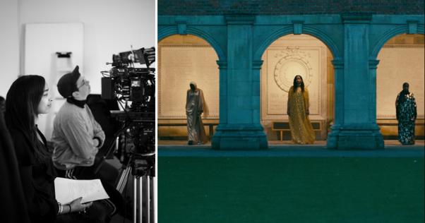

Documentary ”Young British-Somali at Cambridge University”, The Guardian, September 2020

<https://www.youtube.com/watch?feature=share&v=GsPy1guOctw&fbclid=IwAR2GxAIvdixj4He-IKcCild1TOiatc6MrzsYeoFnYJ2Aox61NfwCavga3Is&app=desktop>

|  |  |
| --- | --- |
| Questions: | Answers/notes: |
| What do Samiya, Hafsa, Miske and Awa say about the culture shock they had when arriving at Cambridge University? |  |
| How does London differ from Cambridge? |  |
| What do the four Cambridge girls say about the barrier between their British-Somali background and their parents’ Somali background? |  |
| Why do you think the documentary has the Somali proverb “Either be visible or be absent” in the beginning. |  |
| What does the statistics state in the end of the documentary? |  |
| Overall, what do the girls say about marginalisation and belonging? |  |