The Great War

## Lesson 6: The parable of the old man and the young

# Present the rest of the ppt regarding The Great War

# Recap of sensory imagery (independent work last week)

**Sensory imagery engages the senses**

Visual imagery: sight

Auditory imagery: sound

Tactile imagery: touch

Gustatory imagery: taste

Olfactory imagery: smell

Kinesthetic imagery: movement

# Questions regarding class work about the Sainsbury advert and ‘Dulce et decorum est’?

# Questions regarding the essay about ‘A Wrinkle in the Realm’?

# The parable of the old man and the young

A parable is a short allegorical text designed to teach the reader a truth or moral lesson. In this poem there is a strong allusion/intertextual reference to the story of the sacrifice of Isaac in which Abraham/Abram is willing to give his only son as a burnt offering to God to prove that he believes in God. In the Bible, Abraham stops when an angel tells him to and sacrifices a ram instead, having thus proven his belief in God, while God, in turn, has proven that he is merciful (Genesis 22).

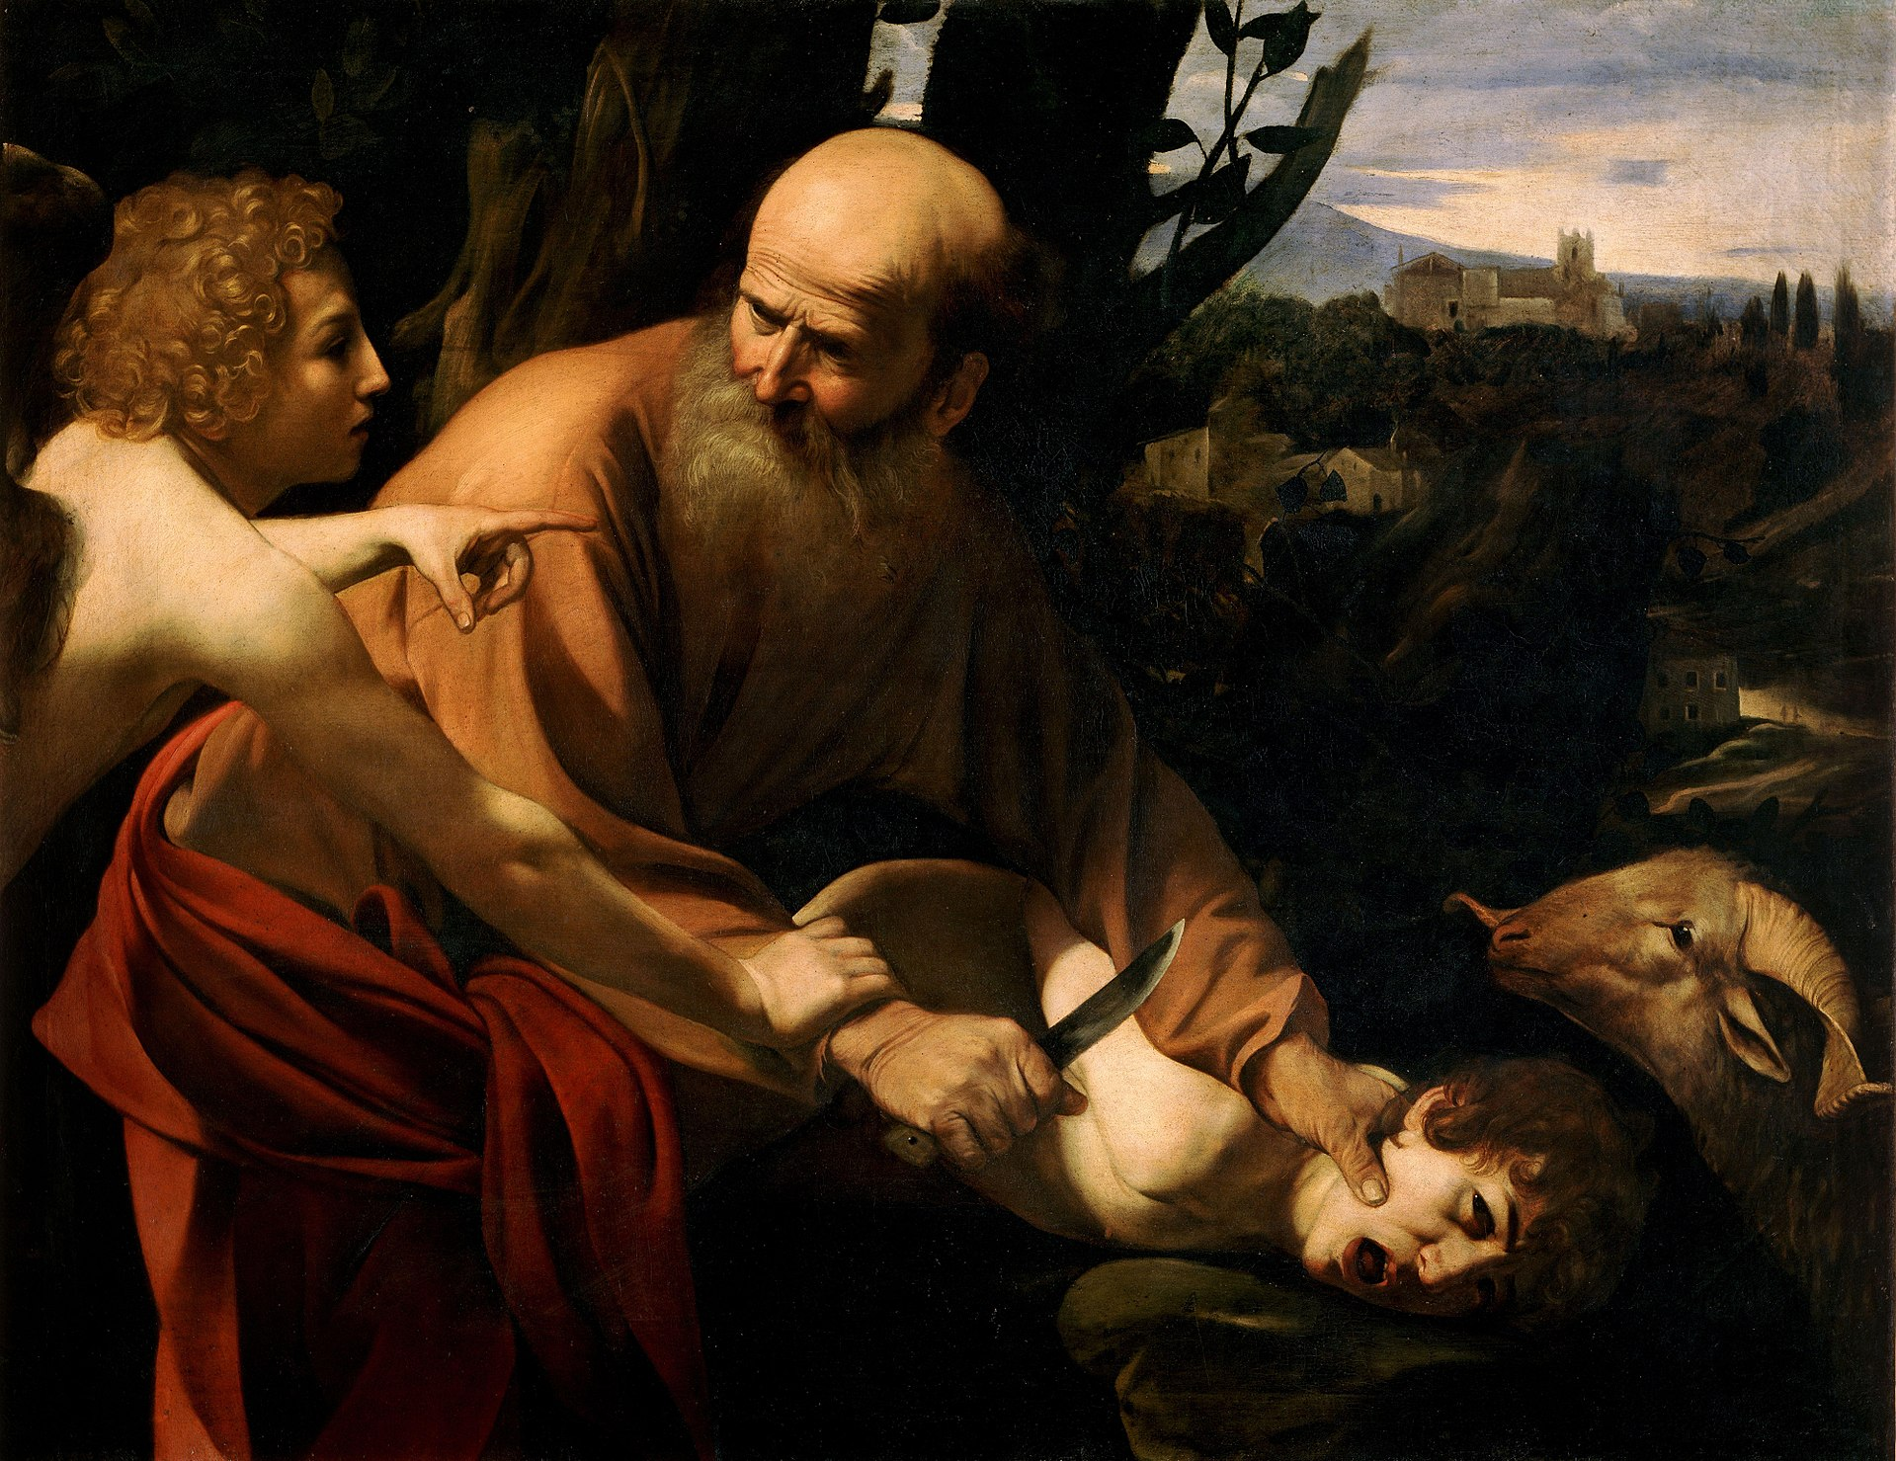

Caravaggio, 1603

## Consonant stops/plosive consonants

The consonants b, p, d, t, (g), k are called plosives or stops as the airflow is stopped. They are often used to reflect harsh feelings in a poem (as opposed to voiced (dansk: ‘stemte’) consonants).

## Listen to the poem ‘The parable of the old man and the young’

(p. 3 in the booklet)

<https://www.youtube.com/watch?v=Wl52M9kiRCo>

## Discuss and write notes to the following questions (whiteboards):

1. Optional: Give examples of the use of iambic pentameter. When does the poem deviate from the pattern? Why?
2. Whom does Abram represent in the war?
3. Whom does Isaac represent in the war?
4. Give examples of how stops (p, t, k) and sibilance (alliteration with hissing sounds, i.e. s, sj, z) are used in to attract attention to important content in the poem.
5. What is the effect of using archaic language in the poem?
6. What is the message of the poem? Include a comment on the ram and the purpose of the final rhyming couplet – the fact that Abram does not listen to the angel. Include the effect of alluding to the Bible in this poem.
7. Relate the poem to *Testament of youth*