Assignment 1
Find alle verberne (udsagnsordene) i præteritum (datid) i nedenstående tekst, og omskriv dem til præsens (nutid). Skriv hele teksten som dit svar, og markér verberne tydeligt som i eksemplet.

Eksempel: She increased throttle and…
She increases throttle and…
She increased throttle and turned her boat toward his, all the while scanning the sea to make sure his friends were out of sight. Chase motioned her north past Barkley Cove – the village serene and colorful in the distance – and landed on the beach of a small bay tucked in deep forest. After securing the boats, he led her down an overgrown path of wax myrtle and prickly holly. She’d never been to this watery and rooty forest, because it stood on the other side of the village and was too close to people. As they walked, thin runnels of backwater seeped under the brush – slinky reminders that the sea owned this land.

Then a true swamp settled deep with its low-earth smell and fusty air. Sudden, subtle and silent all at once, it stretched into the mouth of the dark receding forest. Kya saw the weathered wooden platform of the abandoned fire tower above the canopy, and a few minutes later, they arrived at its straddle-legged base, made of rough-cut poles. Black mud oozed around the legs and under the tower, and damp rot ate its way along the beams. After crossing the sludge, they started the climb, Chase leading. By the fifth switchback, the rounded oak forests tumbled west as far as they could see. In every other direction, slipstreams wove through brilliant green grass to the sea. Kya had never been this high above the marsh.
Delia Owens, Where the Crawdads Sing, 2018

Assignment 2

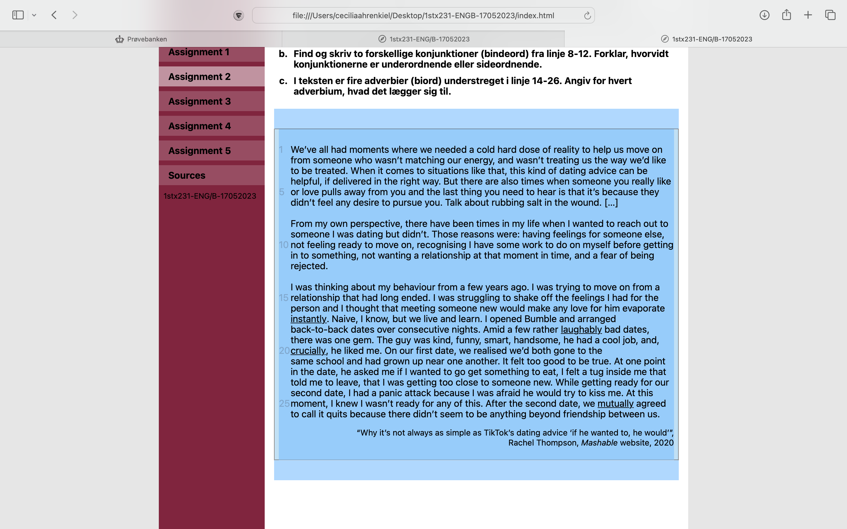
- Find og skriv fire forskellige typer pronominer (stedord) fra linje 1-6. Angiv for hvert pronomen, hvilken type pronomen det er.
Pronomen | Type pronomen
1.
2.
3.
4.

- Find og skriv to forskellige konjunktioner (bindeord) fra linje 8-12. Forklar, hvorvidt konjunktionerne er underordnende eller sideordnende. Skriv dit svar på dansk.
Konjunktioner
1.
2.
Forklaring

- I teksten er fire adverbier (biord) understreget i linje 14-26. Angiv for hvert adverbium, hvad det lægger sig til.
Adverbium | Lægger sig til
instantly
laughably
crucially
mutually

Assignment 3

https://www.youtube.com/watch?v=eXvfqUe4EFQ (indtil 01.58)
Se videoen, og angiv, hvilken ordklasse de nedenstående ord tilhører ud fra sammenhængen. Find ét synonym til hvert af de nedenstående ord ud fra den betydning, de har i sammenhængen. Synonymet må kun bestå af ét enkelt ord.
Ord | Ordklasse | Synonym
delighted | Adjektiv | Pleased
fitting
discharge
impact
well
gathering
intolerable
pale
especially
objective

Assignment 4

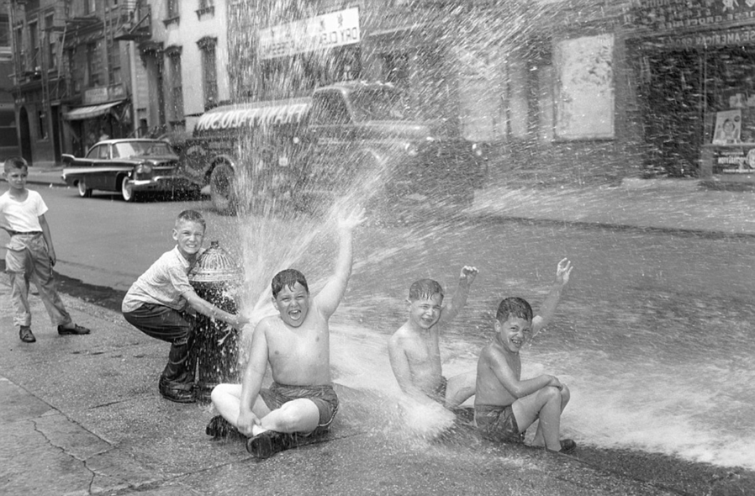
Write a text (50-75 words) to match the photo.
In your text you must use the progressive tense (udvidet tid) at least twice, and you must include at least five different adjectives (tillægsord). Underline the examples of the progressive tense and the adjectives in your text.

