The Great War

## Lesson 18: Inspection (p. 12) and Asleep (p. 13)

Last time: ‘Has your soul sipped’

# Analysis and interpretation of recruitment poster (individually or in groups) (10 min)

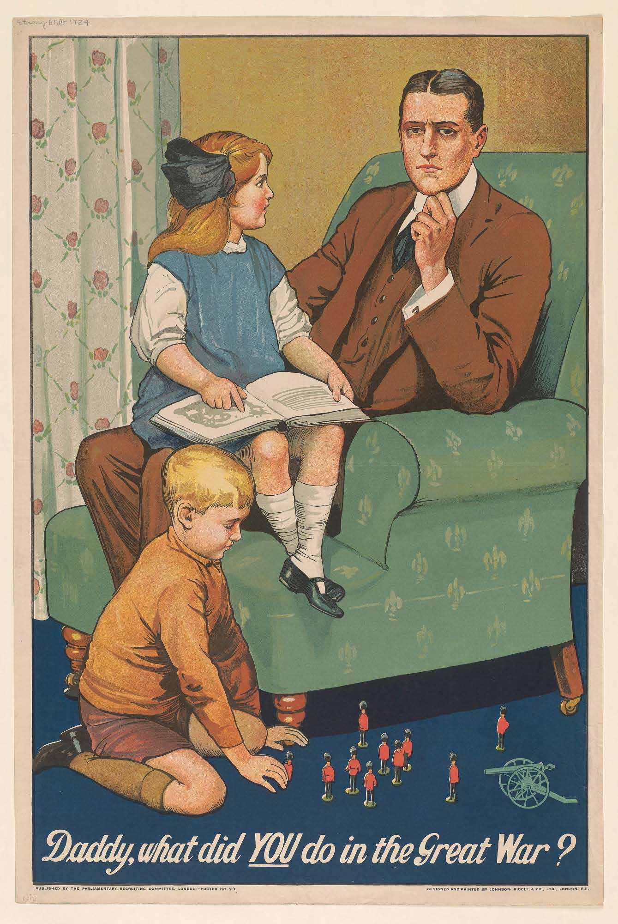

Who is the recruitment poster aimed at?

How does the sender communicate the message and purpose to the audience?

# Analysis of ‘Inspection’ and ‘Asleep’ (20 min)

The class is divided into groups of four who divide themselves into pairs. Read, annotate and analyse a poem each.

## ‘Inspection’

Focus on how the style of language (incl. level of formality, metaphor and personification) is used to carry the message across. You must include an interpretation of the ending.

## ‘Asleep’

Focus on how the peaceful atmosphere is created and how it supports the message regarding the futility of war. You must include an interpretation of the ending.

# Presentions in the groups (10 min)

# Group discussions (5+5 min)

Relate the poems to the poster. Focus on how the man in the poster would want to answer the question that is posed in it compared to how the question would be answered by the speaker in the poems.