The Hollywood Model (berettermodellen)

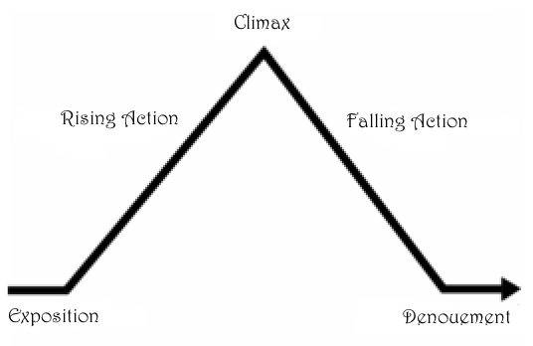

This is a more detailed version of the model

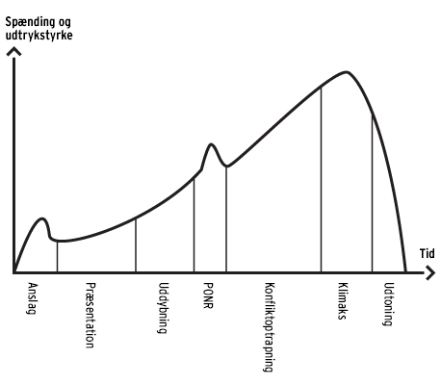
PONR: Point of no return

