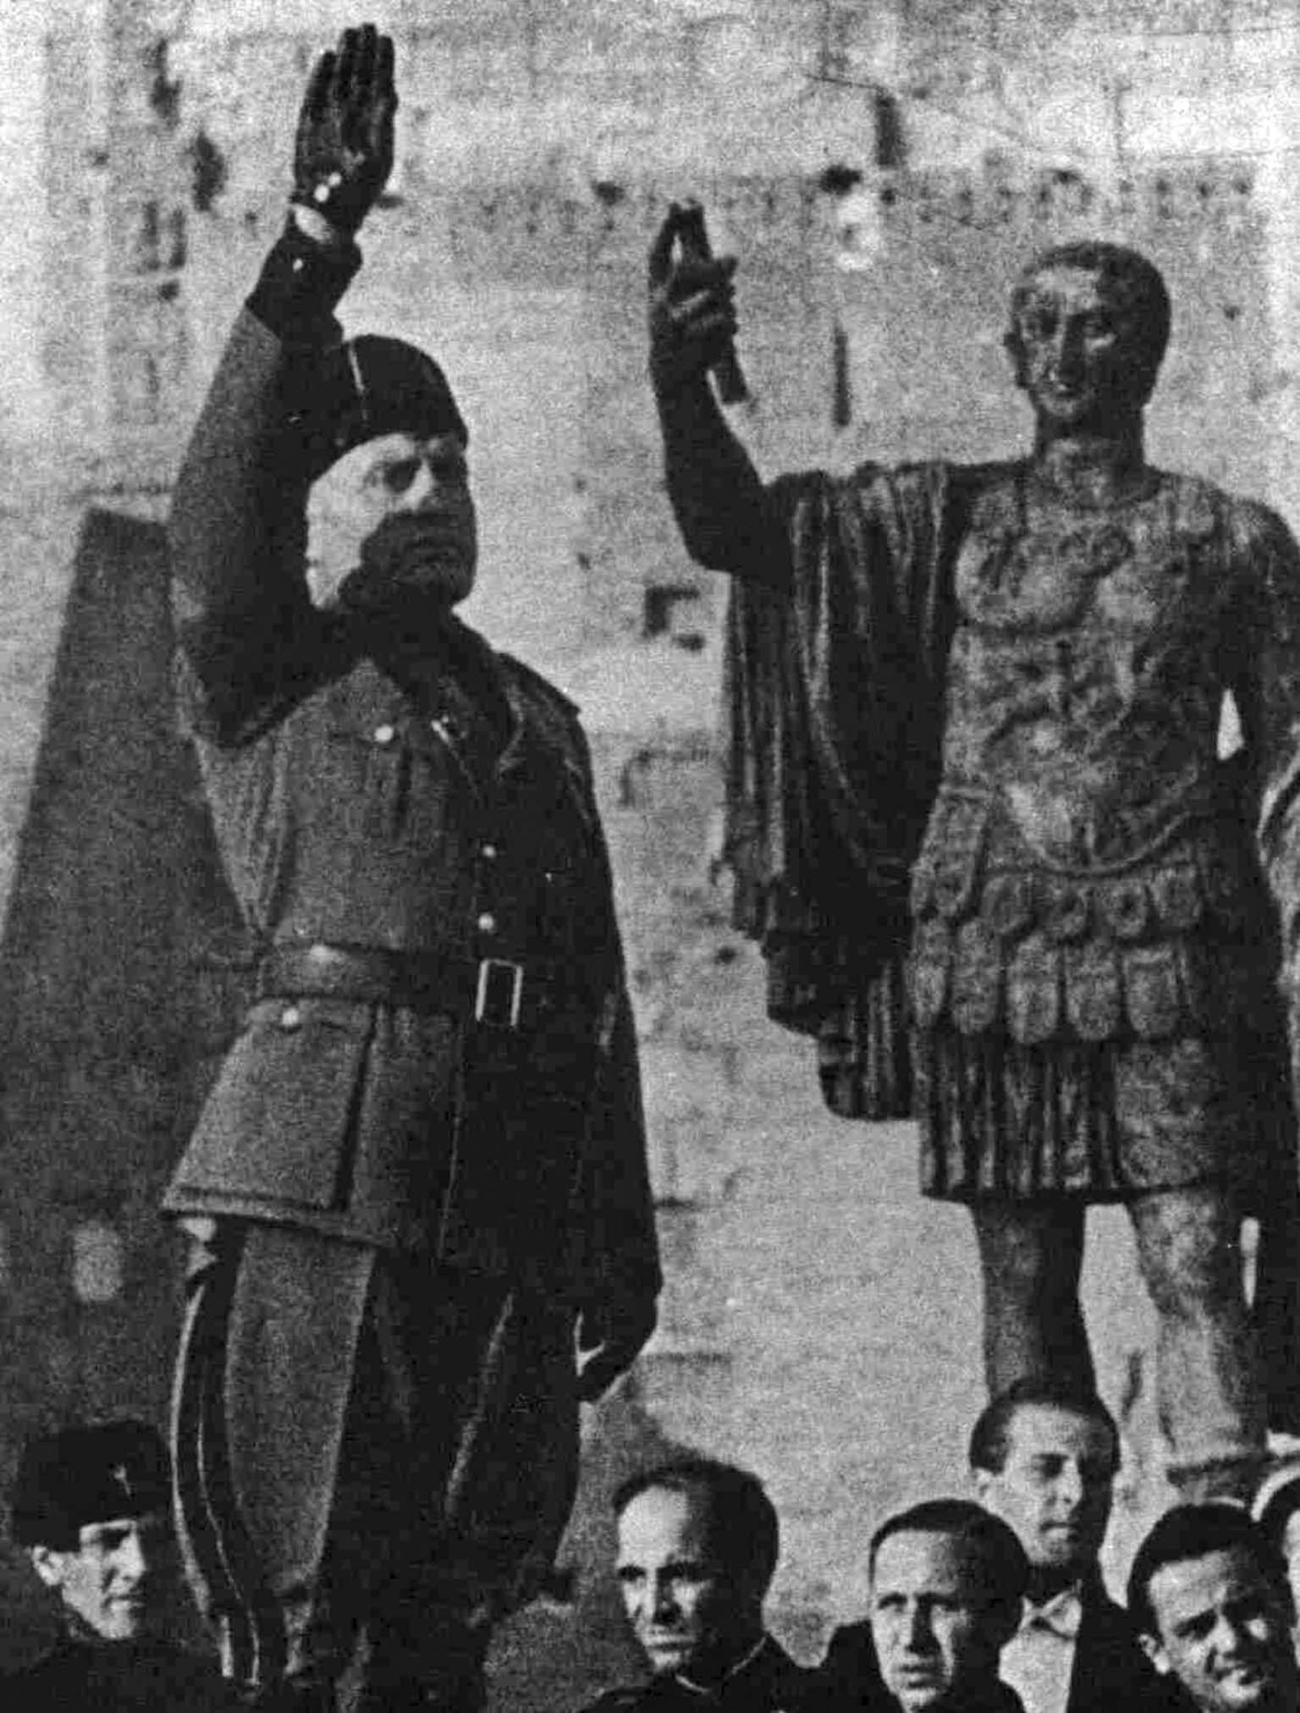
https://albumwar2.com/benito-mussolini-and-the-statue-of-the-roman-emperor/
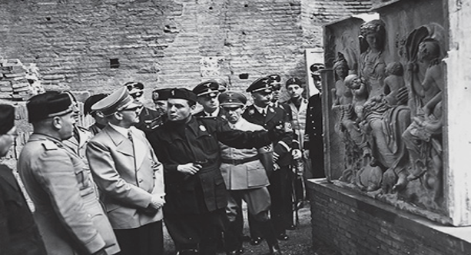
Album of “The Führer’s Trip to Italy”: Adolf Hitler and Benito Mussolini following archaeologist & art historian Ranuccio Bianchi Bandinelli. here showing a fragment depicting Saturnia Tellus, a detail of the Ara Pacis. Henrich Himmler, Joseph Goebbels and Joachim von Ribbentrop are visible in the group. The work was reconstructed in 1938 in celebration of bi-millenium anniversary of Augustus.© Alinari Archives, Florence. (https://sarahemilybond.com/2020/11/23/the-use-and-abuse-of-history-a-syllabus/ )
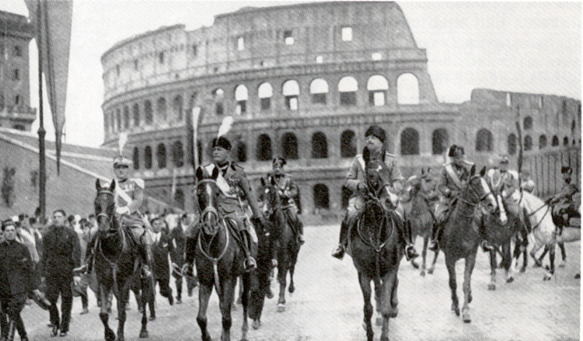
https://commons.trincoll.edu/historyblog/2012/11/07/mussolinis/
Billedet af Mussolini på Via dei Fori Imperiali er fra fejringen af 2000-året for Augustus’ fødsel i 1938.

