THE AMERICAN DREAM and Other Fairy Tales
We are going to watch a documentary in class, called The American Dream and Other Fairy Tales. The format of the film is a personal essay documentary, and in it you will meet filmmaker and philanthropist Abigail Disney, who grapples with America’s profound inequality crisis. The story begins in 2018, after Abigail encounters workers at the company; workers who bear her name but who struggle to put food on the table. Could she, a descendent, with no role in the multinational conglomerate, use her famous last name to help pressure Disney and other American corporations to treat low-wage workers more humanely? Believing her conservative grandfather, Roy Disney, (Walt’s brother and company co-founder) would never have tolerated employee hunger at “The Happiest Place On Earth”, Abigail reexamines the story of modern American capitalism from the middle of the last century, when wealth was shared more equitably, to today, when CEO’s earn upwards of 800 times more than their average employees. What happened? What Abigail learns-about racism, corporate power, and the American Dream, is eye-opening, unexpected, and inspiring in that it begins to imagine a path to a fairer future for everyone. Filmed over a two-year period, The American Dream and Other Fairy Tales expertly weaves together Abigail’s family story and the stories of Disneyland workers; with commentary from historians, authors, and academics. The film artfully employs archive, animation, and never-before-seen Disney family movies. From the boardroom to the union hall, the film will no doubt jump-start urgently needed conversations, about how to make American capitalism work for everyone. As Abigail concludes, “it won’t be easy, but with imagination and courage it can be changed.”
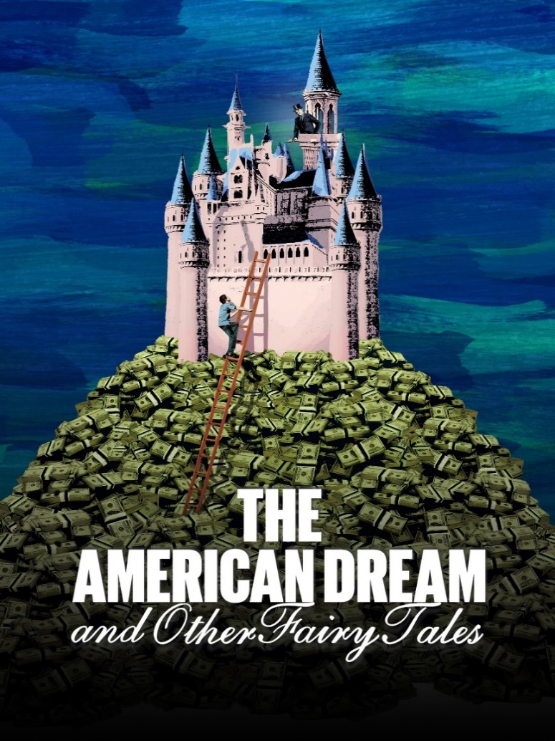
3 tasks to work with after watching the documentary “The American Dream and Other Fairy Tales”:
- Analyse and discuss the use of the documentary genre. Take your p.o.d. in these tasks:
  - How is the genre used to convey the message of economic inequality?

  - Does the genre and its use of interviews, archival footage, and personal stories, like those of Disney employees, help viewers UNDERSTAND the issue better?

  - Does the genre and its use of interviews, archival footage, and personal stories, like those of Disney employees, enhance the CREDIBILITY of the information presented?

- Analyse the concept of the American Dream as it is presented in the documentary. Take your p.o.d. in these tasks:
  - How does the documentary challenge the traditional notion of the American Dream?

  - What examples from the film illustrate the disparity between the ideal and the reality of economic opportunity in America?

  - Compare the concept of the American Dream as it is presented in the documentary with your knowledge about the concept (from the compendium).

- Analyse and discuss the documentary’s message about corporate responsibility and economic justice.
  - First of all, according to the film, what role do corporations like Disney play in maintaining [holde fast i / forlænge] economic inequality?

  - According to the film, what actions can / should be taken by individuals, communities, and policymakers to address these issues? Discuss one/more of these potential ideas/solutions. Would they work? How/why?

  - How effective do you think the documentary is in advocating for change?

