3l EN Friday, Feb. 6 2026
IT'S FRI-DAAY THEN............
Kort om skr. engelsk: ”Two Years to Save” ER jo rettet og, jeg lagde mit feedback-ark ud til jer på Lectio. Har I set det? Jeg har siden hen tilføjet et par ting, og I får en fælles feedback på både Two Years OG Terminsprøve senere. Vi må lige finde ud af om det er i uge 7 ell 9? Men vær obs på at feedback på Terminsprøven er et censorark med noter og karakter; IKKE en rettet opgave!
Plan A: I dag skulle I have haft udleveret romaner Plan B: På timen er vedhæftet dé sider fra romanen, I skal læse i dag og som forberedelse til næste uge.
Men først lidt intro til romanen. Hold tungen lige i munden og styr selv igennem punkt 1-5:
- Let's turn to the book and the author: spend 5 min. reading p. 35 WITH HIGHLIGHTERS.
- Then go to this clip Cardiff BookTalk: The Optician of Lampedusa by Emma Jane Kirby - YouTube and watch from 4-9.38 + from 14.30-17 (7-8 min. in all). While watching, write notes on p. 36 (I’ve already jotted down a few words!)
- Now, check out the reading questions on p. 37-38 (in order to make your reading focused).
Whoops! I have a few corrections for questions 1, 5, 6. See here:
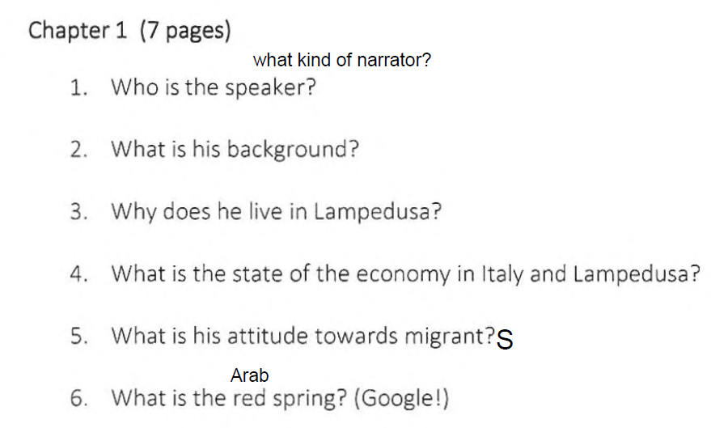
- Finally it’s time to read. Spend 60 min. / 1 hour reading chapters 1-6 on pp. 1-48. While reading, answer as many reading questions on pp. 37-38 as possible!
- When you’re done, upload photos of your work (on feedback): Your highlights on p. 35, your notes on p. 36, and your answers on pp. 37-38. When done, it’s time for me to take attendance [føre fravær]. No later than 13.30, ok!
Be prepared for a small quiz on chapters 1-6 next time

When you finish the above AND have done a thorough job, I will give you NO homework for next week!
(otherwise, you’ll just have to do the work before Wednesday next week!)

Have a great weekend!

