Remarks by Vice President Harris to Kick Off Nationwide “Fight for Reproductive Freedoms” rally
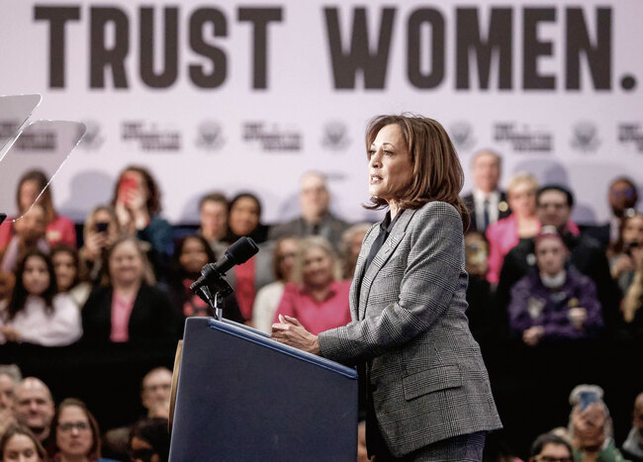
Vice President Kamala Harris speaks at the first rally of a nationwide Fight For Reproductive Freedoms tour. Photo: Tannen Maury/AFP/Ritzau Scanpix.
January 22nd, 2024
Oh, it’s good to be back in Wisconsin. Good afternoon everyone, good afternoon.[...]
Freedom, I believe, is fundamental to the promise of America – freedom of speech, freedom of worship, freedom of assembly, the freedom to vote. In America, freedom is not to be given. It is not to be bestowed. It is ours by right – by right. And that includes the freedom to make decisions about one’s own body, not the government telling you what to do.
Fifty-one years ago today, in the case of Roe v. Wade, the United States Supreme Court recognized the fundamental constitutional right to reproductive freedom. And for nearly half a century, Americans relied on the freedoms protected by Roe. However, 19 months ago, the highest court in our land, the court of Thurgood and RBG, took a constitutional right from the people of America, from the women of America.
And now on the 51st anniversary of Roe, we speak of it in the past tense. In the last 19 months, in states across our nation, extremists have proposed and passed laws that criminalize doctors and punish women; laws that threaten doctors and nurses with prison time, even for life, simply for providing healthcare; laws that, in some states, make no exception, even for rape and incest.
Now, many of you know I started my career as a prosecutor specializing in crimes against women and children. What you may not know is one of the reasons why. So, when I was in high school, I learned that one of my best friends was being molested by her stepfather. And so, I said to her, “You’ve got to come stay with us.” I called my mother, and my mother said, “Of course she should,” and she did.
So, the idea that someone who survives a crime that is violence to their body, a violation to their body, and then would not have the authority to decide what happens to their body next, that’s immoral. It’s immoral.
And let us all agree, one does not have to abandon their faith or deeply held beliefs to agree the government should not be telling her what to do with her body. If she chooses, she will consult her pastor, her priest, her rabbi, her imam, but not the government telling her what to do.
This is, in fact, a healthcare crisis. And there is nothing about this that is hypothetical. Today, in America, one in three women of reproductive age live in a state with an abortion ban – one in three.
And let us understand what that really means for people across our nation. Let us understand the horrific reality that women are facing every single day since Roe was overturned. I have met women who have had miscarriages in toilets because they were refused care. I met a woman who went to the emergency room during a miscarriage and was turned away because the doctors were afraid they’d be thrown in jail for giving care. And it was only when she developed sepsis that they gave her the care she needed.
We know that the majority of women who have abortions are mothers. If they live in a state with an abortion ban and they need to travel to receive care, God help her if she does not have paid leave or affordable childcare. God help them if they don’t have the savings to buy a bus, a train, or a plane ticket or to book a hotel room.
And while these extremists say they are motivated by the health and well-being of women and children, in reality, they ignore the crisis of maternal mortality. The top 10 states with the highest rates of maternal mortality all have abortion bans. The hypocrisy abounds.
And let us be clear about what they’re up to. These extremists want to roll back the clock to a time before women were treated as full citizens – Wisconsin to the 1800s. Just look at what happened here in this beautiful state of Wisconsin.
After Roe was dismantled, extremists evoked a law from 1849 to stop abortion in this state – 1849 – before women could vote, before women could hold elected office, before many women could even own property.
In a state whose motto is “Forward” these extremists are trying to take us backwards. But we’re not having that. We’re not having that.
And just look at what the fallout has been: the reproductive care clinics across the state that had to close, the women that hospitals had to turn away – women like Meagan.
So, Meagan learned she was pregnant early last year. A few months later, she and her husband, Jon, went to their doctor for a routine ultrasound, and it revealed devastating news for them. The fetus had a severe genetic disorder, and Meagan’s pregnancy threatened her life. But because of that 1849 law, Meagan’s doctor could not provide a lifesaving abortion unless he found two other physicians to sign off.
He called doctor after doctor here in Wisconsin, but none were willing to risk going to prison. Ultimately, Meagan had to go to Minnesota to receive care. She had to leave the state where she calls home to save her life. [...]
Meagan and her husband, Jon, are here with us today. And in front of all the friends, let us applaud them for their courage, and I thank them for the time that I had with them today. Can we please applaud them?
And I mention them because I think it’s very important to understand the courage it takes to share those kinds of stories. And the reality of what is happening in real time across our country is that, for every story we hear, there are so many that we do not hear about.
Today, an untold number of women are silently suffering – women who are being subjected to profound judgment; women who are being made to feel as though they did something wrong, as though they should be embarrassed, being made to feel as though they are alone.
And to those women, I say: We see you, and we are listening, and we see your incredible strength. And we are here with you.
And so, as we face this crisis, as we are clear-eyed about the harm, let us also understand who is responsible, shall we? The former President hand-picked three Supreme Court Justices because he intended for them to overturn Roe. He intended for them to take your freedoms. And it is a decision he brags about.
A couple of weeks ago, he said that, for years, quote, “They were trying to get Roe v. Wade terminated.” But he said, quote, “I did it. And I’m proud to have done it.”
Proud? Proud?
Proud that women across our nation are suffering? Proud that women have been robbed of a fundamental freedom? Proud that doctors could be thrown in prison for caring for their patients? That young women today have fewer rights than their mothers and grandmothers?
How dare he.
And the extremists are not done. This afternoon, in the Wisconsin Legislature, extremists will hold a hearing on a new bill that would ban abortion in this state with no exception for rape and incest.
And in the United States Congress, extremists are trying to pass a national abortion ban to outlaw abortion in every single state.
But what they need to know is that if Congress passes a national abortion ban, President Joe Biden will veto it. Yes, he will.
Because here’s the deal about all of us: We trust women. We trust women to make decisions about their own bodies. We trust women to know what is in their own best interest. And women trust us to fight to protect their most fundamental freedoms. And it is going to take all of us, it is going to take all of us.
Joe Biden and I are fighting in court to protect women’s access to medication and emergency care. We strengthened the patient privacy protections so that medical records stay between a woman and her doctor. And we are protecting the right of women to travel for abortion care.
But the bottom line is: To truly protect reproductive freedoms, we must restore the protections of Roe. Because, you see, what the United States Supreme Court took, Congress can put back in place. So, we need a majority of leaders in Congress who simply agree – here’s the thing – simply agree that the government should not be making those personal decisions for folks. And when Congress passes a law that puts back the protections of Roe, Joe Biden will sign it.
So, I’ll close with this. It’s going to take all of us to get us to that place – everybody here. And momentum is on our side. We are winning.
Since Roe was overturned, every time reproductive freedom has been on the ballot, the people of America have voted for freedom. From Kansas to California to Kentucky; in Michigan, Montana, Vermont, and Ohio; the people of America have voted for freedom. And not by a little – by overwhelming margins.
Proving, also, this is not a partisan issue. Tens of millions of Americans in red states and blue, including here in Wisconsin, marched to the polls in defense of fundamental freedoms.
So, I say: The voice of the people has been heard, and it will be heard.
And then I finally ask: Today, Wisconsin, are you ready to make your voices heard?
Do we trust women?
Do we believe in reproductive freedom?
Do we believe in the promise of America?
And are we ready to fight for it?
And when we fight, we win.
God bless you. And God bless the United States of America.

