The Rise and Fall of the British Empire

The history of the British Empire began in the 15th and 16th centuries, at the time when sea routes between Europe and Asia and the newly discovered Americas were established. Many European states – Spain, Portugal, Holland and France for example – were involved in the search for overseas products and markets. England was geographically well placed to develop trade relations with these overseas destinations and started to establish trading posts in places like the West Indies and India in the 17th century. In 1655, Jamaica was annexed as a colony, and in the following 250 years British rule was extended to countries and regions all over the world. As the world’s leading industrial nation, Britain had the economic strength to build a navy that could protect British trade abroad. Its main commercial and military rival, France, was defeated in a series of wars in the late 18th and early 19th centuries. Historians speak of Britain’s first and second empire in this period.

The Rise of the Empire

The ‘First Empire’ was based on commercial activities by private traders and by chartered companies supported by the state. Trading posts were set up in, for example, India, the West Indies and in North America, and where the native populations were badly organised, the British took possession of areas inland. This happened, for example, on the East Coast of North America, where British farmers and traders established settlements such as Virginia and Massachusetts in the early years of the 17th century. Economically, the most lucrative activity in the 18th century was the so-called triangular trade in the Atlantic. British ships from Bristol, Southampton or Liverpool, for example, took goods to trading stations in West Africa, where black slaves were bought and transported to the West Indies and the British colonies in North America to work on the plantations there. The ships then returned to Britain with crops such as sugar, tobacco and cotton.  
   
In the 1763 Treaty of Paris, Anglo-French rivalries in Canada and India were settled in Britain’s favour, but the cost of the wars with the French involved the British government in an argument with the settlers in the 13 North American colonies about who should pay the bill. The American colonists started a war of liberation from Britain. They succeeded, and the emergence of an independent USA in 1783 marked the end of the First British Empire.

The Second British Empire was built on new British acquisitions in Asia and in Africa. Britain’s Indian empire was expanded during the 19th century and became the most populous and economically important British possession in the world, the ‘Jewel in the Crown’. Australia was settled from 1788 onwards and New Zealand in the years after 1840. In Africa, the area around Cape Town was taken over after the British victory in the Napoleonic Wars in 1814, but the large-scale acquisition of territories in Africa did not take place until the European ‘scramble for Africa’ after 1870, in which Britain came to control places such as Egypt, the Sudan, Uganda, South Africa, Nigeria and Ghana.

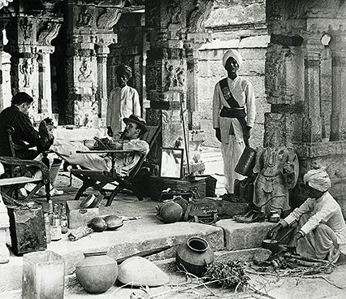

*Masters and servants: A scene from the Chennakshava temple in India in 1900. At that time, the 300 million inhabitants of the subcontinent were administered by about 5,000 officials of the Indian Civil Service.*

At the outbreak of World War I in 1914, the British ruled over the largest European empire in the world, comprising about a quarter of the world’s population. This had important consequences, of course, for people in the colonised areas, but also for Britain’s economy and for British culture.

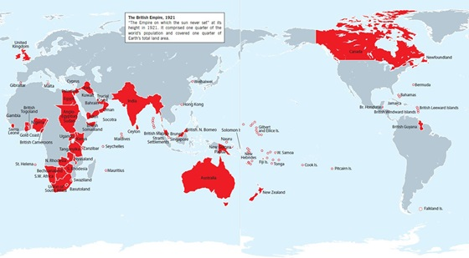

From World Empire to post-imperial state

The defeat of Germany and the Ottoman Empire in World War I (1914-18) brought even more territories under British control in Africa (present-day Tanzania, for example) and in the Middle East (Palestine, Jordan, Iraq). It became increasingly difficult, however, for Britain to find the administrators, soldiers and money needed to run its colonies and mandates. In some territories – Egypt and India for example – nationalist movements started to demand independence for their countries.

In the 1930s, Britain was weakened economically by the world economic crisis, and it came under pressure from totalitarian and potentially hostile regimes in Adolf Hitler’s Germany, Mussolini’s Italy, the communist Soviet Union of Joseph Stalin and the militarist regime in Japan. It became clear that it would stretch Britain’s military resources to the limits to keep all parts of the Empire under British rule.

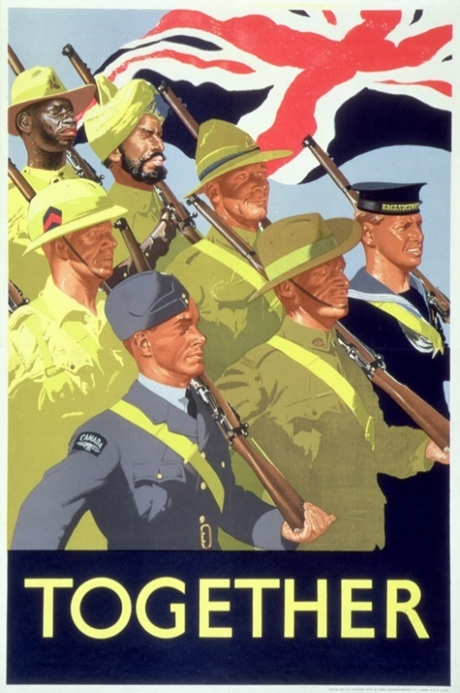

*Together’. A World War II recruiting poster celebrating the joint war effort of the British Empire, 1939.*

World War II broke out in 1939 despite the efforts of the British Prime Minister Neville Chamberlain to find a way of satisfying the demands of Adolf Hitler through negotiations. The countries of the Empire chose to support Britain in the war against Germany with supplies and military assistance as they had done during World War I. During the years 1939-41, the British and Imperial forces managed at great cost to prevent the enemy forces from occupying the British Isles and core areas of the Empire. Winston Churchill, prime minister from 1940 to 1945, became the symbol of Britain’s determination not to give in to Hitler’s Germany. In 1941, Britain gained some powerful allies. After the German attack on the Soviet Union and the Japanese attack on the American base at Pearl Harbor in Hawaii, the Soviet Union and the USA joined the war on Britain’s side. This gave the Allied side the human and material resources that were needed to defeat the Axis powers of Germany, Italy and Japan.

As a member of the winning alliance, Britain played an active role in the early post-war years when the United Nations was created and the Western powers set up a number of other important international organisations such as the Organisation for European Economic Co-operation (*OEEC*) in 1948, and the Council of Europe and the North Atlantic Treaty Organization (NATO) in 1949. Britain took its place among the great powers and got a permanent seat on the Security Council of the United Nations. It also became a member of the exclusive group of countries with nuclear weapons by acquiring its own atomic bomb in 1952.  
   
Nevertheless, the new superpowers in the world were now the USA and the Soviet Union, and from the late 1940s to the Fall of the Berlin Wall in 1989 and the collapse of the Soviet Union in 1991, Britain’s foreign policy was focused on the challenges of the Cold War, i.e. the ideological, military and economic struggle between the Western bloc, led by the USA, and the Eastern bloc, led by the Soviet Union. Here, Britain acted as a close partner of the USA within the NATO alliance.  
   
For a politician like Winston Churchill, Britain’s strength rested in her strong historical ties to the USA, Europe and the countries of the British Empire (see box below on Churchill’s three circles). In the decades after Churchill’s last period as Prime Minister (1951-1955), circumstances changed, however. The Empire turned into a Commonwealth of independent states, and Britain entered into an even closer relationship with her Continental partners within the European Community.

Decolonisation

After World War II, it became increasingly difficult for European colonial powers to justify their control over foreign parts of the world. International opinion voiced, for example, at the United Nations grew hostile to imperialism. Britain, for its part, did not have the material and military resources to control territories in which growing nationalist movements were making demands for independence.

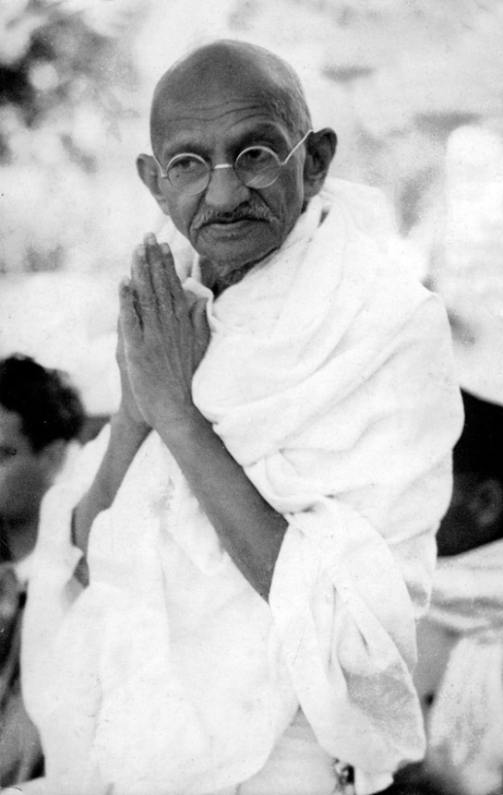

*Mahatma Gandhi (1869-1948) is often described as the father of the modern state of India. From around 1920, he was the political and spiritual leader of the fight for Indian independence. His policies of non-cooperation with the British authorities’ boycott of British goods and non-violent protests attracted worldwide attention.*

The achievement of independence for the millions of inhabitants in the states of India and Pakistan in 1947 was a major step on the road to freedom for most of Britain’s colonies. The campaigns of the Indian nationalist leader Mahatma Gandhi (1869-1948) had inspired nationalists all over the Empire, and the loss of the Indian subcontinent deprived Britain of an important supply of soldiers for its army. Soon, the British also had to give up its control of the Middle East. In 1948, the mandate of Palestine was abandoned and its territory divided between the new state of Israel and its Arab neighbours. Egypt had become independent already in 1922 and had become a republic in 1953, but the British still controlled the Suez Canal, which was seen as a vital gateway to British possessions in Asia. When the Egyptian leader Colonel Nasser nationalised the Canal in 1956, Egypt was attacked by British, French and Israeli military forces. The American government refused to support its European allies and forced them to withdraw their troops. It was, in other words, made clear to the world that Britain could not carry out military operations outside its home territories without the support of the US government. The outcome of the ‘Suez Crisis’ in 1956 was therefore seen as a further demonstration that the days of European mastery of Africa and the Middle East were over.

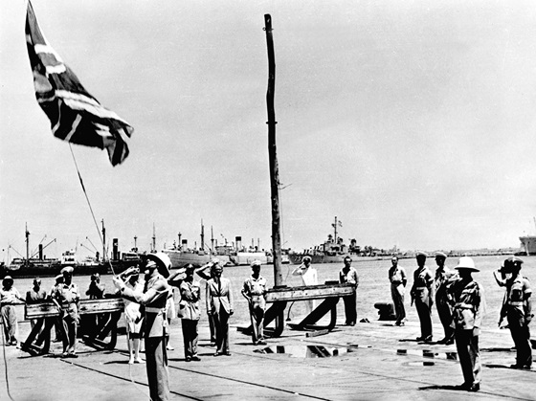

*The end of empire: Between 1922 and 1948, Palestine had been a British mandate. On 14 May, 1948, the State of Israel was proclaimed in Tel Aviv. Shortly after, the Union Jack was hauled down for the last time in Haifa harbour. British rule had ended. In the following decades, similar ceremonies were to take place in many other parts of the world.*

From then on, the process of decolonisation gathered speed. In 1957, Ghana was the first of Britain’s African colonies to become independent, and most other colonies in Africa, the West Indies, the Persian Gulf and in Asia followed during the 1960s. By the end of the 1970s, most of Britain’s military forces stationed ‘East of Suez’ had been withdrawn. For some time, the crown colony of Hong Kong remained the last major British-ruled overseas possession, but in 1997 Hong Kong and its 6.3 million inhabitants were returned to China as a ‘Special Administration Region’ guaranteed a high degree of autonomy for the next 50 years. So today, only a small number of island states such as the Bermudas, the Falkland Islands and St Helena are still administered by Britain. Along with places like Gibraltar and the British Antarctic Territory they constitute the ‘British Overseas Territories’ with a total population of around 260,000 people.  
  
The vast majority of Britain’s former colonies have chosen to join the Commonwealth.