It’s clearer than ever that Brexit has failed – let’s not inflict its miseries on young people

By Zoe Williams, Tue 23 Apr 2024
From: https://www.theguardian.com/commentisfree/2024/apr/23/brexit-failed-inflict-miseries-young-eu
A scheme to allow British under-30s to live and work in the EU has been flatly rejected. Why punish them for older voters’ mistakes?
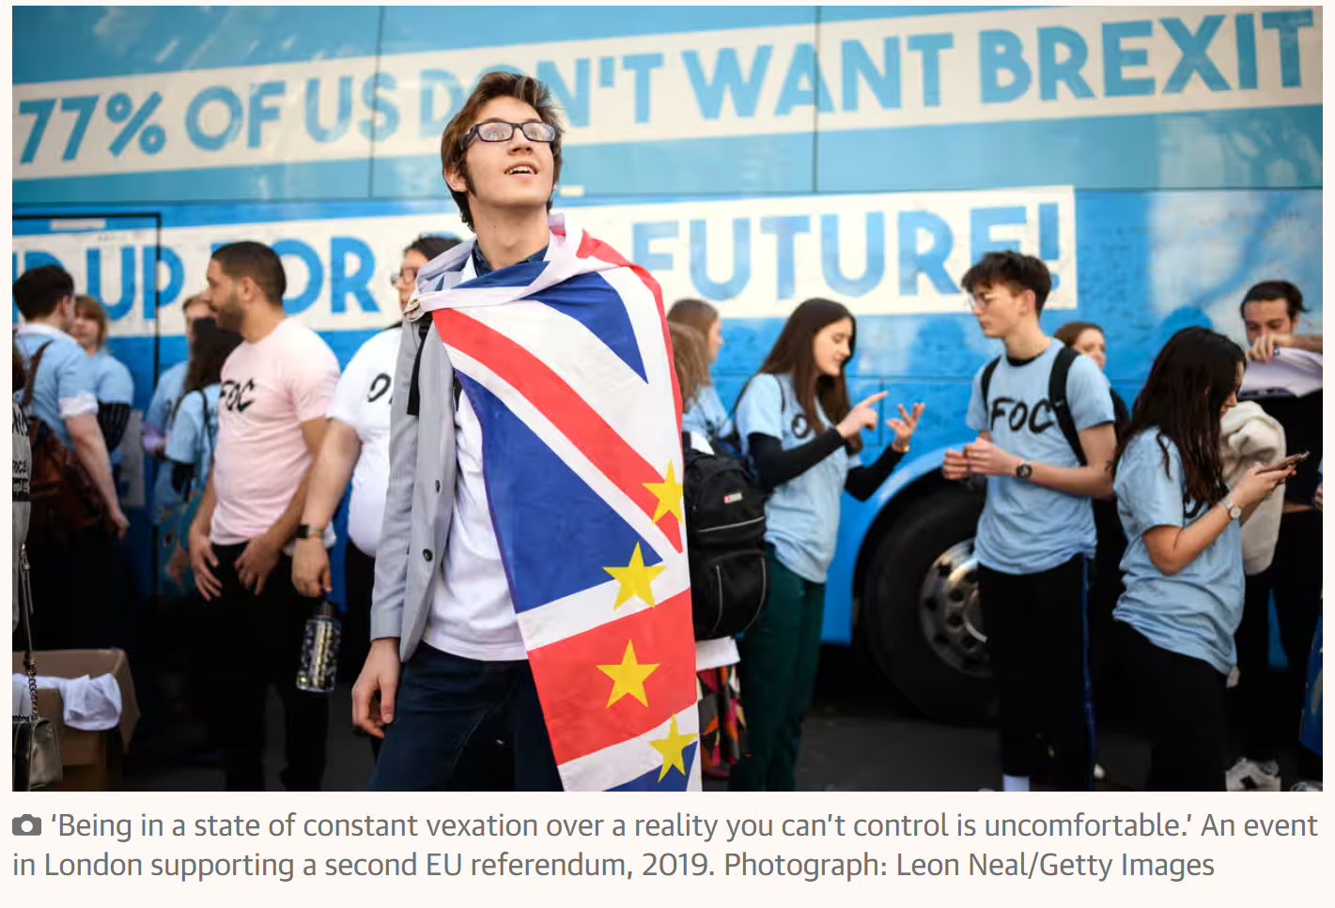
Only those born before 1998 could vote on Brexit, so there is no conceivable way of knowing which way today’s 18- to 30-year-olds would have felt about it. Oh, except there is: 70% of 18- to 24-year-olds think leaving the EU was a bad idea. Of the 25- to 49-year-olds, 66% also think we were wrong to leave. If you can bear to drag your mind back to the immediate aftermath of Brexit, you’ll recall that words like “overwhelming” and “vast” were completely debased by their use in conjunction with majorities that were actually wafer-thin. So let’s just say most young people are remainers.
For a long time, politics has dealt with the young remainer as it does with the rest of us; ignore us for long enough, and we’ll go away. If the Brexit argument had had any foundation – if it had brought trading or other benefits, if it had caused only negligible difficulties and those of the teething variety – then that would probably have worked. Most referendum outcomes get more popular over time.
Being in a state of constant vexation over a reality you can’t control is uncomfortable. You don’t go looking for trouble like that but, particularly if you’re young, trouble keeps on looking for you. That generation had four years of watching Westminster discuss nothing but Brexit, in ever less rational terms, at the expense of any action on the issues – mainly the climate crisis – it cares about. It then had to live through a pandemic, suffering the harshest possible ratio of personal sacrifice to personal risk on behalf of others, while its school and university life was cratered and it found itself responsible for every imaginable social ill, on account of its wokery.
I have become so used to young people being ignored, noticed only when they can be pilloried for going on a protest march or having a mental illness, that I forgot what a normal political contract looks like: young people should be offered every known opportunity, since the realisation of their potential is any society’s highest goal. The European Commission did not forget, and I guess we have its bureaucrats and pen pushers to thank for that.
Ursula von der Leyen suggested a reciprocal scheme in which 18- to 30-year olds from all member states plus the UK could live, work or study across the EU for four years. It was swiftly rejected by Rishi Sunak, a government spokesperson giving as the reason “free movement within the EU was ended and there are no plans to introduce it”. It was a depressingly familiar reprisal of the post-referendum discourse, when engagement and justification were jettisoned in favour of a simple “no, because we said so”. Perhaps even more dispiriting is that Labour responded with a weaker version of the same stance, citing its “red lines – no return to the single market, customs union or free movement”. No, because they said so.
But the context has changed: 57% of Britons of all ages now think leaving the EU was wrong. This is partly demographic change, partly that there are more leavers with regrets (16%) than remainers (6%), and partly that the economic and practical consequences have become impossible to ignore.
Hardline Brexiters were originally spared the embarrassment of a reckoning by the sheer number of factors that could be contributing to our low-productivity, low-growth, low-wage, low-participation economy. It could be Brexit or it could be Covid; it could be the mismanagement of Liz Truss, but hey, don’t forget Boris Johnson.

While all these factors, as well as the war in Ukraine, still get name-checked in polls about our national malaise, specific attributable disasters are building up: businesses describe the border plans being in “complete disarray”; farmers were promised that EU subsidies would be directly replaced, but have found instead an unwieldy system that privileges the largest landowners and is too complex for smaller farms to access; independent trade deals have failed to materialise; Northern Ireland’s economy started to outpace the rest of the UK’s 18 months ago, which analysts have explicitly credited to its barrier-free trade. The project has been unravelling in broad daylight, ever since Johnson triumphantly got it done in 2020.
The lines and the language, the arguments and the tropes of Brexiters all had a tendency to infantilise opponents, silence us with bare assertion and un-won authority, dispensing ad hominem blah about metropolitan elitism and “jam tomorrow” fantasies about the future. Rhetorical manoeuvres that were effective in the half-light of hypotheses simply cannot survive the interruption of so much reality.
Certainly, there are already large sections of the Conservative party who think boosting the salience of migration, via the Rwanda policy and small-boat hysteria, will galvanise support for a new isolationist narrative, in which EU nostalgia will never have a place. But the rest of Westminster needs to wake up to the fact that what looked necessary post-2019 – respecting the referendum, making Brexit work – now looks like wilful denial.



