UK families ‘eating less healthily’ due to cost of living crisis

BBC Good Food Nation survey finds 19% of Britons eating more processed foods because they are cheaper

[**Emine Sinmaz**](https://www.theguardian.com/profile/emine-sinmaz)

Mon 2 Oct 2023

Families are eating less healthily and turning to ready meals and processed foods due to the cost of living crisis, a study has found.

More than two-thirds of people (69%) said they considered themselves to be healthy eaters but 28% said they were eating less nutritious food because it is too expensive, according to the BBC Good Food Nation survey.

The study of 2013 adults across the UK found that 19% are eating more ready meals and processed foods because they are cheaper, while 17% are cooking less from scratch.

The survey, which looks at shopping, cooking and eating habits, found that three in five people (60%) have changed what they eat due to the rising cost of ingredients. This includes 16% who said they have cut back on organic ingredients and 12% who said they were eating less protein as they struggled to cope with higher food bills. The study found that 15% are taking more packed lunches to work to save money.

Meanwhile, over a quarter (28%) of respondents said they had changed their supermarket due to the cost of living crisis and 4% said they had used food banks or alternatives to shops. More than two-thirds of people (68%) said price was the most important factor when picking a supermarket.

[[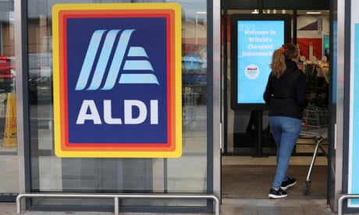](https://www.theguardian.com/business/2023/sep/25/aldi-reports-record-uk-sales-as-shoppers-seek-bargains-in-cost-of-living-crisis)](https://www.theguardian.com/business/2023/sep/25/aldi-reports-record-uk-sales-as-shoppers-seek-bargains-in-cost-of-living-crisis)

Overall, 61% said the cost of living had affected their healthy eating habits in some way, including being more conscious of eating healthily because they cannot afford to get sick (18%) and eating less healthily due to stress (15%). The poll found that 13% said they were eating less healthily due to having less time to cook because of working longer hours.

More than a third of respondents (36%) said they were producing fewer leftovers, with their reasons being to save money (59%); because they are meal planning more carefully (44%); and to reduce waste to help the planet (34%). The survey found that the four most common foods people threw away were salad leaves (31%), bread (29%), fruit (24%) and vegetables (23%).

Christine Hayes, editor-in-chief of BBC Good Food, said the survey shows that “we consider ourselves a nation of healthy eaters and we care about what we eat.

[[](https://www.theguardian.com/business/2023/sep/25/uks-cost-of-living-crisis-will-cause-thousands-of-premature-deaths-study-says)](https://www.theguardian.com/business/2023/sep/25/uks-cost-of-living-crisis-will-cause-thousands-of-premature-deaths-study-says)

“However, rising costs have impacted choices and compromises have had to be made with people buying more processed food and ready meals and swapping supermarkets to save money.”

But increasing costs have not stopped households from embracing technological innovations. Almost half of those surveyed (46%) said they owned an air fryer while another 23% said they were planning a purchase. Meanwhile, one in seven people (14%) said they had used artificial intelligence tools to create a recipe and 12% had used them to create a shopping list.

Hayes added: “The BBC Good Food Nation findings show we embrace innovations in food preparation – air fryers are now part of our everyday lives.”

Sue Davies, Which? head of food policy, said: “These findings echo our own research findings that many people are finding it more difficult to eat healthily as millions struggle with increased food prices and other high household bills.

“Supermarkets have an important role supporting people through this crisis. This includes helping customers who rely on more expensive convenience stores by ensuring they stock a range of budget products that enable people to have a healthy diet.”

From: <https://www.theguardian.com/business/2023/oct/02/uk-families-eating-less-healthily-due-to-cost-of-living-crisis?fbclid=IwY2xjawI7yodleHRuA2FlbQIxMQABHdpA40fVxvTO-7UHu2c9lzl7eMpRPROOMFnWfpn03wocRGakA5JKv5uJAA_aem_QAlfe0jEfVIz-cvle3DA5A>

**Study Questions:**

1. Analyse the article using the rhetorical pentagon

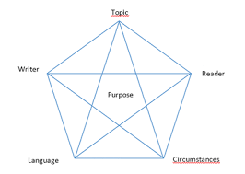

1. Try to compare it to the documentary “Broke”. Are there any similarities between the issues the text rise and those we see in the documentary?
2. Consider what long term effects the cost of living crises have on children, young people and the society in general.