**1½-Minute Presentation**

Each of you must now prepare and make a 1½-Minute Presentation and video it.

1. Write down your answers to the following assignment:

Characterise the narrative style of All My Friends Are Superheroes.

Include SOME of the following points, and elaborate on them, using examples:

* 1. The 3rd person omniscient narrator
  2. The short sentences and what it does to the text
  3. The use of present and past tense
  4. The Chinese Boxes
  5. The fact that the author makes abstract concepts and imagery into real things

1. Turn your text into a manuscript that is easy to read: highlight key words, make the font larger, make space between the lines.

1. Rehearse making the presentation. Make sure that you can make the presentation without more than an occasional glance at the key words of your manuscript. Time it to check that each person’s video is shorter than 1½ minutes long.
2. Record your presentation while making sure you have as much eye contact with the camera as possible. (You should probably not record it in the very best quality, because the file can become quite large.) Try more than once. It can take several tries to get it perfect :-)
3. Share the video with me. **Put a LINK to your presentation in “Elevfeedback” in this lesson on Lectio. Make sure to press ENTER so that it becomes a link.** This can be a **LINK** to your Google Drive or Youtube or…? You probably know which way is easier much better than I do…

Google Drev: You put your video in your own drive. Then get a link for sharing:

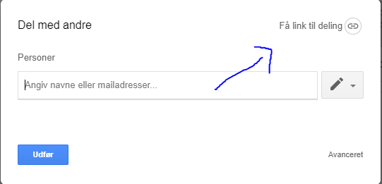

Youtube: Here, you just copy your link.