[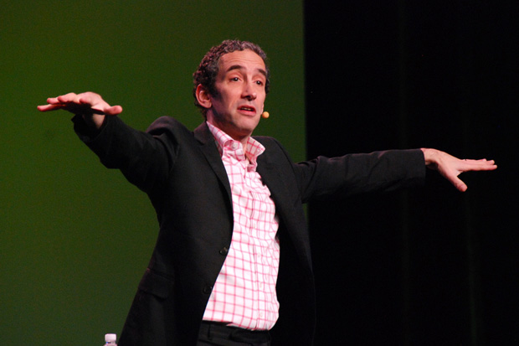](http://www.wired.co.uk/news/archive/2011-09/21/doug-rushkoff-hello-etsy/viewgallery/270874)**You are Facebook's product, not customer**

21 SEPTEMBER 11  by [OLIVIA SOLON](http://www.wired.co.uk/search/author/Olivia+Solon)

People need to understand that they are the product of Facebook and not the customer, according to media theorist and writer Douglas Rushkoff.

Speaking at the inaugural Hello Etsy conference in Berlin, the author of *Program or Be Programmed* said: "Ask a kid what Facebook is for and they'll answer 'it's there to help me make friends'. Facebook's boardroom isn't talking about how to make Johnny more friends. It's talking about how to monetise Johnny's social graph."

He added: "Ask yourself who is paying for Facebook. Usually the people who are paying are the customers. Advertisers are the ones who are paying. If you don't know who the customer of the product you are using is, you don't know what the product is for. We are not the customers of Facebook, we are the product. Facebook is selling us to advertisers."

Rushkoff believes that this lack of understanding is a construct of software companies who don't want you to understand their inner workings. He explained that in the early 1990s, to use a computer was the same thing as to program a computer. He explained: "It took anywhere from a few hours to a day to learn how to use a computer back then, but then you knew the whole thing. You were using the computer. You weren't dependent on boxes of software you bought off the shelf, you were making that world as you went along. There was no such things as an 'end user', just a 'user'. We were all equals."

However, he explained, companies realised it was hard to make money out of people who communicated with each other through interfaces that they made themselves. So they created more of a distance between the programmer and the user, building packages of software that were easy-to-use but removed the end user from being able to appreciate the biases embedded within them.

"I'm not asking you to know how your computer works and how to change the power supply or solder," he said. "I'm asking that you understand the language, the interface, the software that the computer is using. You don't want your kids to be James Joyce, you just want them to learn how to write. If you are not prepared to program then you are being programmed."

"It's not the difference between being a driver and a mechanic, I'm talking about the difference between being a driver and a passenger. If you depend on a driver like in *Driving Miss Daisy*, you'd better trust Morgan Freeman." He said.

One of the barriers to understanding is a reticence among some programmers to reveal their processes. "I'd love everyone to document their code on their website, explaining how it works and why they made this or that decision."

He proposes that we create interfaces that encourage programming literacy rather than protecting proprietary software. I guess he hasn't heard about initiatives such as Codeacademy?[1]

How do you see your relationship with Facebook? Do you realise you are being 'sold' to advertisers? Or are you just like poor little Johnny?

**START THE CONVERSATION**

<http://www.wired.co.uk/news/archive/2011-09/21/doug-rushkoff-hello-etsy>

1. Free online coding lessons using a ”gamified” approach, i.e. it is game-like.