Here are three songs – *Advance Australia Fair*, *The Wild Colonial Boy* and *Waltzing Matilda* - that represent the ideals of Australia. As you read and listen to them, ask yourself what you think those ideals are.

<https://www.youtube.com/watch?v=Xqczty1FpSs> ***(First verse is repeated.)***

***Advance Australia Fair***

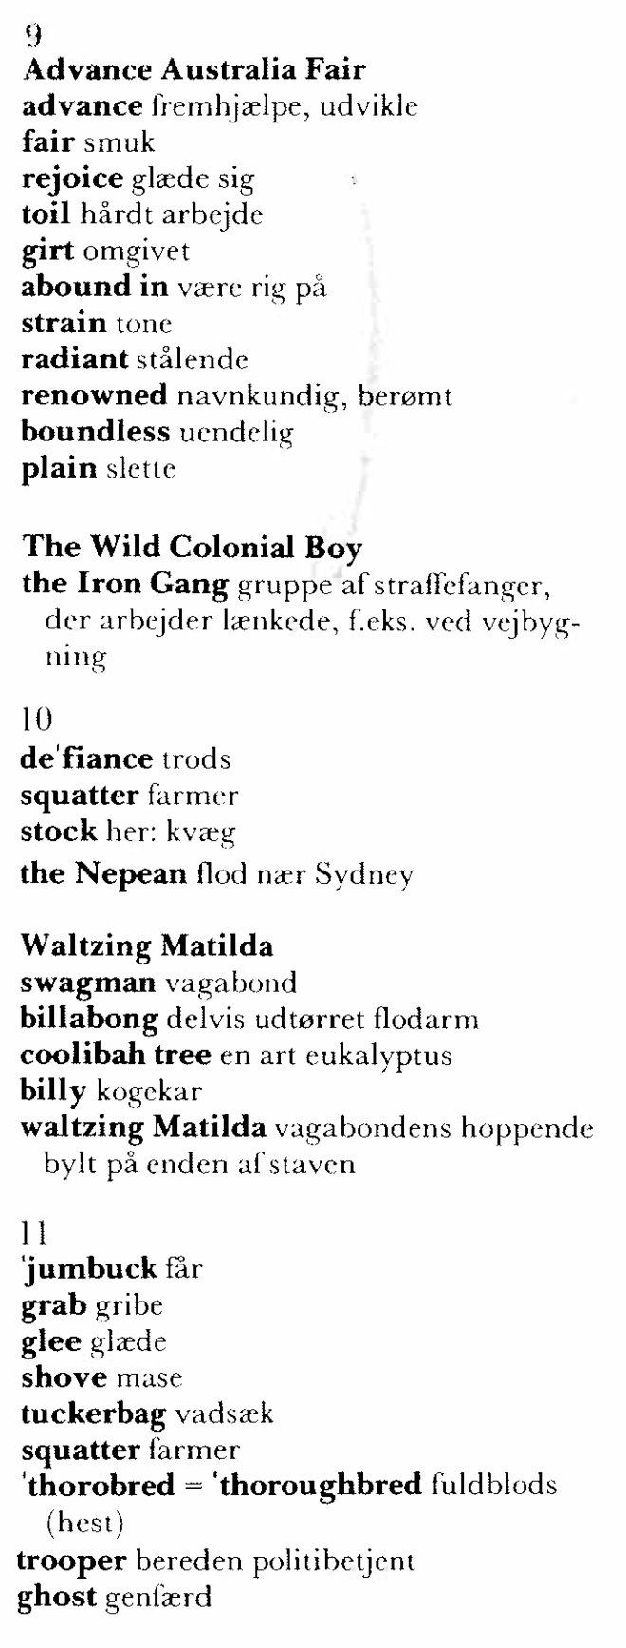*Australians all, let us rejoice,  
For we are young and free;  
We've golden soil and wealth for toil,  
Our home is girt by sea;  
Our land abounds in Nature's gifts  
Of beauty rich and rare;  
In history's page, let every stage  
Advance Australia fair!  
In joyful strains then let us sing,  
"Advance Australia fair!"*  
  
*Beneath our radiant southern Cross,  
We'll toil with hearts and hands;  
To make this Commonwealth of ours  
Renowned of all the lands;  
For those who've come across the seas  
We've boundless plains to share;  
With courage let us all combine  
To advance Australia fair.  
In joyful strains then let us sing  
"Advance Australia fair!"*

**The Wild Colonial Boy**  <http://www.youtube.com/watch?v=PyjsGdyRE6w> (This is the version that comes closest. We use this text!)

There was a wild colonial boy, Jack Donahoe by name,

Of poor but honest parents he was born in Castlemaine.

He was his father’s dearest hope, his mother’s pride and joy.

O, fondly did his parents love their Wild Colonial Boy.

He was scarcely sixteen years of age when he left his father’s home,

A convict to Australia, across the seas to roam.

They put him in the Iron Gang in the Government employ,

But ne’er an iron on earth could hold the Wild Colonial Boy

*Chorus:*

*So ride with me, my hearties, we’ll cross the mountains high.*

*Together we will plunder, together we will die.*

*We’ll wander through the valleys and gallop o’er the plains,*

*For we scorn to live in slavery, bound down with iron chains!*

And when they sentenced him to hang to end his wild career,

With a loud shout of deﬁance bold Donahoe broke clear.

He robbed those wealthy squatters, their stock he did destroy,

But never a trap in the land could catch the Wild Colonial Boy.

Then one day when he was cruising near the Broad Nepean’s side,

From out the thick Bringelly bush the horse police did ride.

‘Die or resign, Jack Donahoe!’ they shouted in their joy.

‘I’ll fight this night with all my might!’ cried the Wild Colonial Boy.

He fought six rounds with the horse police before the fatal ball,

Which pierced his heart with cruel smart, caused Donahoe to fall.

And then he closed his mournful eyes, his pistol an empty toy,

Crying: ‘Parents dear, O say a prayer for the Wild Colonial Boy.’

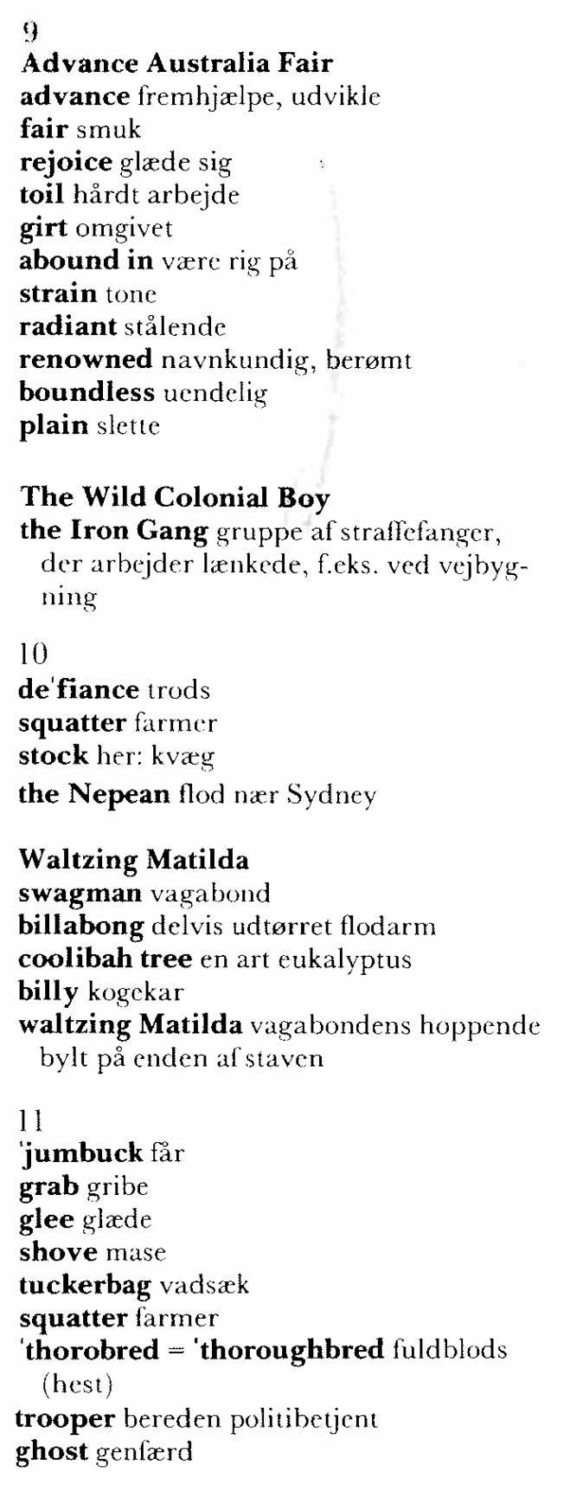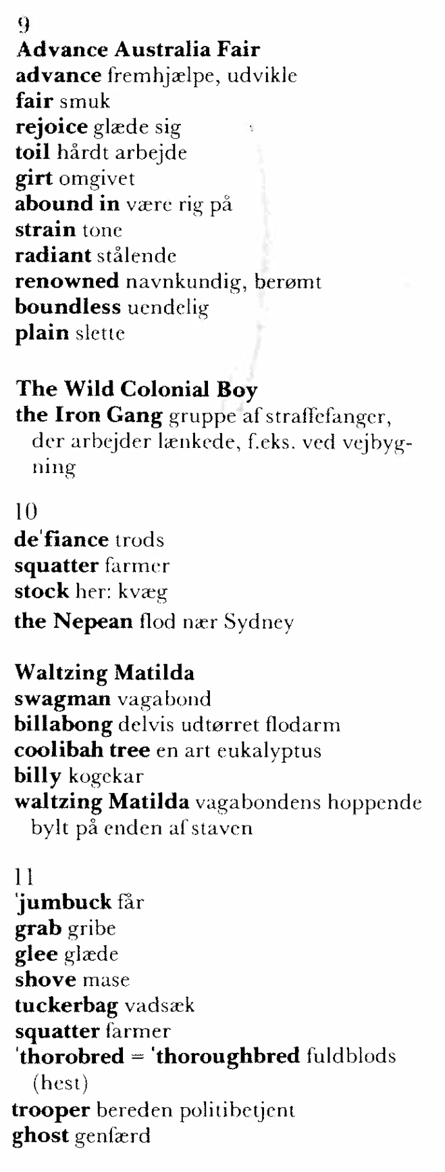

**Questions to help understand *The Wild Colonial Boy*:**

l. Why does Jack go to Australia? What is his background?

2. What did he do when he was put in the Iron Gang?

3. Why did he rob the squatters?

4. Describe his fight with the police. Find the words that are said about the policemen and their side of the ﬁght, then those that are said about Jack Donahoe.

5. Is there any connection between his life and his last words?

6. What has made Jack Donahoe a hero?

**Waltzing Matilda**

[**http://www.youtube.com/watch?v=Pu5byI6pZY0**](http://www.youtube.com/watch?v=Pu5byI6pZY0) **(This is the version that comes closest. We use this text!)**

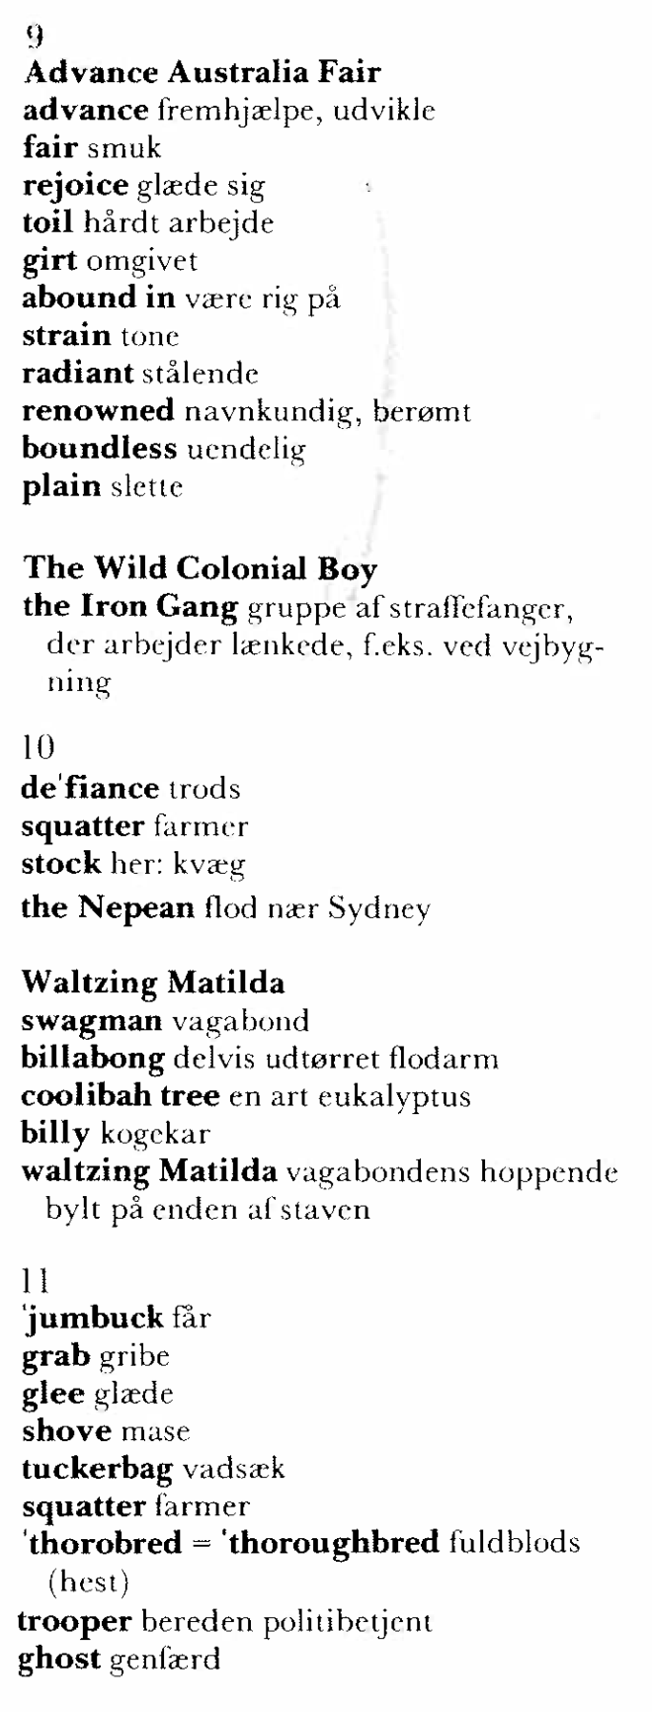Once a jolly swagman camped by a billabong,   
Under the shade of a coolibah tree,   
And he sang as he sat and waited while his [billy](http://www.hamilton.net.au/matilda.html" \l "billy) boiled,   
"You'll come a-waltzing Matilda with me.”

*Waltzing Matilda, Waltzing Matilda,   
 “You'll come a-waltzing Matilda with me."   
 And he sang as he sat and waited while his billy boiled,   
 "You'll come a-waltzing Matilda with me"*

Down came a jumbuck to drink at the billabong,   
Up jumped the swagman, grabbed him with glee.   
And he sang as he shoved that jumbuck in his tucker-bag,   
"You'll come a-waltzing Matilda with me.”

Down came the squatter, mounted on his thorobred,   
Up came the troopers, one, two, three,   
"Whose that jolly jumbuck you've got in your tuckerbag?   
You'll come a-waltzing Matilda with me!

Up jumped the swagman, sprang into the billabong,   
"You'll never catch me alive," said he.   
And his ghost may be heard as you pass by that billabong,   
"You'll come a-waltzing Matilda with me!”