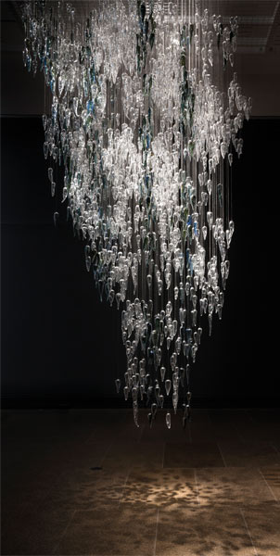Yhonnie Scarce

I think I’m in a position of power, I don’t usually like to use that term but compared to what my Ancestors and my grandparents had to deal with I think I’m in a really great position to talk about their history and my history.

*Thunder Raining Poison* is a work relating to the nuclear bomb tests that happened in the 1950s at Maralinga. A lot of the bomb clouds had travelled across Kokatha Country, which is my grandfather’s and my Country. When I first started my research relating to Maralinga, what I found was a lot of people didn’t know about it. I found that really interesting because it wasn’t that long ago that those tests happened. I wanted to create a large-scale work that spoke about one of those bomb clouds. I felt like I needed to go up and see what was up there. I am aware that there were quite a large number of bombs tested. I felt quite uneasy at the Breakaway bombsite—that particular bomb blast turned the surrounding dirt into glass—so it seemed fitting that I made the cloud out of glass yams.

I was quite nervous about it to be honest, cause it’s the biggest work I’ve ever made. It’s a suspended work over five-metres high, so there’s over 2000 yams. I think the fact that I can make the yams out of my own breath, I find it empowering. It’s a part of who I am. It’s something I feel really strongly about. It’s something I think about every day. I’m quite proud that I am able to tell my grandfather’s story through my artwork.

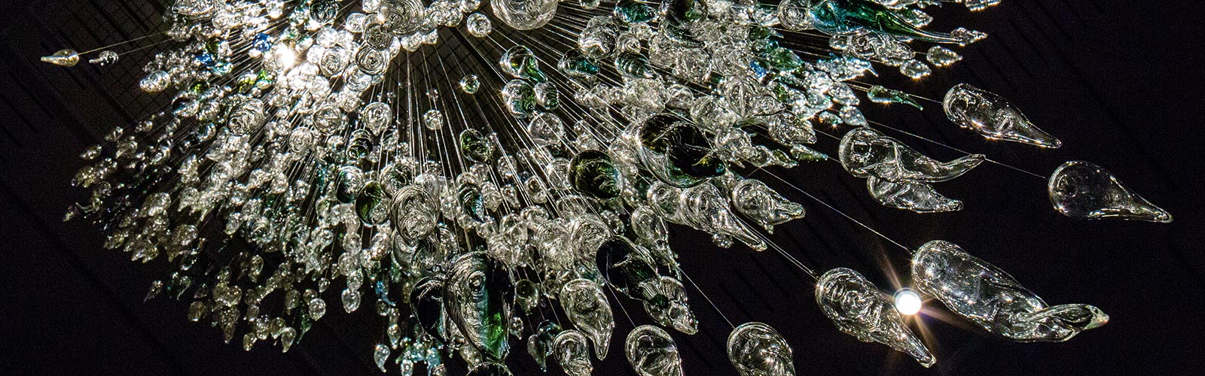

**Geography: Nuclear Test Site Maralanga (yellow star) and Kokatha Country (red outline):**

