2-3-Minute Presentation: South Africa.

Dette er en individuel opgave, der skal afleveres i NÆSTE blok.

Each of you must now prepare and make a 2-3-Minute Presentation and video it.
- Write down your answers to the following assignment:

What has Nelson Mandela meant for South African politics? Include what the development in South Africa after his presidency shows about his influence.
Include references to at least three of the texts we have worked with in class.

- Turn your text into a manuscript that is easy to read: highlight key words, make the font larger, make space between the lines.

- Rehearse making the presentation. Make sure that you can make the presentation without more than an occasional glance at the key words of your manuscript. Time it to check that it is shorter than 3 minutes long.

- Record your presentation while making sure you have as much eye contact with the camera as possible. (You should probably not record it the very best quality, because the file can become quite large.) Try more than once. It can take several tries to get it perfect :-)

- Share the video with me. Put a LINK to your presentation in “Elevfeedback” in the next lesson on Lectio. Make sure to press ENTER so that it becomes a link. Make sure that your video is NOT “private”.

- This can be a link to your Google Drive or Youtube or…? You probably know which way is easier much better than I do, but I do NOT use other SoMe platforms than facebook and youtube. :-)

Google Drev: You put your video in your own drive. Then get a link for sharing:
Remember to give people with the link access.
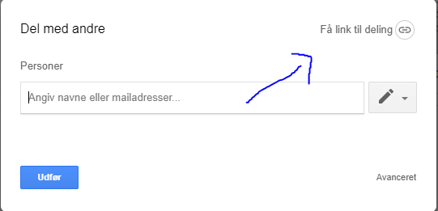

Youtube: Here, you just copy your link.
Remember not to make it private.

