At skrive en personkarakteristik

Når du skal lave en karakteristik af en person er det en del af engelskfagets metode. Personkarakteristikken er en del af tekstanalysen og dermed et trin på vejen til at nå en fortolkning af teksten.

Du kan vælge at se på en sådan karakteristik på tre forskellige niveauer, som alle supplerer hinanden – intet niveau er altså ”bedre” end et andet.

- Personens handlinger og ageren i forhold til andre
- Personens ytringer: ordvalg, dialekt osv.
- Fortællerens beskrivelse af personen – heriblandt kan du vælge at evaluere fortælleren: Er det en pålidelig fortæller? Er han/hun subjektiv/objektiv/alvidende?

I Texting kan man læse følgende:
”When we characterize, we sum up our impressions of the character based on evidence in the text. To characterize, we use adjectives that match the qualities we see in the person[.]”

Det er altså din opgave at finde adjektiver, der beskriver, hvordan personen fremstår oven for læseren. Det, du finder på, skal understøttes af eksempler fra teksten! Sidstnævnte er ultra vigtigt!

Følgende spørgsmål kan bruges undervejs til inspiration (bl.a. fra Texting):

- What facts do we learn about the character? (age, appearances, job, family situation, background…)
- How would you describe the character?
- What part(s) of the story made you feel this way?
- Is the character flat (one-sided, stereotype) or round (complex, hard to describe)?
- Does the character develop or change?
- How does the character interact with the other characters in the text? And what do the other characters think about the character in question?
- Would a person behave in real life like the character does in the story?
- What do the character’s actions tell us about him/her?

Checklist Character's Name__________________

1.a. What type of person is the character? (honest, annoying, sympathetic, pathetic, etc. Choose suitable adjectives)

1.b. What parts of the story make you feel this way about the character?

2. In what ways has society or the environment created the character (May not be possible to answer)?

3. How is this character's society different than yours?

4.a. How does the character appear to other characters? Which characters? Write their opinions about the chosen character.

4.b. Is the character aware of how he/she appears to others? Yes__ No__ Explain:

4.c. How self-aware is the character? Very little 1 2 3 4 5 6 7 8 9 10 Completely (Circle one) Explain:

5.a. How does the character view his/her own world?

5.b. Is this view realistic? Why/Why not?

6. Would a person behave in real life like the character does in the story? Yes__ No__ Explain in detail:

7. Is the character complex/round _____ or simple/flat _____? (*NB: How many things do you know about the character? Detail and variety make a character complex.) Explain your choice:
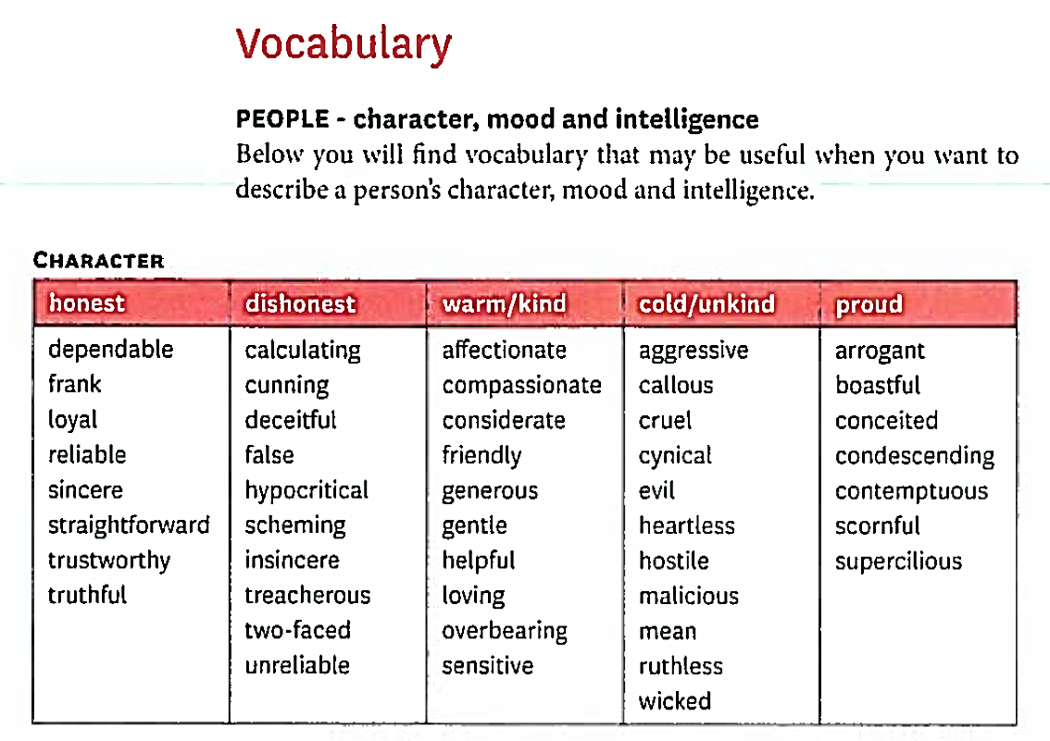
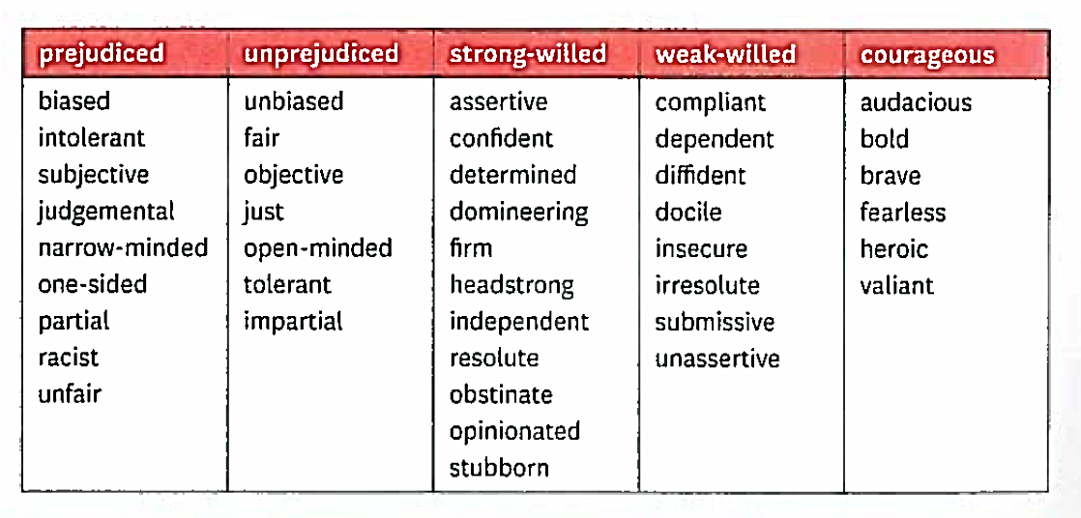
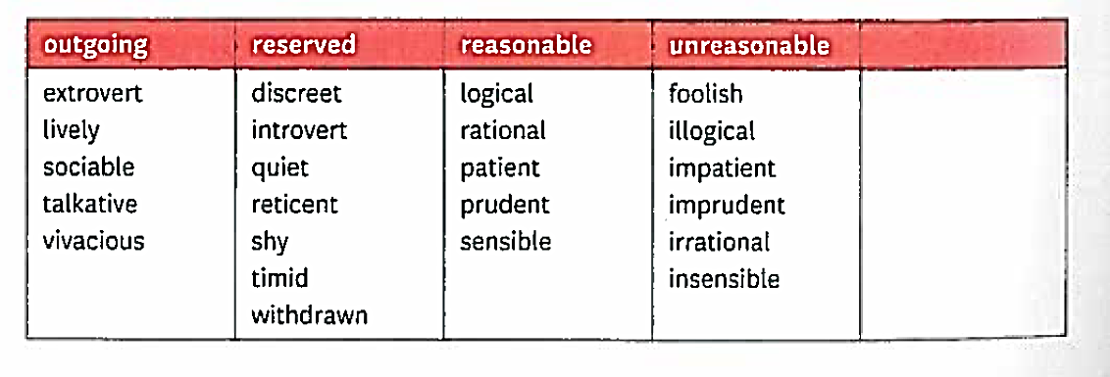
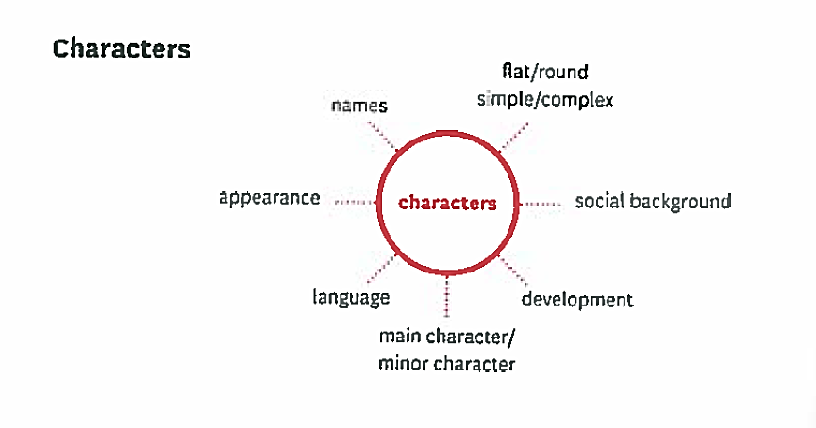

Egebjerg et al: Texting – 1st Year Fiction. Systime 2005, p. 7.

