***15 things I learned about Islam and British values as a gay boy living opposite a mosque***

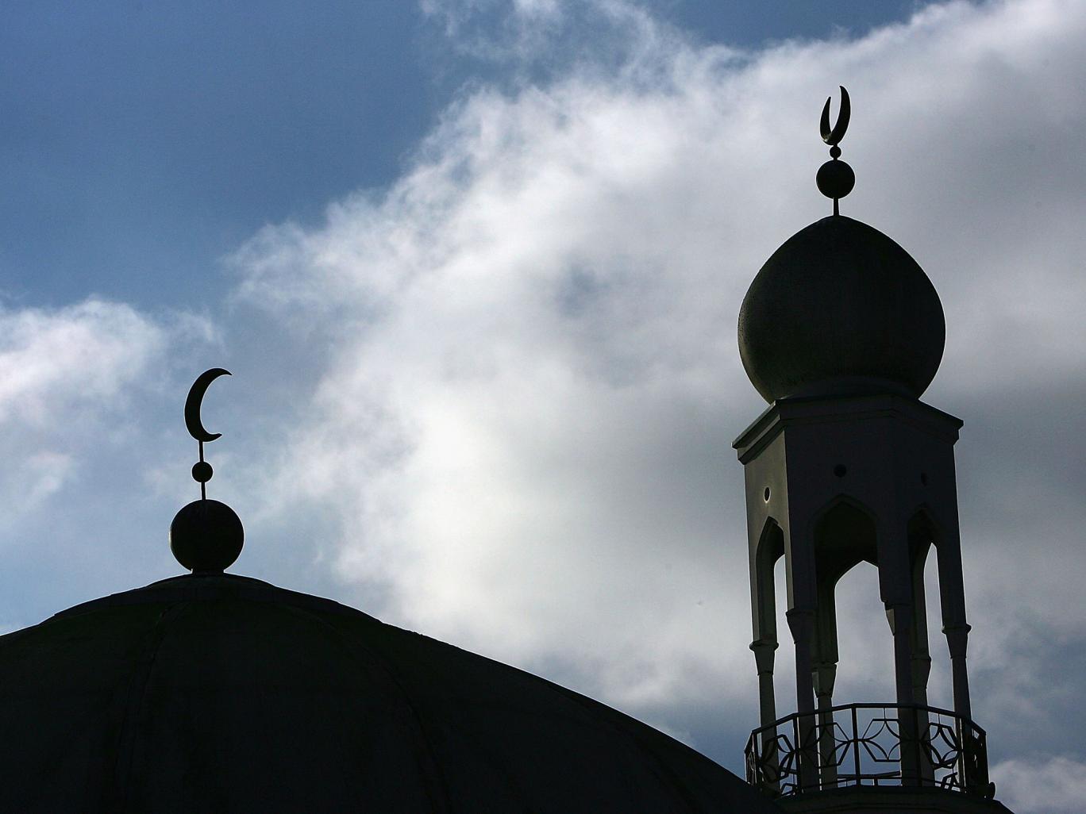

The media stories about Islam meant that I was genuinely a little nervous about moving in across the road to a mosque. What I have learned in the four years since I moved is that the ridiculousness of British culture is universal. We all love tea, are really polite and tut rather than saying something, no matter our religion

* [Thomas Mauchline](http://www.independent.co.uk/author/thomas-mauchline)
* Monday 7 December 2015
* 15 comments

The minaret and dome of the Birmingham Central Mosque Getty

1. No mosque has enough parking and Muslim men love to complain about it. I don’t care how young or trendy they are; within seconds they will be pointing at bits of pavement and muttering about the number of cars you could fit in there — like my Granddad from Manchester does at Sainsbury’s.

2. You can do that look British people do to each other, when someone nearby is making a scene, in a full face veil.

3. Muslims pray a lot.

4. You will be happy they pray a lot when you get stabbed on your doorstep and are too scared to go outside, so you time your trips to the shops to coincide with these prayers as the streets are full of friendly people.

5. Muslims, like all British people have that one problematic uncle that kinda ruins family occasions.

6. When confronted with something out of their comfort zone, like me and my boyfriend in full drag dancing down the road, Muslims - like all British people - get flustered and overcompensate by being overly polite — a bit like Hugh Grant.

7. When finding out you have been dating your boyfriend for five years, your Muslim neighbours will be disgusted that you haven’t proposed. You hear “Get a civil partnership — for your mother's sake” a lot.

8. Apparently there is usually half a cup of tea next to the prayer mat when praying at home — especially for morning prayers.

9. Like the rest of British dads, all Muslim fathers think their daughter is smarter than everyone, even though she is only 6 years old…

10…and that their son is a heartbreaker even though it's clear to everyone else that he spends all his time on his Xbox.

11. Young Muslim women are really, really, really ambitious.

12. British people’s dry sarcasm works really well when confronting the times the more traditional parts of Islam come face-to-face with modern gay culture. For example, when I donated three sequined crop-tops to the Islamic Relief Syria clothing drive, one of the older guys there smirked while shaking my hand and said, “Our brothers and sisters in Syria thank you for the evening wear.”

13. There is always an aunt who gets too involved in the wedding planning and annoys the bride.

14. During ramadan and eid there will be so many people on the streets going to mosque that the drugs dealers will have to move to other places — making your area really safe for a while.

15. Mothers will say anything to stop their kids nagging them. I once saw a Muslim mother tell her kid who wanted some fried chicken after Friday night prayer, that the shop wasn’t halal - even though there was a 5ft square neon halal sign in the window. Reminds me of when my mum told me that the chip shop was closed for a private event as she wanted some peace.

*This article was originally posted on* [*Thomas Mauchline's private blog*](https://medium.com/@tommauchline/15-things-i-learnt-about-islam-and-british-values-being-a-gay-boy-living-opposite-a-mosque-ebd385eb3113#.4uiyroyz5)

<http://www.independent.co.uk/voices/15-things-i-learned-about-islam-and-british-values-as-a-gay-boy-living-opposite-a-mosque-a6763466.html>