Strategi 5, Luk virksomheden op s. 90-93 og egen artikel
Plan (CSR: en vigtig del af virksomheders strategi – rigtig socialt ansvar eller green washing?)

- Hvad lærte vi sidste gang?
  - Undersøg ”Flying Tiger” s. 68-69 vha. Ansoffs vækstmatrice s. 93, figur 31.16ces på DAMI A/S og hjælpedokument (to markeder og dermed to strategier).
- Dagens lektie; Luk virksomheden op s. 98-103
  - Hvad er CSR?

- Kort brain break: informationskløft

- Dagens undersøgelse: CSR i virkeligheden: Fastfood-restauranten McDonald's og heavy metal-bandet Metallica har ikke umiddelbart så meget til fælles. De har dog det til fælles, at de begge har en CSR-strategi.
- læse følgende artikel fra TV2.dk: Metallica donerer stor musikpris til velgørenhed.
- Læse om McDonald's tilgang til CSR på hjemmeside: www.mcdonalds.com/dk/da-dk.html
- Undersøge hvilken type CSR som henholdsvis Metallica og McDonald's anvender. Inddrag også viden fra Marketing 6
- diskutere, hvilke årsager der kan være til, at Metallica og McDonald's har disse tilgange til CSR.

- Dagens sætning:

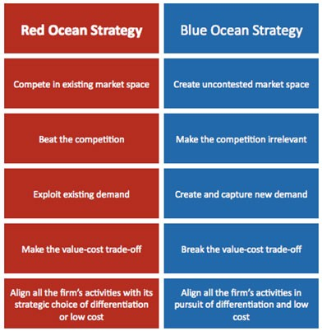

WHAT IS BLUE OCEAN STRATEGY?
Blue ocean strategy is the simultaneous pursuit of differentiation and low cost to open up a new market space and create new demand. It is about creating and capturing uncontested market space, thereby making the competition irrelevant. It is based on the view that market boundaries and industry structure are not a given and can be reconstructed by the actions and beliefs of industry players.
Red oceans are all the industries in existence today – the known market space. In red oceans, industry boundaries are defined and accepted, and the competitive rules of the game are known.
Here, companies try to outperform their rivals to grab a greater share of existing demand. As the market space gets crowded, profits and growth are reduced. Products become commodities, leading to cutthroat or ‘bloody’ competition. Hence the term red oceans.
Blue oceans, in contrast, denote all the industries not in existence today – the unknown market space, untainted by competition. In blue oceans, demand is created rather than fought over. There is ample opportunity for growth that is both profitable and rapid.
In blue oceans, competition is irrelevant because the rules of the game are waiting to be set. A blue ocean is an analogy to describe the wider, deeper potential to be found in unexplored market space. A blue ocean is vast, deep, and powerful in terms of profitable growth.

