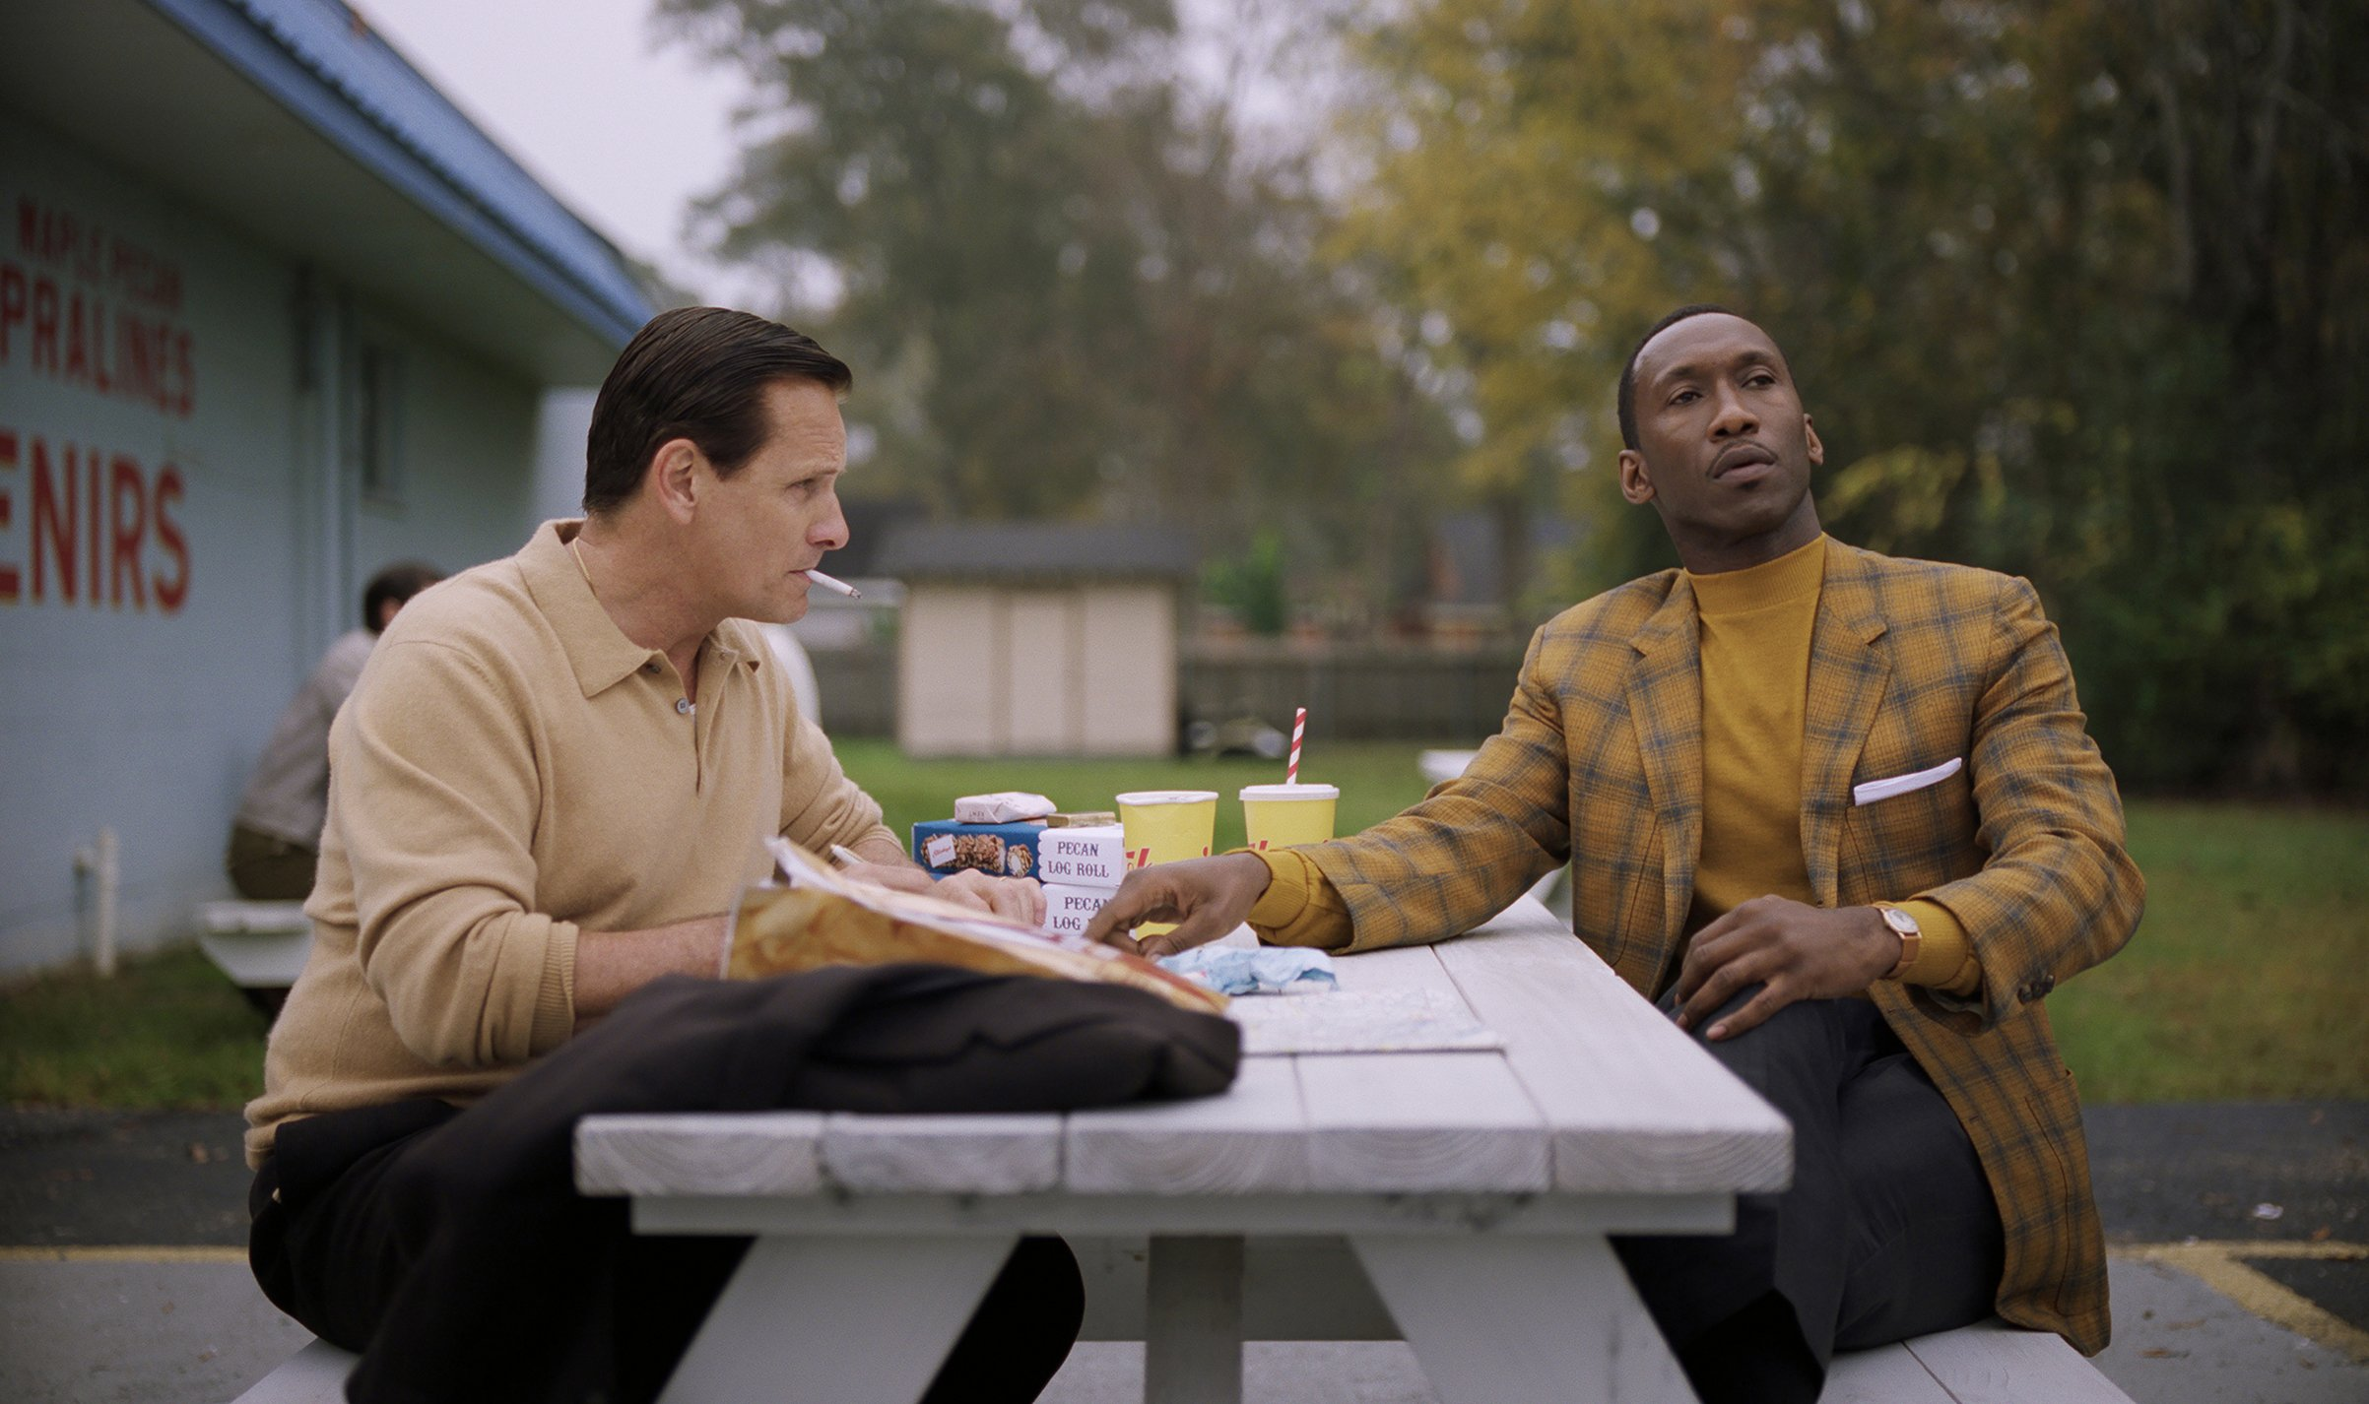
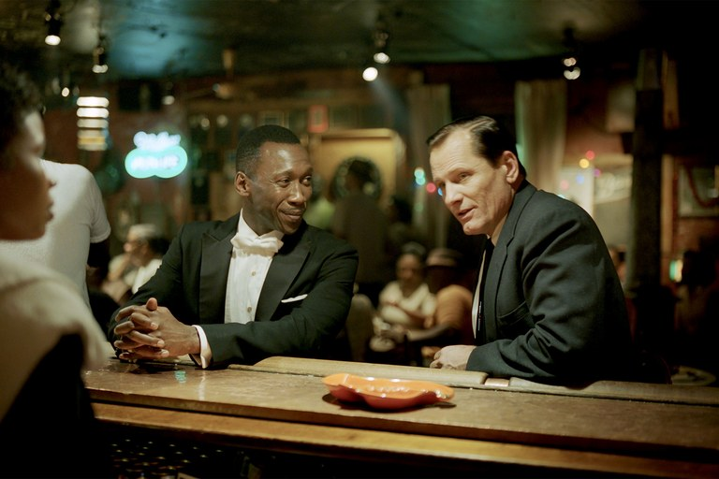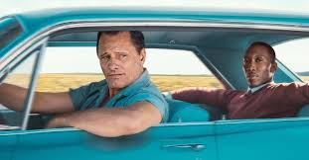

Green Book (Peter Farrelly, 2018)

Pre-watching:
Find interesting facts on the internet about:
- The Negro Motorist Green-Book
- Tony Lip
- Don Shirley

Useful links:
https://en.wikipedia.org/wiki/The_Negro_Motorist_Green_Book
https://allthatsinteresting.com/don-shirley-green-book
https://www.biography.com/people/don-shirley
https://en.wikipedia.org/wiki/Don_Shirley

While-watching:
Question | Answer
Write down examples which characterise Tony - his background, his values?

Write down examples which characterise Don - his background, his values?

List examples of race prejudice
(= racefordomme, altså forudindtagede holdninger)

List examples of race discrimination
(= racediskrimination, forskelsbehandling)

After-watching:
- Individually: Write 4-5 questions about the film. Ask one of your classmates to pretend to be one of the main characters and place him/her in the ‘hot seat’

- In groups: Pick a particular scene (around 3 minutes) and make a filmtechnical analysis of the scene (pay attention to angles, framing, sound, lighting, colours, camera movement and editing).
How do the cinematic devices (= filmtekniske virkemidler) contribute to the content?
You can re-watch parts of the film at CFU
- Present your analysis of a particular scene to other classmates (MD will give you further instructions)

- Based on your findings in the pre-reading task, does the film appear to be a realistic presentation of the two people and their relationship – why/why not?

