for Vendetta – film analysis

- What is the film about? (Give a very brief summary, and state the main theme(s) of the film – return to the theme later on as you gain a more thorough understanding through your analysis)
- What genre does the film belong to?
- Structure/composition
What are the major plot points of the film?
- Inciting incident/first turning point:
- Point of no return:
- Second turning point:
- Climax:
What do the plot points reveal about the conflict of the film, the journey/development the main character goes through? And how can this be linked to the theme of the film?
- Characters, setting etc. (storytelling)
- Take a look at this screen shot of chancellor Adam Sutler. And what other dystopian novel does the screen shot remind you of?

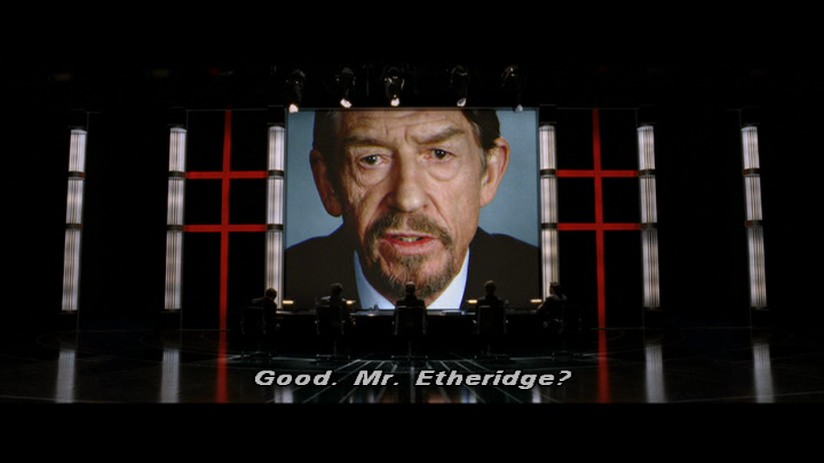

- V and Evey: How are V and Evey the same, but also different?
If you find this question too difficult look at the following screen shots and questions and return to this question later.
- Look at the following screen shot and V’s comment on Evey’s name (or should I say IV’s name). Why “of course”?
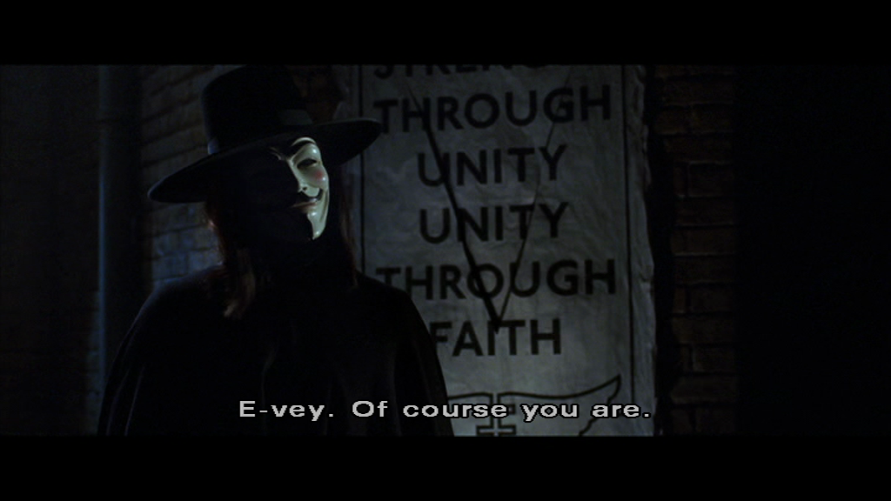
If you don’t get it just yet – then take a closer look at these two screen shots – bonus info: crosscutting is used between the shots:
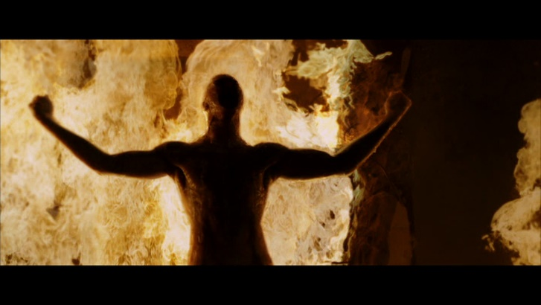
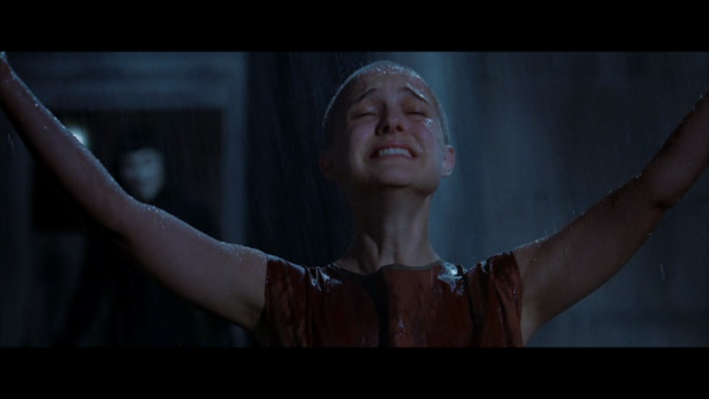

- V has stacks of books and historical artefacts and a jukebox – all of them confiscated. And he quotes Shakespeare and many other writers. Who or what does he represent?

- Symbols: Here are two quotes from the film:
- Evey (voive-over): “An idea can still change the world” (the very beginning of the film)
- V: “People shouldn’t be afraid of their government. Governments should be afraid of their people.”
Evey: “And you’ll make that happen by blowing up a building?”
V: “The building is a symbol, as is the act of destroying it. Symbols are given power by the people. Alone, a symbol is meaningless, but with enough people … blowing up a building can change the world.” (31:11-31:29)
Mention some of the symbols in V for Vendetta, and explain the importance of symbols in V for Vendetta.
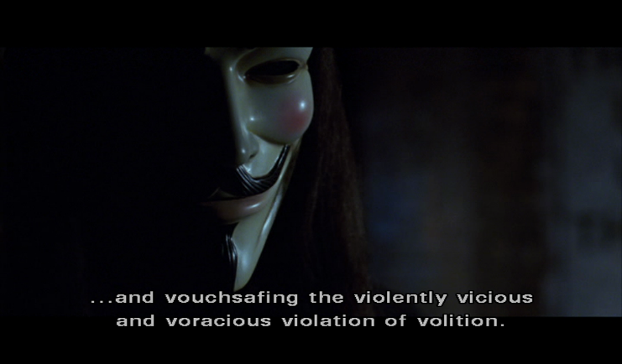
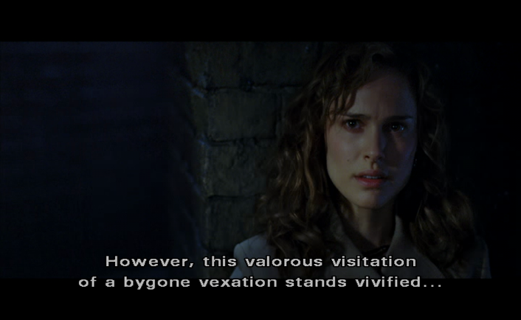
If you need help look at the following two screen shots and V’s momonologue

- Return to question 1 - What are the main theme(s) in V for Vendetta?

Ding ding ding: Hermeneutiske spiral

