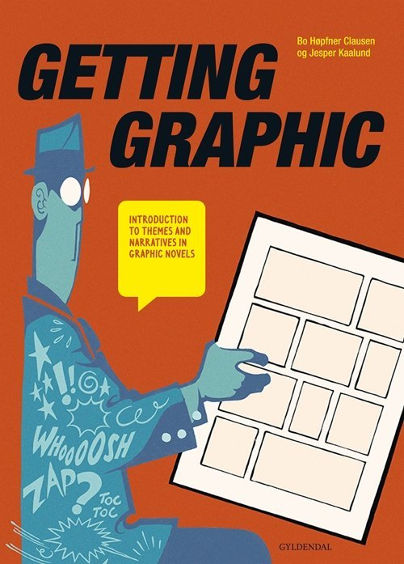
Getting Graphic – terms and definitions

On pages 11-23 a lot of useful terms and definitions are mentioned.
All groups must read pages 11-13

Group 1 read pages 14-15
Group 2 read pages 16-17
Group 3 read pages 18-19 And you are then responsible for explaining the highlighted terms
Group 4 read pages 20-21
Group 5 read pages 22-23

One student creates a Google Doc in which you collect all the notes of the groups. Make it visually cohesive! Like so:

Single page spread: one page of a graphic novel. This is typically considered as an artistic whole.

