”Why do we find comfort in terrifying stories?” by Nyshka Chandran

Just a little warm-up:

- In your own words shortly explain what the article is about.

- Do we find comfort in terrifying stories? Have a look at pages 5-6

What you need to share with the rest of us on the blackboard:
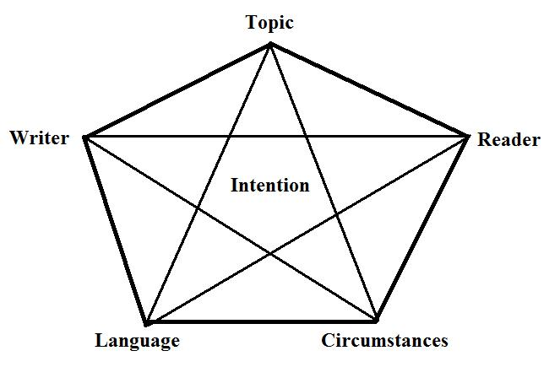
- Fill out the rhetorical pentagon

- Under language: Find at least three rhetorical features, analyze their qualities and explain their functions (if you’re thinking ‘rhetorical what now?’ have a look at the document “Analyzing non-fiction – Rhetoric). Use this table:
 | 1 | 2 | 3
Feature
Quality
Function

