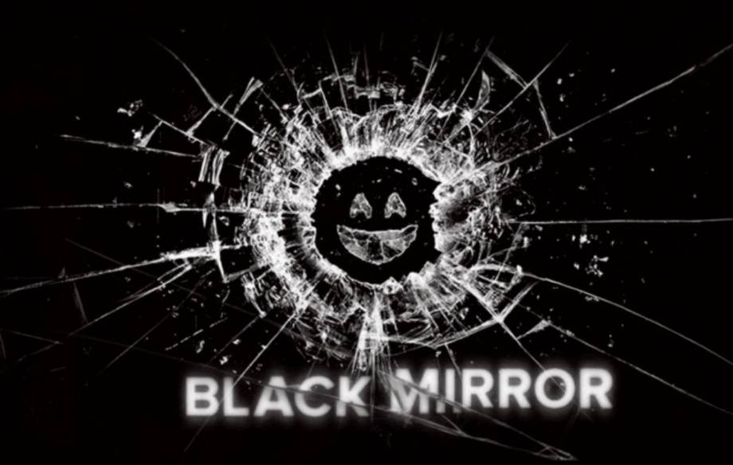
1 +2  San Junipero | 3  Hang the DJ | 4  15 Million Merits | 5  Nosedive | 6  White Christmas
Hjalmar  Sille  Luna  Katrine  +  Botan  Line  Sofie  Muneer | Alberta  Viktoria  Jasmin  Islam | Elias  Amalie  Zainab  Rim  +  Haben  Suhuur  Emmi  Yasir | Adam  Bejan  Rayann  Maj | Esben  Aisha  Kalina  Mustafa

You must prepare a BEAUTIFUL presentation with an IN-DEPTH analysis of your episode.
Your analysis must focus on the following:
- Plot
- Setting
- Characterization of main character(s)
- Theme and message
- Utopian or dystopia? (is it a story about a utopian or dystopian society?) Perhaps there is help to be found in the article.

When I say, “beautiful presentation”, it means that I want you to fill it with relevant screen shots.
Remember to present an outline at the very beginning of your presentation.
Everyone in the group has to say something.
Your presentation should last app. 5-7 minutes.
You have the rest of this lesson + 30 minutes next time (February 23rd) The presentation is on February 26th).

Måske lidt udfordringer her – nogle computere kan godt, andre kan ikke (Netflix har software, der hindrer screenshots). HVIS I ikke kan, så må I TIL NØDS tage billeder af skærmen med jeres mobil. MEN én pr. gruppe er rigeligt, og det tager ikke lang tid, at tage sådanne billeder, når man har bestemt sig for hvilke, man vil bruge (notér minut- og sekundtal), så telefonen skal hurtigt tilbage i bakken igen.

