To stay relevant, Black Mirror has to change how dystopian fiction works
The series shows us our nightmares, but it also needs to show us how to live with them
By Devon Maloney@dynamofire Jan 31, 2018

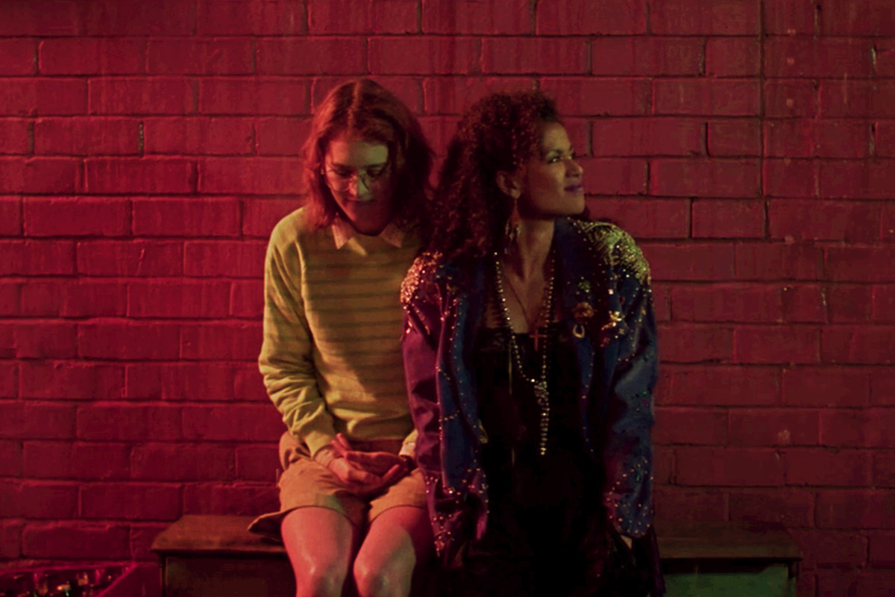Image: Netflix
Dystopian science fiction has spent more than a century in the popular imagination, but the more popular it gets, the more it confronts a major existential dilemma: making people fear a dark future is no longer a useful tool in preventing it. Dystopian futures have never been more piercingly relevant. We live in an era when many of the genre’s most far-reaching prophecies have come true, from radical inequality and authoritarian doublespeak to irreversible climate change and unsettling breakthroughs in AI. Dystopian fiction is inherently political, but it also gained steam because it was good entertainment, an escapist adventure into the frightening hypothetical consequences of human frailty. But when the real world is so thoroughly exhausting, it’s hard to get any kicks from such a deeply cynical format: a genre that predicts steadily worse conditions on the horizon.
This […] is particularly evident in the evolution of Black Mirror. Since its 2011 debut, Charlie Brooker’s techno-horror series has been heralded for its unsettling ability to both predict and inform our technological future in unusually bleak ways. But as the show has grown over time, its familiar pattern of “What if phones, but too much?” narratives are becoming predictable. Black Mirror needs to evolve. Over the past two seasons, Brooker has shown a willingness and even a tendency to change and grow, but if he wants the show to stay relevant, he will need to abandon his worst impulses and go even further in complicating his original, brutally dismal premise. Eventually, that may mean reshaping how dystopian fiction functions.
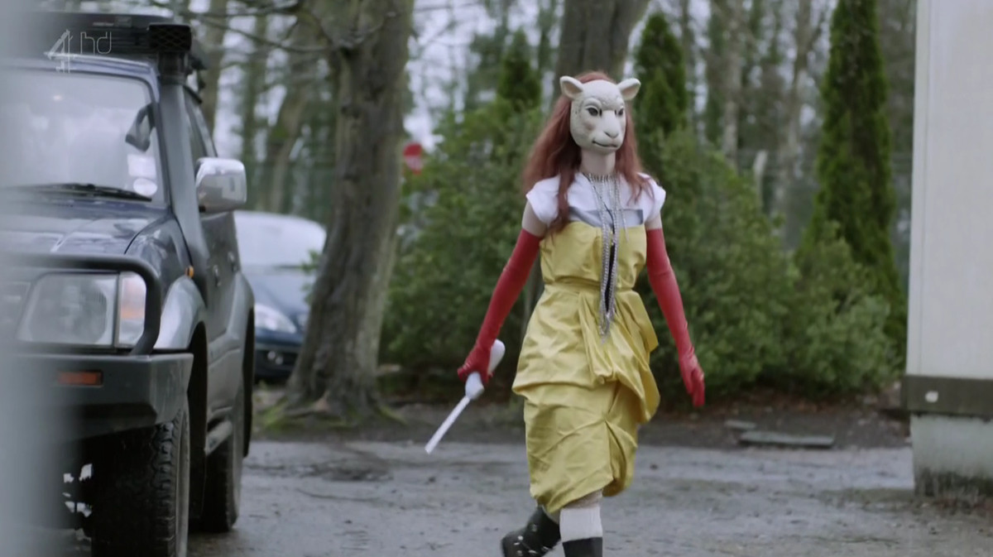Image: Channel 4
Black Mirror first arrived in 2011, as social media companies were taking off, consumer tech like cheap tablets and voice assistants were making futuristic lifestyles more tangible than ever, and audiences were begging for a fresh look at the future of technology, no matter how dark. […] The show’s third season took a slightly different approach, moving beyond bleak tales […] to more ambiguous and even redemptive endings. The digital afterlife romance “San Junipero,” in particular, enjoyed a wave of critical and fan praise for its happily ever after ending, even winning two Primetime Emmys for its writing […]
The show’s fourth season, which hit Netflix in December, officially established that pattern. While half the episodes — “Crocodile,” “Arkangel,” and “Metalhead” — end badly for their protagonists, in the tradition of the show, the other three — “Hang the DJ,” “USS Callister,” and “Black Museum” — offer more optimistic conclusions. […] These episodes […] offered […] the possibility of surviving even worse future horror shows than the one we’re living now.
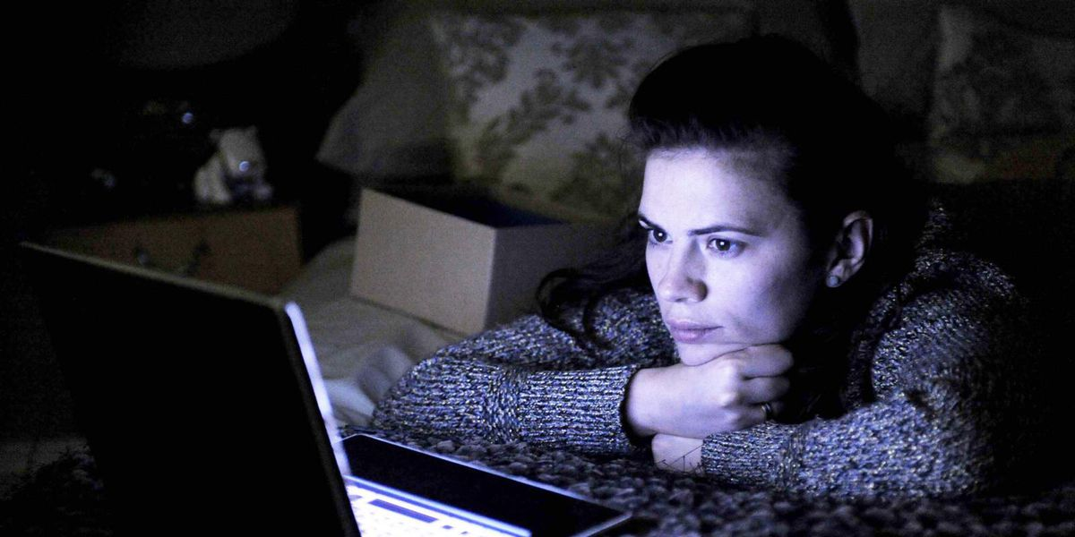Image: Channel 4
[…]
The real question is whether the Black Mirror we knew could survive any longer. Given that we’ve created the future that authors once envisioned in their metaphors for critiquing their present, it’s clear the dystopian genre hasn’t had its intended warning effect on society. Early seasons of Black Mirror did jolt people from their comfort zones, making them think twice about […] technology. But in 2018, Waldo has won the presidency. […]
Dystopian stories didn’t become a powerhouse in the ‘90s and ’00s because they paralyzed audiences into terrified surrender. Those bleak outlooks are meant to make us analyze our present choices, then spur us to act to prevent the world from going to hell. There is no point to a horror movie if we can’t believe the protagonists have some chance of survival. Why bother creating a terrifying future at all, if not to communicate that we still have some time to prevent it?
[…] In its fourth season, Black Mirror periodically suggested that while the future no doubt has many nightmares in store, we can make worthwhile choices and survive in spite of them. That’s the message that will save Brooker’s series — and maybe us, as well.

From 1984 (e.g.: war is peace)
Essentially, naturally
Imaginary/theoretical
Weakness/imperfection
Pessimistic, negative
Grim/depressing
Argument/idea
Real/substantial
Vague/uncertain
Redeeming (forløsende = positiv slutning)
Reference to Donald Trump

