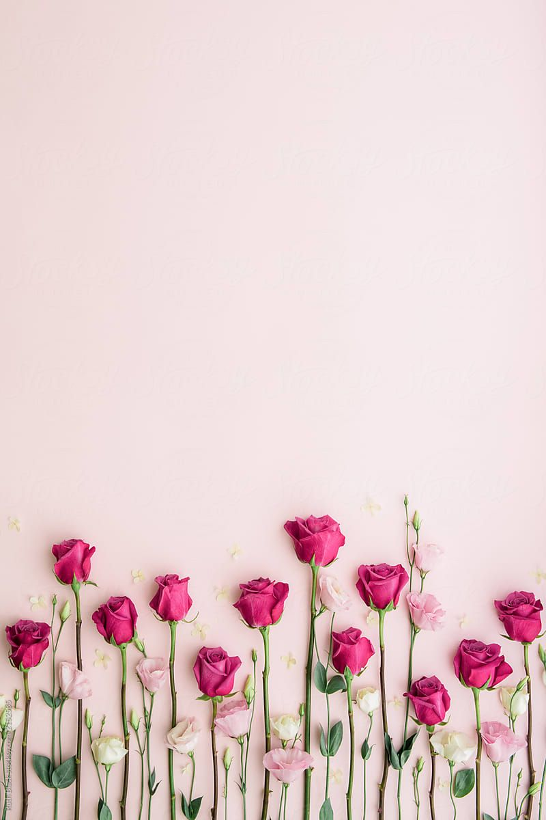
The Man Who Loved Flowers
By Stephen King
20 Quick Questions
- Where and when does the story take place? Is it important for the story?
- What does the main character look like?
- Who is the first person he meets on his way to his “beloved Norma?”
- How does the woman respond to the young man? Why?
- Why does the young man stop to buy some flowers?
- What does the flower vendor look like? How does he behave towards the young man?
- What kind of flowers does the young man decide to buy? What are these flowers normally a symbol of?
- “… so much in love that you practically zoomed in everywhere.” – try to explain. Do you know the feeling?
- What mood is the young man in when he has left the flower vendor? How do the people surrounding him respond to his appearance and behavior?
- Where does he finally end up? What is this place like?
- What is the effect of the growing darkness? What is the contrast to the darkness?
- How does the young man react when “Norma” appears?
- “… it was always for you… all for you.” – What does he mean by that?
- Do you think the young man has asked the girl to come here, or does he just bump into her by accident?
- How does the girl react when he offers her the flowers?
- “Norma was dead, she had been dead for ten years.” – What does that mean?
- Why does Stephen King bring the screaming and yowling of the alley cats into the story?
- “Some unknown time later…” – What does that shows us about his state of mind?
- Why does the young man call himself “Love”?
- How does he feel after the murder? Do you think he will continue his killing?
Analysis
Before analyzing the short story, take 5 minutes to research who Stephen King is.
- What creates the idyllic and romantic atmosphere at the beginning of the story? Make a list of the words and sentences that create this atmosphere. Next, find all the elements that break the romantic atmosphere.
- Make a character sketch of the main character: why do you think he murders girls by knocking them down with a hammer? What is the matter with him? Do we get any hints in the story?
- Composition: How does Stephen King structure his story to make his readers interested in going on reading? Why do you think that buying the flowers takes up so much of the story? What difference would it make if this scene was shortened?
- The flower vendor thinks, “If this kid were sick, they’d have him in intensive care right now.” – what do you think of this remark in the light of what happens later in the story?
- What do you think of the title of the story? Is it good or bad? Would you prefer a different title?
- What are the main themes of the story?
- Message: What does Stephen King want to tell us through this story? What impression do we get of people’s sexual life/married life in this story? Find some examples. What impression do we get of life in a big city?
Written work
Make a different ending from the point when the young man leaves Seventy-third Street. Make sure that you keep up the same style and tone the story has been written in so far.

