Postmodernism and Hotel des Boobs by David Lodge, 1987

Postmodernism and form
Postmodern writers experiment with form; e.g. a text may be “glued together” using several different genres. There are many examples of texts that use poetry, drama, regular fiction and cartoons in one and the same work = pastiche! Another way to play with form is using metafiction and explicitly commenting on the writing process. Both the use of pastiche and metafiction is very experimental, and it deconstructs the form of the text, because it reminds the reader that he or she is in fact reading fiction – the illusion of reality, of imagining and “living” the story is broken – and this has traditionally been the thing writers thought to avoid (think of fantasy, a horror story and other texts that require the reader to accept the story as reality).
Thus, the literary conventions are destroyed, and the reason why they are destroyed is that postmodern writers think that reality has become far too complex to represent or depict in a text. The idea of creating something “real” within fiction is therefore impossible according to postmodern writers. The idea that a text can represent something “out there” in the real world is seen as an illusion and instead the texts represent nothing but themselves.

Some literary conventions:
When dealing with fiction, we usually speak of two levels of story (this has to do with the literary device composition).
There is the level of “the told” (that which we, the readers, are told) = the story. And then there is the level of “the telling” (the process of telling the story, the choices the author makes when e.g. structuring the story – perhaps he or she chooses to start with a flashback, or present the reader to several flashbacks throughout the story to uncover a character’s true identity) = the plot.
Usually the plot is completely invisible to reader (until he or she begins to analyze it). But this is sometimes not the case in postmodern texts, where the author can be seen commenting on his or her thoughts about the plot (this is what is known as metafiction).

The frame tale convention
This is a very common “tool” used in writing (this also has to do with the literary device composition), and it is seen in e.g. One Thousand and One nights (1001 nats eventyr) – a girl tells stories to avoid being killed. The frame tale convention is also seen in Frankenstein – a series of letters are sent to a sister from her brother, who has spoken to Frankenstein (the scientist, not the monster!), and Frankenstein has told the brother about this monster he created, and what the monster did – as seen below:
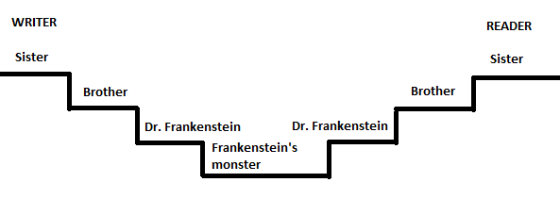

Conventionally, we, the readers, know about the frame tale, because we are told this / made aware of this from the beginning of the story. Normally, there is not much of a relationship between the “framed story” (the “actual” story) and the “frame story” (in Frankenstein – the story of the sister reading letters)… but this is not the case with Hotel Des Boobs.

Take all of this into consideration when analyzing Hotel Des Boobs!

Assignment
Hotel Des Boobs – a presentation

- Make an analysis and interpretation of the story and prepare a presentation of your analysis and interpretation using PowerPoint.
- Things to consider:
- Relevant fictional elements to examine (characters, composition, point of view, etc.) and the literary period – postmodernism. Are there any postmodern features?
- The theme(s)
- Compare the text to other po-mo texts
How is it similar/different? You have to do this for the exam.
- The structure of your analysis / presentation (make it logical! Like an essay – remember to guide your listeners by e.g. making an introduction with an outline, also mention theme here). Also consider who will say what (everyone has to say something).

You have today’s lesson + next time (April 9th). Your presentation (on April 14th) should last approximately 5-7 minutes (you present to me).

I want to mention one thing before you start your work, and it has to do with the frame tale convention. In Hotel Des Boobs the frame tale could be illustrated like this:
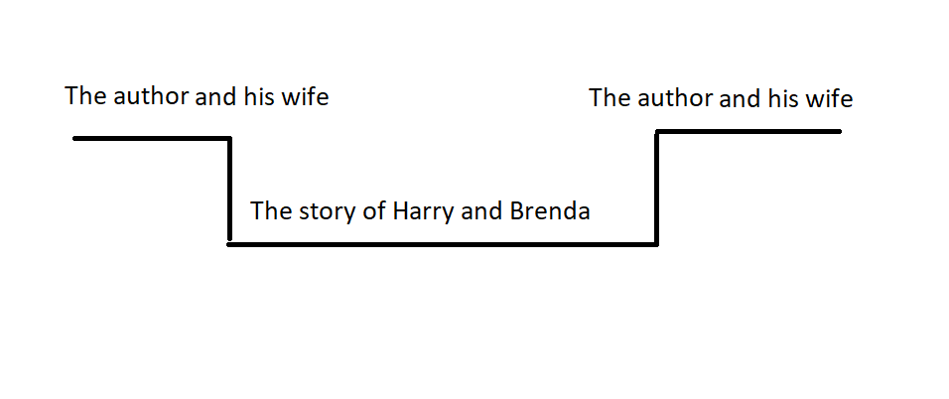
But because the connection between the framed story (Harry and Brenda) and the frame story (the author and his wife) is so strong (there are numerous examples of how the story of Harry and Brenda is very much based on the author’s and his wife’s lives – I will leave it to you to find these numerous examples), it could lead the readers to consider if the frame tale does not in fact look like this:
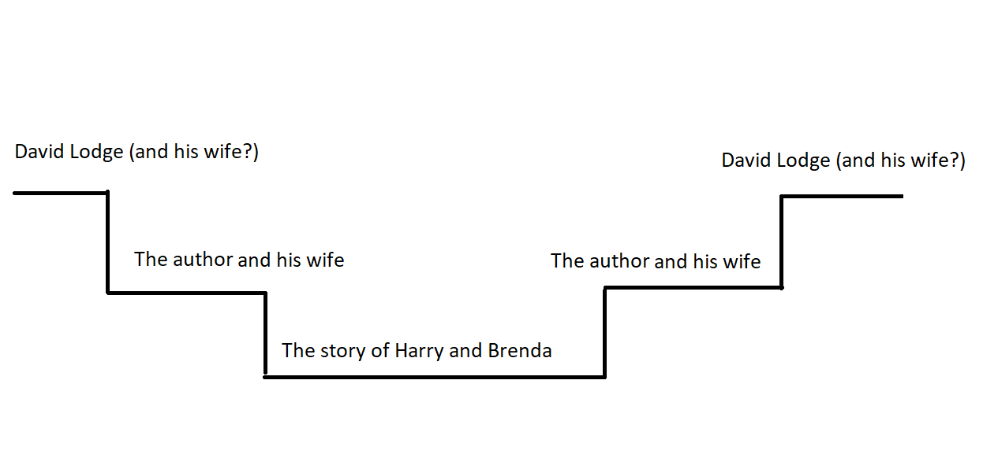

Another evidence of this being the case is near the ending of the story where the author’s wife says that he should write the story about how his pages were scattered by the wind and that he should call it Hotel Des Boobs… and who do we know, who has written such a story? Well, David Lodge of course! BOOOOM! Right? Mindblowing…I know. And this affects the reliability of the narrator quite a bit. AND it is also highly uncommon for an author to involve him- or herself to such a degree in his or her story … except for perhaps a postmodern narrator who wants to destroy or deconstruct the literary conventions
So, try to work that into your analysis.

Also (one final thing, I promise!), Google Tender is the Night by F. Scott Fitzgerald.

Relevance = connection to theme
If you find inspiration on the internet make sure to make references in your PowerPoint

