The seven social classes of 21st century Britain - where do you fit in?

The BBC has released the latest analysis of data of the 21st century social classes - what does it mean to be 'elite'?
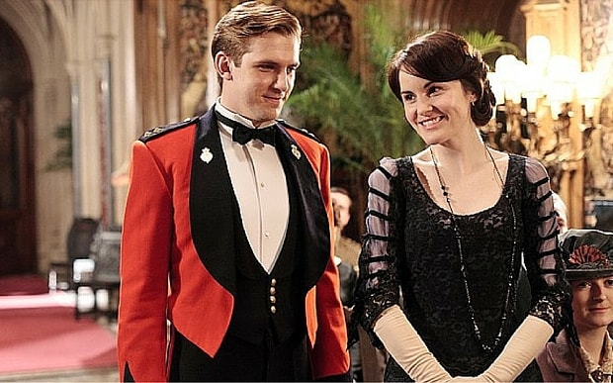
"I love opera and not having to rent"

By Helena Horton
1:25PM GMT 07 Dec 2015
In 2013, everyone went crazy for the BBC's social classes calculator.
It sorted us all into seven distinct social groups, from the precariat to the elite.
Professor Mike Savage from the London School of Economics thinks that the traditional three-class analysis is out of date, so he created a new way of sorting class-obsessed Britain into social groups.
In his new book, Social Class in the 21st Century, Savage delves deeper into the Great British Class Survey findings from 161,000 people.

The seven social classes
- Elite - This is the wealthiest and most privileged group in the UK. They went to private school and elite universities and enjoy high cultural activities such as listening to classical music and going to the opera.
- Established middle class - This is the most gregarious and the second wealthiest of all the class groups. They work in traditional professions and socialise with a wide variety of people, and take part in a wide variety of cultural activities.
- Technical middle class - This is a small, distinctive and prosperous new class group. They prefer emerging culture, such as social media, and mix mainly among themselves. They work in science and tech and come from middle-class backgrounds.
- New affluent workers - These people are economically secure, without being well-off. This class group is sociable, has lots of cultural interests and sits in the middle of all the groups in terms of wealth. They're likely to come from working class backgrounds.
- Traditional working class - This group has the oldest average age, and they're likely to own their own home. They mix among themselves and don't enjoy emerging culture. Jobs in this group include lorry drivers, cleaners and electricians.
- Emergent service workers - These young people have high social and cultural capital - so they know people from all different walks of life, and enjoy a wide range of cultural activities - but are not financially secure.
- Precariat - The poorest and most deprived social group. They tend to mix socially with people like them and don't have a broad range of cultural interests. More than 80% rent their home.

The elite are more obsessed with class than anyone else
Around 6% of the population are elite. However, 22% of the people who took the survey turned out to be in this social group.
25% of the population are estimated to be in the established middle class - but 45% of the survey respondents got this result.
Compare this to the precariat - they make up 15% of our society but less than 1% of them took the quiz.
Savage said this may have been because they found the survey "intimidating".

The elites are concentrated around London and the South of England
As you can see from the map, the darkest areas - which correspond to concentration of elites - are mainly in London and the South of England.
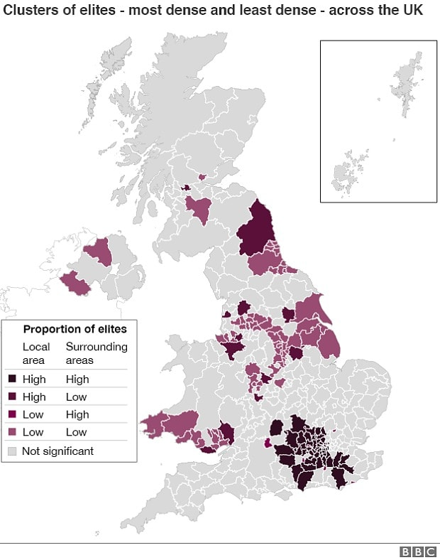 Photo: BBC
However, not all people in the South are classed as elite. Towns like Swindon, Slough and Crawley have relatively low proportions of elites, but with wealthy clusters not far away.
As we go further North, and in to Wales and Ireland, the clusters become pink, which means that less people there are classed as elite.
This isn't that surprising - but it is striking to see the difference on a map.

The elite are more likely to have gone to university than most - but so are emergent service workers
The young and cultured, but financially insecure emergent service workers are very likely to have gone to university.
They have a higher proportion of graduates in their class than any of the others, except those at the very top of society.
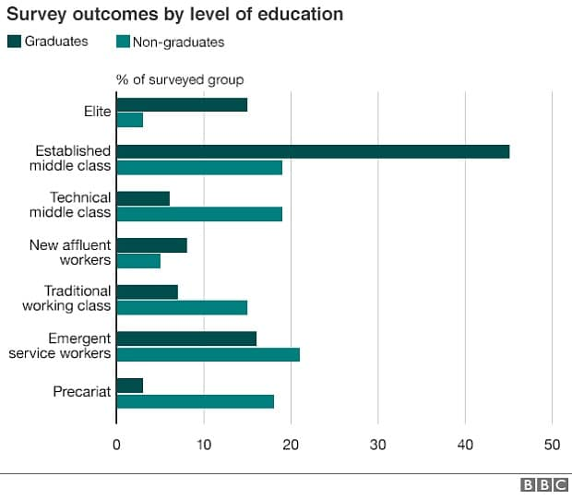 Photo: BBC
Most of the graduates are in the established middle class, which isn't a surprise, but perhaps it is surprising that some of the most financially insecure people in the country have a university degree.
The graph does, however, show that it is possible to be in the elite group without a degree.
Savage concludes that getting a good degree can affect which class people are likely to end up in - but not going to university does not mean they have no prospect of moving up.

It appears that people in high-salary jobs, whose parents were also in high-salary jobs, get paid more
It seems from the data that people in the same job might get paid more or less, depending on what their parents did.
People whose parents were in high-salary jobs seem to get paid more in the top industries than those whose parents were not in high-salary jobs.
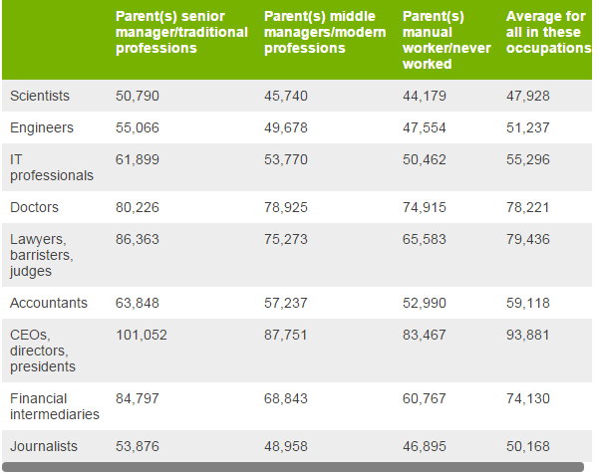 Photo: BBC
Is the old adage "It's not what you know, it's who you know" still true today?
"There are various possibilities as to why those from senior management family backgrounds have higher pay," says Savage. "It could be either because of the support they were given to get better qualifications, or because strings were pulled, or because they have more confidence."

