How to read a non-fiction text
The term non-fiction text covers a wide range of very different kinds of writing. It may be articles, leaflets, advertisements, diary entries, letters, essays, biographies, speeches, blogs or similar types of writing. Non-fiction texts may be written for various purposes – to inform, to describe, to persuade, to argue or to entertain.
When working with non-fiction texts, first try to understand what the text is about and distinguish between what is fact and what is opinion. Then analyse how the material is presented and how this influences the reader's understanding of the text.
The rhetorical pentagon can be used both when analyzing speeches and when you work with fiction and non-fiction texts:
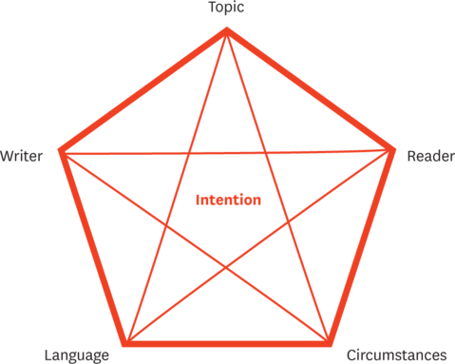
The following questions may be useful to get a detailed analysis of the text. In your analysis identify characteristic features, and in your interpretation explain their effect.
Type of text /topic
- What type of text is it?
- What is the medium (quality press, popular press, free papers, internet, magazine …)?
- What is the text about? Find keywords in the text or give each paragraph a heading (if it has not already got one).
Writer/speaker
- What is the writer's background? Consider age, sex, education, occupation, religious or political point of view.
- How does the writer establish his/her ethos (credibility, trustworthiness and knowledge)?
- Does the writer include himself as part of the group addressed? If so, why?
Reader/audience
- Who is the intended/explicit audience?
- Is there an implicit audience?
- What is the intended reader's background? Consider age, sex, education, background, occupation, religious or political point of view.
Language/presentation
- Where and how does the writer/speaker appeal to logos (the appeal to reason with arguments, evidence, facts and logical reasoning)? Some of the questions below may help you answer this.
- Where and how does the writer/speaker appeal to pathos (the appeal to emotion with emotional language, passion and a personal angle)? Some of the questions below may help you answer this.
- How is the text structured? (Is there a coherent overall structure? Is the theme introduced at the beginning and then elaborated on? Is there a conclusion at the end …?)
- Is the sentence structure simple or complex, paratactic or hypotactic? Are the sentences long, short or incomplete?
- Is the vocabulary concrete or abstract, colloquial, formal or neutral? Is a particular word class predominant in the text? Is there a use of or a lack of adjectives and adverbs? Are specific words or phrases repeated?
- Is there anything characteristic about punctuation or word order?
- What is characteristic of the tone and style?
- Are there any connotations? Positive or negative?
- Sound effects: are there examples of alliteration or assonance?
- Is imagery implied? Is symbolism? Are there examples of metaphor, simile or personification?
- Does the language belong to a certain dialect or sociolect?
- Are there quotations? If yes, by whom, and in what way are they used?
- Are there any references to specific topics, places or people?
- What arguments are used? Are they weak or strong?
- What is the lay-out of the text?
- Are there illustrations? If yes, what kind and what is the relationship between illustration and text?
- Is the presentation balanced and fair, or is it biased?
- Does the form complement the content?
Circumstances
- What occasion has caused the writer to produce this text?
- In what way(s) has this situation influenced the text?
Intention
- Why has the writer written this text? (To describe, to inform, to provoke, to persuade, to explain, to entertain, to manipulate or …?)
- Does the text succeed in fulfilling the writer's intentions?
Wider contexts
- Relate the text to other texts on the same or a similar theme. What are the similarities and differences? What is conveyed or achieved by the comparison?

