A Bullingdon in reverse: how working-class student club is taking on elitism

https://www.theguardian.com/education/2021/mar/06/bullingdon-in-reverse-working-class-student-93-club-taking-on-elitism, The Guardian, Robert Verkaik, 6/03/2021

Sophie Pender started the 93% Club when she was at Bristol University for students who felt discriminated against for not being rich and from private schools. Photograph: Graeme Robertson/the Guardian
The 93% Club, begun at Bristol University by a state-educated student, is snowballing nationally, with big firms now taking note
Sophie Pender was the first in her family to go to university and believed what her mother had always told her – in a meritocracy you can use education to rise above your family circumstances.
For Pender, this was perhaps more important than for most students leaving home for university. Her childhood had been deeply affected by her father’s addiction to drugs and alcohol. “We lived on a council estate in Borehamwood and had very little money. My mum did her best. But Dad was violent, and things had become so bad there were panic buttons in the house connected to the police station to protect us should he try to visit.”
When Pender, now 24, was in her second year of secondary school her father died from substance abuse. She decided to throw herself into her schoolwork: “Education was something that I felt I could control and was a way of alleviating my circumstances. By working hard at school I could achieve anything.”
At her school, only about 30% of her year achieved a C grade or above at GCSE. Nevertheless, she managed to attain three A* grades at A-level, the first person in her school to do so.
Remembering how inspired she was, Pender says: “I wanted to go to Bristol University, and I wanted to be a lawyer, and it was all going to be great.”
But at university she was in for a nasty shock. “When I got to Bristol I thought not having a dad and growing up on a council estate wouldn’t matter because after all I had these grades. I didn’t think people would care about my background.”
Instead she found that to her peers, her background and her class mattered more than her academic achievements. Private school students mocked her accent and for the first time she encountered “chav parties”, where undergraduates dressed up in clothes that parodied their perception of working-class people.
“I remember going to a flat where we were having drinks and a boy told my friend that his tweed jacket was worth more than her house. When I heard a girl talking about her ‘allowance’ for going on holiday I asked how much it was. But she just shut me down and said people didn’t discuss family money. At my school we didn’t discuss it because none of us had any money. These were new social rules that I didn’t understand. I started to feel ashamed of my background. Very quickly my dream of my exciting new life at university was turning into a nightmare.”
Roughly 7% of pupils in the UK attend a private school but at Bristol University, they make up nearly a third of the graduate intake. Most of the so-called elite universities have disproportionately high numbers of private school students, including Oxford and Cambridge, which respectively have 31% and 32% representation from independent schools. At Bristol in 2016, the year Pender began her English degree, the proportion was closer to 40%.
After those early damaging encounters with privately educated students Pender decided to make a stand. “I wanted to even things out a bit, so that those who didn’t come from privileged backgrounds could help each other get on in life. And I didn’t see why people from working-class families should feel ashamed of their upbringing.”
The result was the establishment of the first 93% Club.
Pender describes the club as a kind of old boys’ network in reverse: “It’s artificially creating a movement against the idea that a small number of people get all the good jobs. It’s bringing people together who simply don’t have those connections. The question of ‘what school did you go to?’, which private school people are always asking each other, is being replaced with ‘which 93% Club are you a member of?’”
During the pandemic the movement has snowballed, from just two clubs at the start of 2020 to 36 participating universities today and a reach of more than 10,000 students. In December the club attained charitable status and has now attracted a plethora of high-profile corporate sponsors, including Accenture, CapitalOne, Herbert Smith Freehills, Newton Europe, DLA Piper, Teach First, OC&C Consulting and Freshfields Bruckhaus Deringer.
Finley Wright, the 93%’s marketing director, says the club is still growing, adding a new university nearly every week. “I think before Covid-19, lots of students regarded their job prospects as pretty bleak. But when they were sent home and denied a campus education they realised just how big the gap was between themselves and the more privileged students they had met. Zoom tutorials also brought home to them how different their family homes were from wealthy students’. Some find it so shaming they turn off their video cameras so people can’t make judgments about their homes.”
The rapid spread of the club has met some hostility. There has been a rash of abusive messages on social media, and online networking events have been disrupted by gatecrashers. An event arranged by Edinburgh University’s 93% Club in September was almost abandoned, say members, when anonymous zoomers started heckling the organisers and hurling obscene abuse at the invited speakers.
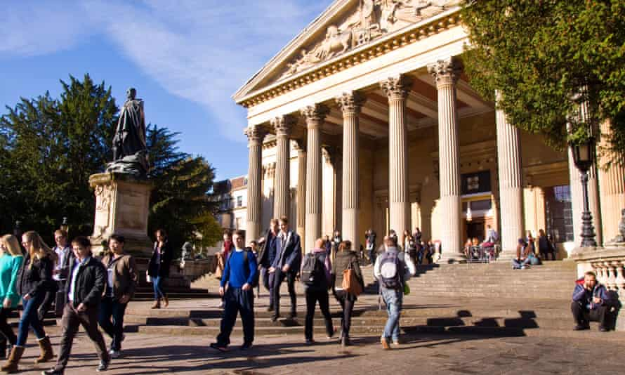
At Bristol in 2016, the year Sophie Pender began her degree, the proportion of private school pupils was close to 40%. Photograph: Alamy
More moderate voices accuse the clubs of being divisive, even elitist themselves. One private school student posted a message asking them to imagine the uproar if he decided to set up a 7% club.
Pender dismisses this as public school sophistry: “What they forget,” she says, “is that every university already has its own 7% club where membership is determined by how much money parents spent on their child’s education. They don’t need to set up a 7% club because they already benefit from privileged networks. The difference is our club is transparent – out in the open for all to see.”
And she points out there are already elitist societies run for the benefit of very privileged students. The most famous is Oxford University’s Bullingdon club, whose membership is exclusively public school and whose principal purpose is the riotous celebration of class war.
Wright says there is nothing to stop an Etonian who genuinely wants to appreciate how the other half are educated contacting the 93% Club: “But we are really catering for those who haven’t been so fortunate to benefit from such a privileged start in education. We are not about denying others opportunity, what we want to do is even things up a bit.”
Thousands of state school students feel that they have had to seize the moment because universities have not done enough to advance social mobility through more progressive admissions systems. Long-term progress has been glacial, although in the past two years a number of wider-access initiatives at Oxford, Cambridge and Bristol have started to close the gap between private and state-educated entrants.
Nevertheless, the numbers are not all heading in the right direction. At Durham University, admissions from fee-paying schools have risen for the third successive year to 37.8%. And when universities take account of the growing number of overseas students, who are predominantly privately educated, the overall figures do not look good.
At Bristol, students believe only radical measures will even up the numbers. On 2 March, the student union proposed a motion to cap private school graduate admissions at 7%, following criticism of the university for its low levels of social inclusivity. Other student unions are expected to hold their own votes.
Pender has now been taken on as a trainee solicitor by the City law firm Herbert Smith Freehills. Her success shows it is still possible to go from a disadvantaged background to a top job in the professions, but it may be harder work and more of a challenge.
Some tackle this by disguising their accent or hiding their family circumstances, says Pender. “There’s a problem when people from working-class backgrounds start assimilating into professions and don’t talk about where they have come from. Because I work at a law firm I have been trying very hard to be honest about my background. Otherwise you are just perpetuating the perception that people from ordinary backgrounds can’t succeed.”
Which is why, despite her personal success, Pender says the 93% Club is the achievement of which she is still the most proud.

Robert Verkaik is the author of Posh Boys. His new book, Why You Won’t Get Rich, is published by Oneworld on 1 April.
Questions:
Remember to use the text as a support (refer to it and write down lines) but also to formulate your own sentences. No Google docs, everyone writes their own notes.

While reading: Read the text actively in groups.
- Write down explanations in English for the words and expressions in yellow.
- Look up the words or references you do not know.

Research / Google is your friend:
- What is the Bullingdon Club? Find names of former members (at least three names).

Comprehension questions:
- Describe Sophie Pender. What does the article say about her? (The article gives much information about her – write down a complete and precise answer).
- What did Sophie expect of attending university? What happened instead?
- How did she react?
- With your group, write down two Comprehension questions and their answers.

Analysis questions:
- The members and the meetings of the 93% Club have been met with harassment by some. Who do you think is harassing them? Why do you think that is?
- However, the 93% Club is also very successful. Find some examples in the article. What do you think explains this impressive success?

Discussing questions:
- Why do you think social classes are so marked in British culture?
- Can you draw parallels to material studied in class? Can you draw parallels to other issues?
- With your group, write down at least one analysis question and answer it.

