CSR and Eco‑Friendly Buildings - Velux
This worksheet is about how companies in the building industry use CSR (Corporate Social Responsibility) and how some projects might be examples of real sustainability – or brand washing.
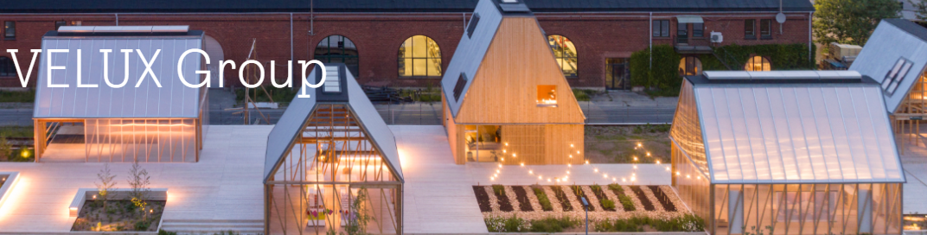

Key Vocabulary
- CSR (Corporate Social Responsibility) – virksomheders samfundsansvar
- sustainability – bæredygtighed
- eco‑friendly – miljøvenlig
- greenwashing – når en virksomhed udgiver sig for at være bæredygtig uden at være det
- carbon footprint – CO₂‑aftryk
- renewable materials – fornybare materialer
- energy‑efficient – energieffektiv

Text 1: VELUX – Building a Sustainable Future
VELUX, a Danish company known for its roof windows, has focused on sustainability for many years. They aim to make all their buildings carbon neutral by 2041. VELUX uses FSC‑certified wood and energy‑efficient glass to reduce the carbon footprint of homes. They also support forest projects to balance the CO₂ used in production. Some critics say that buying carbon offsets is not enough, but VELUX argues that real change takes time.

Before Reading
1. What do you know about sustainable buildings? Write 3–4 ideas below:
Comprehension Questions
Link: https://www.velux.com/what-we-do/sustainability
1. What are two ways VELUX tries to be more sustainable?
2. What does it mean that VELUX uses FSC‑certified wood?
3. Why is wood seen as a green material in construction?

Research Tasks (Online)
1. Go to https://www.velux.com/what-we-do/sustainability. Find one CSR goal and explain it in your own words.

Discussion
1. Do you think VELUX’s sustainability goals are realistic? Why or why not?
2. How can builders or companies prove that their projects are truly eco‑friendly?
3. Have you heard about any green building projects in Denmark? What do you think about them?

