Energy

Video
Watch this small video from Kurzgesagt on nuclear energy:
Do we Need Nuclear Energy to Stop Climate Change?
https://www.youtube.com/watch?v=EhAemz1v7dQ

Please answer the questions for the video and write down your answers:
- What are the benefits and drawbacks of renewable energy sources such as hydro-, wind- and solar power?
- Why is the world’s energy demand rising?
- Why is it important to focus on energy (electricity) production?
- What are the benefits and drawbacks of nuclear energy?
- Do you agree with the opinion voiced at the end of the video?

Suggestion-time (individual task) – write down your answers:
You must come up with 3 suggestions for cutting down on your energy consumption.

Share your suggestions with the people sitting at your table.
- Are the suggestions realistic?
- Is it something you might put into practice?
- Which suggestion was the best one?

Creative task:
Create a poster which either is a call for MORE nuclear power in the world OR a call for LESS nuclear power.
You may use AI to create a poster, however, you must be able to argue why the poster looks the way it does, how your message is delivered, and who is the intended target for the poster.

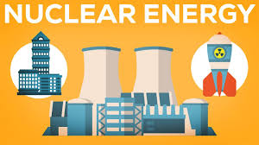
Copy paste your poster here….. and hand your work in on Lectio.

