US Culture and Values

Introduction
The United States is a country of immigrants. Many different cultural backgrounds are represented, and you will find many local differences as well, from city to city, from east to west.
Because of its multiculturalism, the country has been described as “a melting pot”. The idea behind the term was that the different groups of immigrants would gradually “melt” together and become one homogeneous group, and cultural differences and diversities would disappear. But to some extent, the different groups of immigrants have kept their identities, and another term, “a mosaic”, has been introduced. A mosaic is a picture made up of many different small pieces, where each piece has its own shape and colour. Even though the mosaic may form a pattern, every little piece can be identified. This view on American culture shows acceptance of the different ethnic groups and minorities, and in the United States you will find terms to describe American citizens with roots in other cultures, for instance African-Americans or Mexican-Americans.
Even though American culture is more difficult to describe than homogenous cultures such as Japanese culture, it is possible to generalise and find common features of a mainstream American culture. After all, the different ethnic groups are still part of a common society, and even though ethnic groups or minorities keep their identities, eventually they will become more and more “Americanized”, and after all, immigrants travelled to America for one reason: to go to a new world in which they could create a new life – or in other words: to fulfil their dream. This was called “the American Dream”. They dreamt of freedom and opportunities, and this is why “the Statue of Liberty” stands in the harbour of New York welcoming all the newcomers.
Task 1 American Patriotic symbols
Look at the symbols on page 2. Which of the symbols do you know and what do they symbolise?

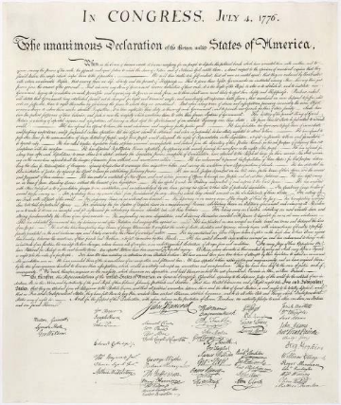
Patriotic symbols of the US
The flag of the United States of America
The Declaration of Independence (1776)

The Bald Eagle

The Statue of Liberty


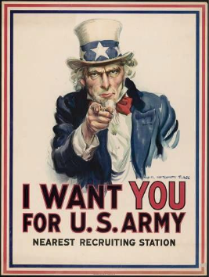
Uncle Sam

The White House


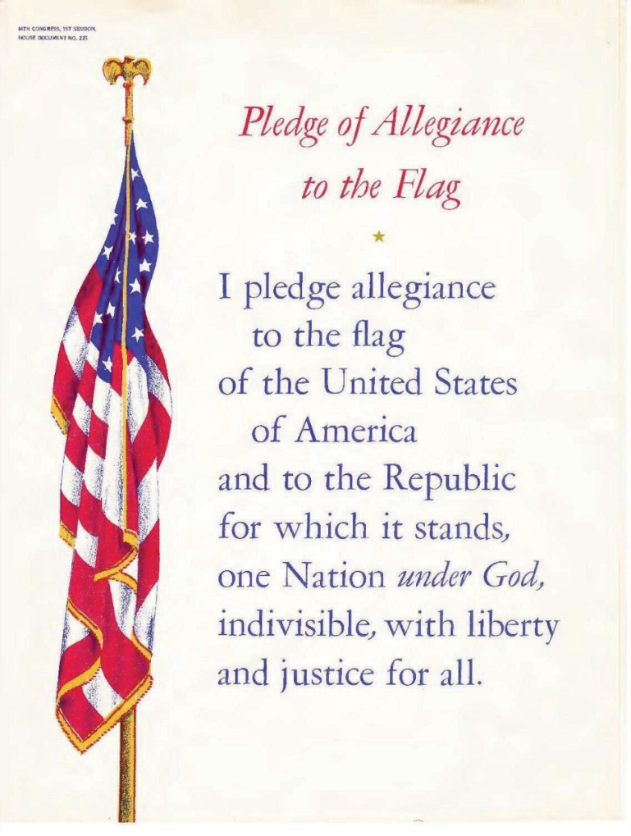
National anthem of the United States of America
The Star Spangled Banner
Oh, say! can you see by the dawn's early light
What so proudly we hailed at the twilight's last gleaming;
Whose broad stripes and bright stars, through the perilous fight,
O'er the ramparts we watched were so gallantly streaming?
And the rocket's red glare, the bombs bursting in air,
Gave proof through the night that our flag was still there:
Oh, say! does that star-spangled banner yet wave
O'er the land of the free and the home of the brave?
On the shore, dimly seen through the mists of the deep,
Where the foe's haughty host in dread silence reposes,
What is that which the breeze, o'er the towering steep,
As it fitfully blows, half conceals, half discloses?
Now it catches the gleam of the morning's first beam,
In fully glory reflected now shines in the stream:
'Tis the star-spangled banner! Oh, long may it wave
O'er the land of the free and the home of the brave!

Task 2: How do Americans perceive themselves based on the national anthem and the pledge of allegiance?
Task 3: Melting pot or Salad Bowl?
Read the text ‘A United Nation or a Divided Nation’ below
1. Which one of these metaphors do you think describes the American culture the best? Why?
- Choose one and argue why this is the best metaphor for the American culture

A Nation United or a Nation Divided?
The United States of America is, to a large extent, an immigration nation. It is a country whose demography is comprised of cultures and people with backgrounds and origins from all over the world. Hence, The United States of America has often been called a 'melting pot' in which cultures from all over the world blend together to form one united culture: The American. Others regard The United States as a 'salad bowl' in which the many different cultures flavor the overall impression and qualities of the nation. Regard-less of whether one puts emphasis on the definition of the 'melting pot' or 'the salad bowl' - the idea that different cultures, people and religions can co-exist in the American society has always been central to the understanding of the mighty nation. However, to perceive the American society as 'unified' is certainly worth a debate. The vastness of The United States is not only geographical but also social, cultural, racial and economic and therefore, as studies show, Americans today tend to be more polarized than has been the case for many years.

Task 4: The History of the United States in 14 minutes
First, we are going to be watching a video:
https://www.youtube.com/watch?v=7O_-M6rDPNw

Timeline Poster
Create a poster that visually shows the most important events from the video in chronological order

Elements:
- Choose about 5–7 key events mentioned in the video.
- For each event: write a short description (1–2 sentences), the year, and include a symbol or picture you draw or find.
- Use colours or icons to show different categories — for example “political,” “economic,” or “social.”
- Finish with a short reflection: Which event do you think was the most significant, and why?

Below you will find some mainstream American values and beliefs:

Personal Freedom



Personal freedom is, overall, the most important value to an American. Freedom plays an important part in the country’s history, since people emigrated to the United States to find the freedom, they did not have in their home countries. Individual or personal freedom is guaranteed in the Bill of Rights, the ten amendments to the constitution. For instance, personal freedom includes freedom of speech, the freedom of assembly, freedom of religion, freedom to earn money and spend your money the way you choose to, and the freedom to move and to live wherever you like.
In Denmark, the Danish Constitution guarantees Danes rights that are similar to some extent, but it is important to remember that there are countries in the world that do not guarantee their populations any rights. In Denmark however, we have strict rules which do not appeal to an American. We pay high taxes in Denmark, but in return we get free health care, free education and many other benefits which are supposed to give Danes equal options. Americans are against paying high taxes, and therefore they are not provided with the same benefits for free.
Another aspect of American personal freedom is the right to own and use firearms, which is stated in the second amendment of the constitution. Americans see the gun as a symbol of their personal freedom, a concept which can be traced back to the American Revolution.

Equality
Equality is an important ideal to Americans. They believe that “all men are created equal” (quote from The Declaration of Independence), meaning that factors such as rank, hierarchy and status are not important. Equality goes hand in hand with the value of personal freedom. Equality is an ideal or a value, but it has never existed as a fact, and questions of interracial relationships and discrimination are still issues in American society. However, the value is visible in the way Americans minimise the importance of status in the workplace and treat all colleagues in the same way.

Individualism and Privacy


The American culture is very individualistic, meaning that the individual is in focus, as opposed to collective cultures, where the individual’s relationship to the group is the first priority.
It is an American ideal to look after yourself and to be independent of others. This value can be traced back to the very first settlers in America. They had to rely on themselves to be able to make it in a new country under the tough conditions they had to face, building up everything from scratch. They had to learn to find a way of dealing with the different aspects of settling without any help from others.
Nowadays, individual ownership in business is much admired.
Being individualistic people, Americans have a need for privacy. They allocate time to themselves to think or to be alone, and they do not understand people from other cultures who tend to be together all the time.

Change and Future Orientation
Americans live by the value that change is a positive, healthy condition in life. You should not focus on the past; it is the future that is interesting and matters. This is very different from cultures that value tradition and believe that rituals and customs from their past are very important and should be passed on to new generations.
An American believes that progress is in his or her own hands and one should try to improve one’s situation all the time, and make a change for the better. It could be a question of looking for a better job or a better place to live. Future orientation is based on optimism and a strong belief in achieving the goals you have in life.

Informality, Directness and Openness
Americans are very informal and casual, and to people from formal cultures they might even appear disrespectful in certain situations. In business, American leaders prefer to be addressed by their first names, and Americans do not seem to treat authorities differently from the way they treat colleagues. The language contains idiomatic speech, (slang), which is only omitted on very formal occasions. They dress casually, and if an event requires a dress code, it should be suggested on the invitation.
They address superiors as well as close friends with the common greeting, “hi”, and believe that you should speak in a direct and open manner and deliver even negative messages in a direct way. They consider it dishonest to “beat around the bush”.
Americans may lean on walls or furniture when they are having conversations, appearing to be very informal and relaxed. If you visit an American home, you will probably be offered a tour of the house, and if the host has a dog or a cat, you will find that the pet is a family member and there are no restrictions as to where it is allowed to rest.
Achievement, Action and Work Orientation


Americans believe that whatever you want to achieve in life is all up to you. It is your responsibility to take action, to do something, to achieve your goals in life. They have great respect for people who achieve things in life through hard work. “He gets the job done”, is a sentence that shows respect for a hardworking and structured person who does not waste time.
Americans are very committed to work and they work hard. They often identify themselves with their professions, and ask the question, “where do you work”, when they talk to someone for the first time.
Americans believe that you should be active most of the time. Hanging around doing nothing is almost a sin. Being active in any kind of way is better than being inactive. They like to schedule their time, so even relaxation is planned. In that way, you can be more effective and work even harder after your planned break!
Task 5: Questions for the texts
- What is the American Dream?
- How do American and Danish ideas about taxes differ?
- What does it mean that Americans are individualistic?
- How do Americans show informality and directness?
- Which American value is most different from Danish values?
- Is strong individualism good or bad? Why?
- What can we learn from the American attitude to work and success?

Arnold Schwarznegger
Pre-reading: Find out who Arnold Schwarznegger is.
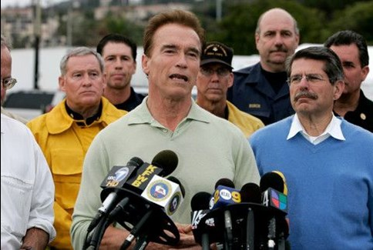

Arriving now
Call me Arnold.
I was born in a little Austrian town, outside Graz. It was a 300-year-old house. When I was 10 years old, I had the dream of being the best in the world in something. When I was 15, I had a dream that I wanted to be the best bodybuilder in the world and the most muscular man. It was not only a dream I dreamed at night. It was also a daydream. It took me five years of hard work. Five years later, I turned this dream into reality and became Mr. Universe, the best-built man in the world.
"Winning" is a very important word. There is one that achieves what he wanted to achieve and there are hundreds of thousands that failed. It singles you out: The winner.
When I was a small boy, my dream was not to be big physically, but big in a way that everybody listens to me when I talk, that I'm a very important person, that people recognize me and see me as something special. When I came here to America, I felt I was in heaven. In America, we don't have an obstacle. Nobody's holding you back.
I'm trying to make people in America aware that they should appreciate what they have here. You have the best tax advantages here and the best prices here and the best products here.
One of the things I always had was a business mind. When I was in high school, a majority of my classes were business classes. When I came over here to this country, I learned English and then started taking business courses, because that's what America is best known for: Business. Turning one dollar into a million dollars in a short period of time. Also when you make money, how do you keep it? That's one of the most important things when you have money in your hand, how can you keep it? Or make more out of it? Real estate is one of the best ways of doing that. I own apartment buildings, office buildings and raw land. That's my love, real estate.
I have emotions. But what you do, you keep them cold or you store them away for a time. You must control your emotions, you must have command over yourself. Three, four months before a competition, I could not be interfered by other people's problems. This was sometimes called selfish. It's the only way you can be if you want to achieve something. Any emotional things inside me, I try to keep cold so it doesn't interfere with my training.
Many times things really touched me. I felt them and I felt sensitive about them. But I had to talk myself out of it. I had to suppress those feelings in order to go on. Sport is one of those activities where you really have to concentrate. You must pay attention 100% to the particular thing you're doing. There must be nothing else on your mind. Emotions must not interfere. Otherwise, you're thinking about your girlfriend. You're in love, your positive energies get channeled into another direction rather than going into your weight room or making money.
You have to choose at a very early date what you want: A normal life or to achieve things you want to achieve. I never wanted to win a popularity contest in doing things the way people want me to do. I went down the road I thought was best for me. A few people thought I was cold, selfish. Later they found out that's not the case. After I achieve my goal, I can be Mr. Nice Guy. You know what I mean?
California is to me a dreamland. It is the absolute combination of everything I was always looking for. It has all the money in the world there, show business there, wonderful weather there, beautiful country, ocean is there. Snow skiing in the winter; you can go in the desert the same day. You have beautiful-looking people there. They all have a tan.
I believe very strongly in the philosophy of staying hungry. If you have a dream and it becomes a reality, don't stay satisfied with it too long. Make up a new dream and hunt after that one and turn it into reality. When you have that dream achieved, make up a new dream. I am a strong believer in Western philosophy, the philosophy of success, of progress, of getting rich.

Task 6: Arnold Schwarzenegger
- Which American values appear in Arnold’s story? (Give examples)
- In what ways does Arnold represent the American Dream?
- Do you agree with his idea of always “staying hungry”? Why / why not?

Task 7: Grammar & Vocabulary Practice
A – Match the words with their meanings
Word | Meaning
1 Equality | a Freedom to live your own life
2 Individualism | b Focusing on yourself rather than the group
3 Achievement | c Working hard to reach goals
4 Personal freedom | d Having the same rights and chances
→ 1 ___ 2 ___ 3 ___ 4 ___
B – Complete with the correct verb form
- Americans usually ________ (believe) that change is positive.
- Immigrants ________ (come) to the USA to find freedom.
- Arnold _______ (work) very hard to achieve his goals.
- Americans ________ (speak) in a direct and open way.

C – Mini-writing: Write 4–5 sentences about the American value you find most interesting or strange.

