Synopsis –English EUX GF1-Tech

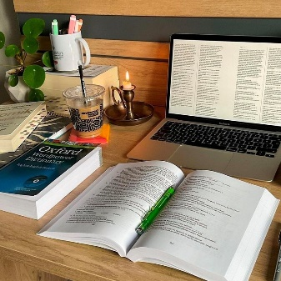
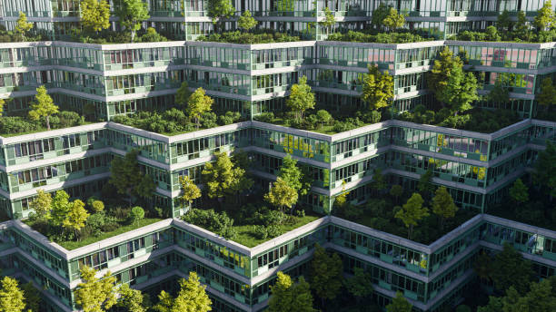
Your synopsis should show how you worked on your chosen topic. In other words, it explains what you did during school time to prepare your presentation. The points you include in your synopsis should be carefully selected to show this.

Your synopsis should contain the following:
  - • Introduction
  - Briefly introduce your topic.
  - Briefly state your purpose and the reason for choosing to work with it.

  - • Methodology
    - Here, briefly state where and how you have obtained your knowledge (“I found my sources on the internet, and I deemed the sources credible because…”)

        - Summary of Findings
- Here, state what have you learned in your research.
- Bullet points are accepted, but so are brief paragraphs.

• Literature List
  - Here you write your actual sources (book titles, website URLs, newspaper articles etc. that you have used in your research)

You can see an actual exam synopsis from a student on the next page. ↓

English C– synopsis

Sustainable construction

I have chosen sustainable construction in the United Kingdom. I will compare the ideas of sustainable construction with Denmark. Through this examination I will explain what sustainable construction is and dive into several areas for the topic. I will talk about some of the dilemmas there are within sustainable constructions.

What is sustainable construction?

- Environmental-
- Financial-
- Social sustainability

Sustainable construction in the U.K and Denmark

- World commission

Dilemmas

- Material energy

- Recycling

- Social sustainability around the construction

What do I think?

Conclusion
I can conclude that sustainable construction is a balanced distribution of three perspectives: Environmental, financial and a social perspective. It can be tough to balance it perfectly, because it always ends with one of the perspectives having been weighted higher than the others. There are several drawbacks and challenges from material energy, recycling and the use of social sustainability in and around the building.

Sources:

- https://webarchive.nationalarchives.gov.uk/+/http:/www.bis.gov.uk/files/file46535.pdf
- https://bu.dk/introduktion/baeredygtig-udviklings-historie/1987-brundtland-rapporten/
- http://bygningsreglementet.dk/file/554542/baeredygtigt_byggeri.pdf
- http://www.legislation.gov.uk/uksi/2010/2214/made

