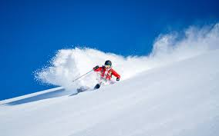
Powder by Tobias Wolff

Work in pair and do the following assignments.
The first assignments deal with analysis of the text. The last assignment is a creative writing assignment. Please do the analysis first. Afterwards, we’ll sum up in class. Lastly, you may work on the creative assignment.
Remember, when you work with analysis, you need to find examples in the text. A good way of doing this is to highlight examples in the text (which you have on paper).
Analysis: After reading
- Characterisation: Give a short characterization of the father and son and explain how they are different from each other.
- Setting: Describe the setting of the short story. How does the snowy mountain and the drive make the story feel?
- Conflict: What is the main problem in the story? How does it move the story along?
- Themes: What is one big idea in the story? How do the characters and events show this idea?
- Symbolism: What does the snow represent in the story? How does it affect what the characters do?
- Point of View: Who is telling the story? How does this change how we see the characters and events?
- Character Change: How does the son change from the start to the end of the story? What makes him change?
- Father's Actions: Do you think the father did the right thing? Why or why not? What would you have done if you were the son?
Creative Assignment:
With your partner, you must now write a text about what happens next in the story "Powder". Your text must be about 300-400 words, and it will count as a hand-in.
What should your text consist of?
You must imagine what happens after the father and son get through the snowstorm, and how the mother reacts when they return. How does their adventure change their relationship? Write a creative text and think about how they might grow or change because of what happened.
Hand in your task on Lectio.

