# Vulkantyper

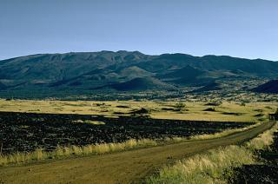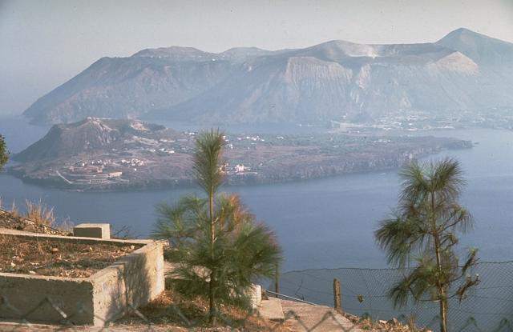

Vulkan 2

Sicilien

Vulkan 1

Hawaii

**Hvad for tæller de om billedet om**

|  |  |  |  |  |
| --- | --- | --- | --- | --- |
|  | **Dannelse/type?** | **Magma/viskositet** | **Udbruddets karakter** | **Lokalitet** |
| **Vulkan 1** |  |  |  |  |
| **Vulkan 2** |  |  |  |  |

|  |  |  |  |  |
| --- | --- | --- | --- | --- |
|  | **Dannelse?** | **Magma/viskositet** | **Udbruddets karakter** | **Lokalitet** |
| **Vulkan 3** |  |  |  |  |

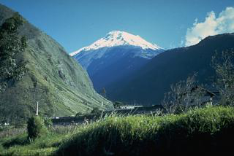

Vulkan 3

Ecuador