3: Description game

🚩Go together with your buddy-group (makkerskabsgruppe) and talk about the images below. Write two (or more) key words in English to every picture.

Is there a system?

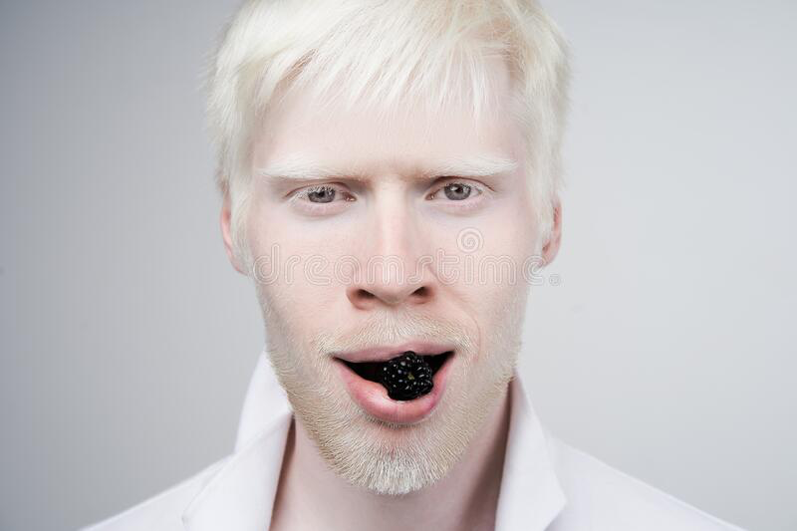

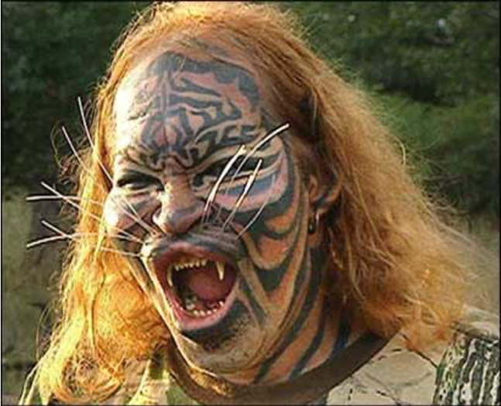

1
2

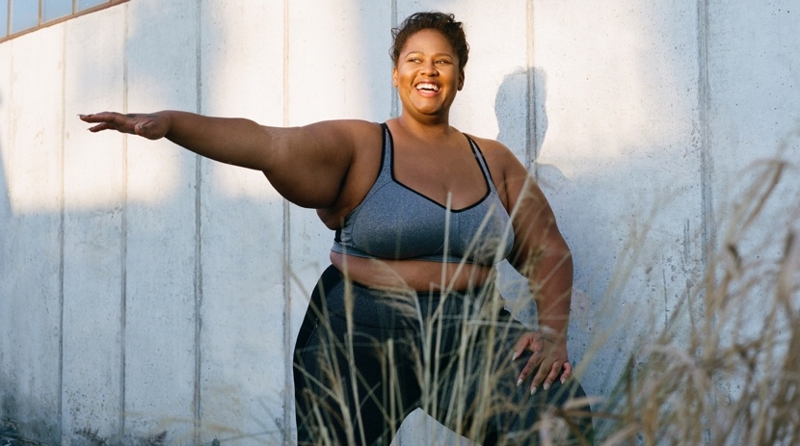



3
4

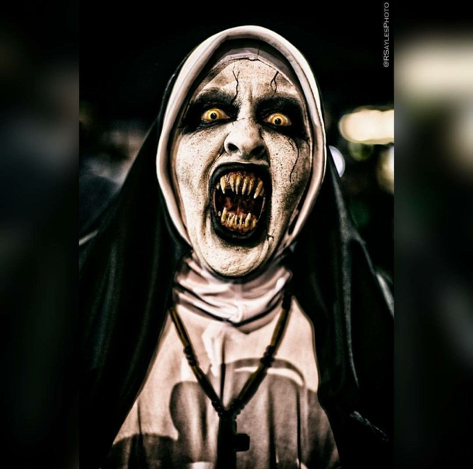

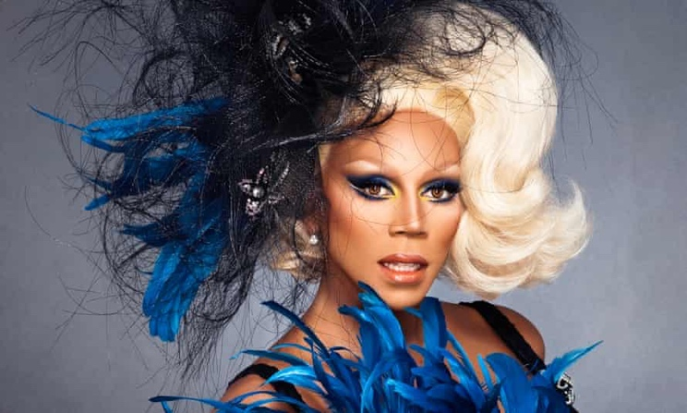

6
5

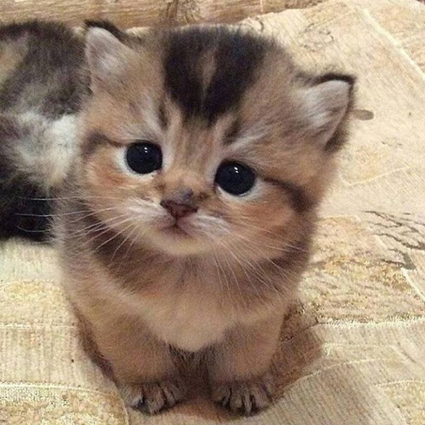

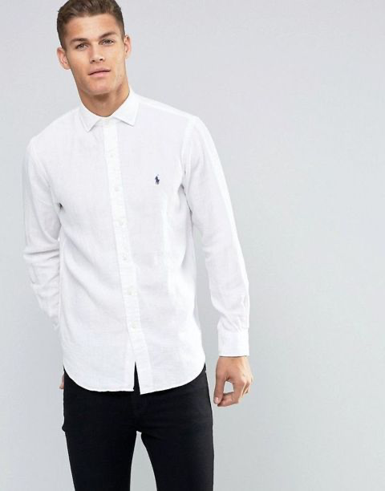

7
8

Text | Vocabulary
- Hate to give the *satisfaction, asking how you're doing now  How's the castle built off people you pretend to care about  Just what you wanted  Look at you, cool guy, you got it | Satisfaction - Tilfredsstillelse  Pretend - At lade som om  You got it - "Du har det der skal til" - Ironisk tone.
2) I see the parties and the diamonds sometimes when I close my eyes  Six months of torture you sold as some forbidden paradise  I loved you truly  Gotta laugh at the stupidity | Torture - Totur  Forbidden - Forbudt  Love truly - elskede dig ægte og dybt  Gotta (talesprogsversion) - "got to" "have to"  Stupidity - dumhed
- 'Cause I've made some real big mistakes  But you make the worst one look fine  I should've known it was strange  You only come out at night  I used to think I was smart  But you made me look so naive  The way you sold me for parts  As you sunk your teeth into me, oh  Bloodsucker, famefucker  Bleedin' me dry, like a goddamn vampire | Cause (talesprogsversion) - because  Naive - naiv "at man er lidt godtroende og tror let på, hvad folk siger til én.  Sold me for parts - solgte ud af mine kropsdele  Sunk your teeth into me - sank tænderne i mig/bed hende  Bloodsucker - blodsuger - ref til Vampyr  Famefucker - opmærksomhedshungende/afhængig af berømmelse  Bleedin - forbløde  Goddamn - satans
- And every girl I ever talked to told me you were bad, bad news  You called them crazy, God, I hate the way I called them crazy too  You're so convincing  How do you lie without flinching?  (How do you lie, how do you lie, how do you lie?)  Ooh, what a mesmerizing, paralyzing, fucked-up little thrill  Can't figure out just how you do it, and God knows I never will  Went for me, and not her  'Cause girls your age know better | Convincing - overbevisende  Without flinching - uden at blinke  Mesmerizing, paralyzing, fucked-up little thrill - fortryllende, paralyserende og forbandet lille spænding  Cause (talesprogsversion) - because  Know better - ved bedre
- I've made some real big mistakes  But you make the worst one look fine  I should've known it was strange  You only come out at night  I used to think I was smart  But you've made me look so naive  The way you sold me for parts  As you sunk your teeth into me, oh  Bloodsucker, famefucker  Bleedin' me dry, like a goddamn vampire | Naive - naiv "at man er lidt godtroende og tror let på, hvad folk siger til én.  Sold me for parts - solgte ud af mine kropsdele  Sunk your teeth into me - sank tænderne i mig/bed hende  Bloodsucker - blodsuger - ref til Vampyr  Famefucker - opmærksomhedshungende/afhængig af berømmelse  Bleedin - forbløde  Goddamn - satans
- You said it was true love, but wouldn't that be hard?
You can't love anyone, 'cause that would mean you had a heart
I tried you help you out, now I know that I can't
'Cause how you think's the kind of thing I'll never understand

7) I've made some real big mistakes  But you make the worst one look fine  I should've known it was strange  You only come out at night  I used to think I was smart  But you made me look so naive  The way you sold me for parts  As you sunk your teeth into me, oh  Bloodsucker, famefucker  Bleedin' me dry, like a goddamn vampire | Naive - naiv "at man er lidt godtroende og tror let på, hvad folk siger til én.  Sold me for parts - solgte ud af mine kropsdele  Sunk your teeth into me - sank tænderne i mig/bed hende  Bloodsucker - blodsuger - ref til Vampyr  Famefucker - opmærksomhedshungende/afhængig af berømmelse  Bleedin - forbløde  Goddamn - satans

Questions:

- The following phrases are metaphors and can be understood 2 different ways. Explain the literal meaning and the metaphorical meaning.
  - Six months of torture you sold as some forbidden paradise

- You only come out at night

- The way you sold me for parts
As you sunk your teeth into me, oh
Bloodsucker, famefucker
Bleedin' me dry, like a goddamn vampire

- How does the girl describe her love interest? On verse 1, 4 and 6 - underline the words and phrases that describe him.
- Look at the refrain (omkvædet) section 3, 5 and 7. What is her state of mind?
- What is the song about? On a litter level and on a metaphorical.

