The British Empire
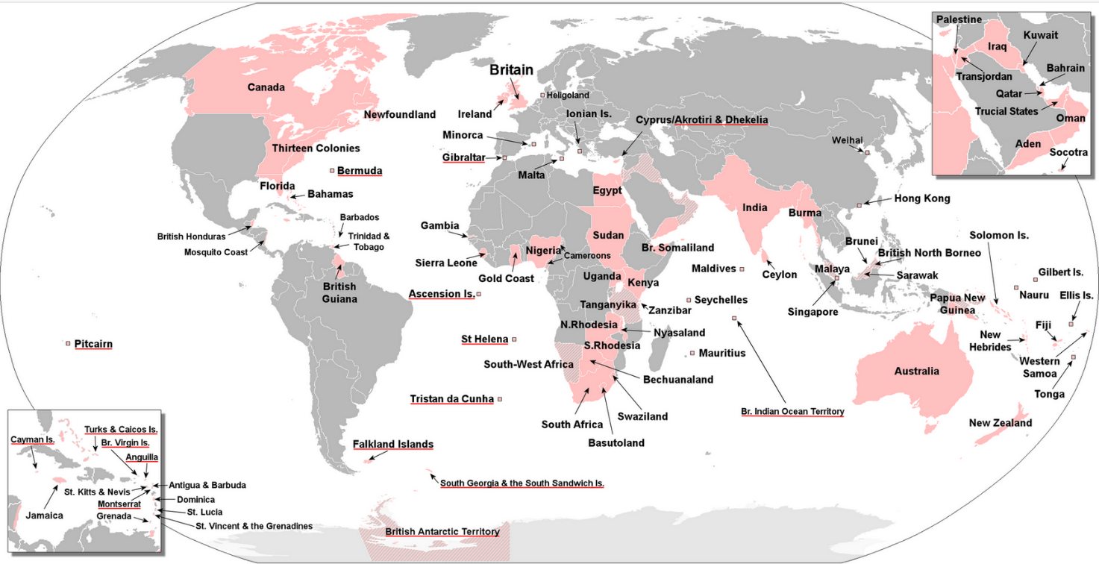

The British Empire was one of the most important developing forces in world history. The empire was enormous, about one fourth of the world's land surface. Britain's sway lasted a long time, from around 1600 to circa 1950, and it brought tremendous changes to many parts of the world.
The primary purpose of imperialism, as it peaked between 1800 and 1900, was an ongoing competition with the continental powers for territory, natural resources and a market for domestic manufacturers. Ruling the waves, Britain exported their system of government, laws and education, culture and infrastructure along with of course, their language, which became the shared language of communication.
However, we cannot study the greatness of the British Empire without also adding terms like these: transatlantic slave trade, violence, inequality, stripping indigenous people of land and culture, suppression, exploitation, diseases.
From the beginning of 1900, dissatisfaction, riots and nationalist movements grew, and the colonial period ended with a string of countries gaining their independence.

Post-colonial Britain: An introduction

Decolonization
After the Second World War, Britain – along with other imperialist countries – lost many of their colonies. This development was brought about by many different factors. The most important ones had to do with a change in world opinion on race and human rights as well as a growing national awareness and demand for self-determination. Furthermore, the colonies were becoming a moral, financial and military burden on the imperial powers after the war. This development left both the former colonies and the former colonial powers with new challenges and opportunities. The former colonies had to (re-) establish their states and find a place in the world order, while the former colonial powers had to rethink their identity and position in the world.

New alliances
For Britain, treaties and alliances in many cases replaced the old colonial rule. In the Commonwealth of Nations of 1926, many former colonies kept close ties to Britain: They have the same monarch, exchange goods and services more easily, etc. – and in many cases English is the only or one of more official languages.
Close ties were also made with other partners following World War Two: The United Nations with their focus on human rights and international development (1945), NATO as a defence partner (1949), and the EU making Britain a part of a gradually more closely knit economic and political European union (1973-2020).
Though the relationship between Britain and its former colonies in some cases seems quite strained today, their shared past has undoubtedly shaped both parties for better or worse. Globalization, immigration and cross-cultural exchanges have resulted in a strong diversity in literature and culture.
Britain's relationship with Europe has been slightly ambivalent, on the one hand cherishing their sovereignty as an independent nation and on the other wishing a strong alliance, post-Brexit Britain being an example of this. On a final note, the future will show whether the shrinking British Empire will shrink even more after Brexit with Scotland voicing a growing desire to leave the 300-year-old union with England. Or will Brexit, as some argue, be the first step for Britain to regain its former glory?

Glossary: From island to empire and back

Ambivalent adj tvetydigt, dobbelt
bring about vb foranledige, afstedkomme
cherish vb dyrke, sætte pris på
decolonization sb afkolonisering
domestic adj indenlands, national
goods sb pl varer
indigenous adj oprindelig
knit adj sammenvævet
manufacturer sb fabrikant, producent
riot sb oprør
self-determination sb selvbestemmelse
sovereignty sb suverænitet
strained adj anstrengt
strip vb fratage
sway sb herredømme
tie sb bånd
voice vb udtrykke

The Empire quiz underline the answer
1.
The British Empire began with maritime explorations in the
13th and 14th centuries
15th and 16th centuries
17th and 18th centuries

2. Britain's imperial century was between
1492 and 1600
1626 and 1801
1815 and 1914

3. How big was the empire?
15% of the world's land surface
25% of the world's land surface
42% of the world's land surface

4. Which of these countries was not part of the English Empire?
South Africa
New Zealand
Argentina

5. How could a small country like Britain rule so much territory? Find the wrong answer.
by using force
Through cooperation with local rules
Because Britain was democratic

6. After which war did most of Britain's colonies become independent?
World War I
World War II
The Cold War

7. What did most of the former colonies do after having achieved independence from Britain? Find the wrong answer.
They formed completely independent states
They joined the Commonwealth of Nations
They formed the Post-Colonial Defence Organization

8. Complete the sentence with two words from below.
The ….. never ….. on the British Empire.
Clouds falls gather sets snow sun

9. Why did the British Empire decline? Find the wrong answer.
The First and Second World Wars left Britain weakened and less interested in its Empire.
Colonial nationalist movements used a range of methods to end British rules
The British left as soon as the local people wanted them to

