Colonialism and globalization
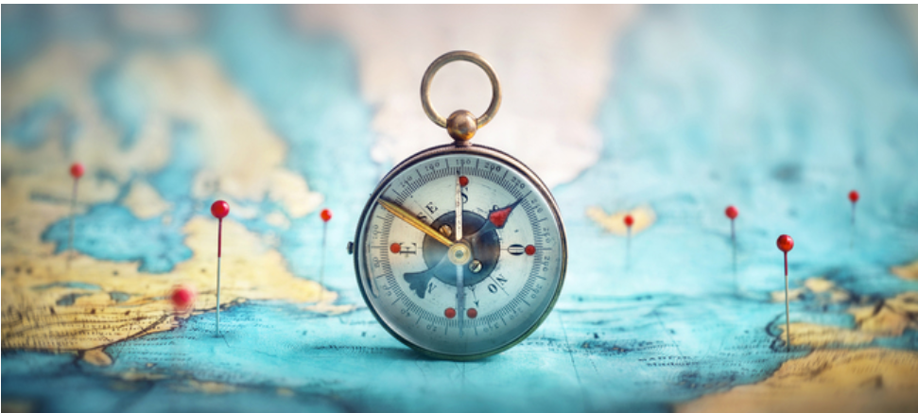
Once upon a time, Great Britain was great in almost all senses of the word. Britain, which used to be a fairly small island nation, went global and expanded into an empire, leaving their mark all over the world. However, Britain's role as super power diminished in the years following World War II, leaving world leadership to other "players".
In the 19th and 20th centuries, Britain's leading role was gradually taken over by America, who some say employs another kind of "colonization" for democratization, Americanization, oil and markets. For many years the Soviet Union challenged America's role and the world stage was occupied by the two superpowers. Today, the distribution of world power is growing more complex with China's engagement in the state and development of the world, economically and otherwise.
No matter which nation is 'cast' as superpower, globalization seems to have taken on a force of its own with capitalism, multinational companies, and the all-connecting infrastructure of air, sea and land mobility, trade, markets, global pandemics and last but not least, the Internet – the world wide web. But maybe it was always like that. People have always travelled across regional and national boundaries by the season or permanently, fleeing from famine, persecution or war – or looking for better pastures, more fertile soil, (better) jobs, etc. Perhaps even more similar to the modern concept of globalization, we can see ancient caravans with merchants travelling across deserts with their goods as historic forerunners of it.
There are differences, of course. In the modern sense globalization refers to the fact that the economies, cultures and societies of the nations across the globe are interrelated and interdependent. Thus, globalization also affects those who stay at home. Nations must adopt some of the same laws and regulations for their citizens and companies as other nations to ensure a degree of trade and economic advantages. Between nations such laws and agreements are often made through the establishment of treaties by intergovernmental organizations such as the UN (the United Nations), NATO (the North Atlantic Treaty Organization) and the EU (the European Union).
In class we will hear a video by Lars Jensen where he talks about how colonization and globalization is linked. The questions below are connected to the video.s
In Lars Jensen's view, colonialism and globalisation are not two completely different processes, one being a historical phenomenon that ended after World War II and the other a process that is unfolding now. Instead, he sees them as closely linked.
- How did colonialism divide the world?
- How does globalisation connect the world?
- How are colonialism and globalisation interlinked?
- What is the post-colonial world order?
- Globalisation is not monolithic: it changes. Give an outline of globalisation since 1492.

