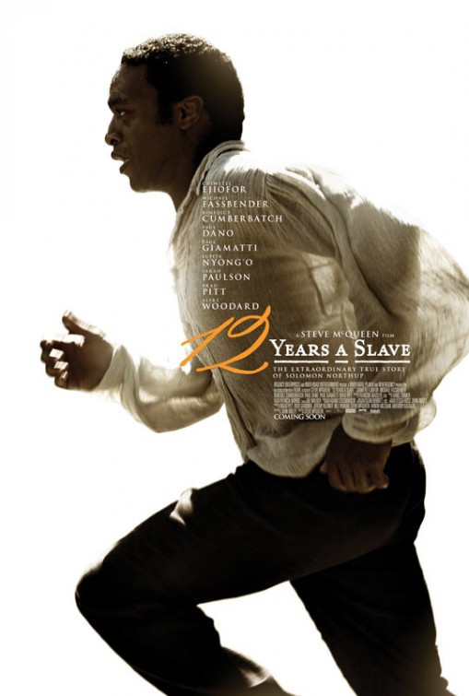
12 Years A Slave (2013)
Work questions
- Describe the setting of the movie (5-8 lines).
Link to how to analyze setting: https://theenglishhandbook.systime.dk/?id=148#c2308
- Make a list of the characters who play an important role in the movie.
- Make a THOROUGH characterization of the main character Solomon Northup focusing on internal, external and personal character traits.
Useful tips on how to analyze character traits: https://theenglishhandbook.systime.dk/?id=148#c2309
- What is the overall theme of the movie? (4-6 lines)
Link to theme-analysis: https://theenglishhandbook.systime.dk/?id=148#c823

