# Topic: What is sustainability?

1. Skim-read the text below.
2. Why is there a need for sustainability?
3. Identify the various aspects of sustainability mentioned in this text.
4. Which areas of sustainability do you believe a company such as Nike focuses on?

# An introduction to sustainability

[[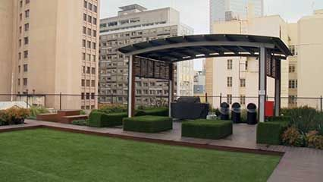](https://kids.britannica.com/students/article/sustainability/631791/media?assemblyId=239276)](https://kids.britannica.com/students/article/sustainability/631791/media?assemblyId=239276)

[© University of Melbourne, Victoria, Australia](https://kids.britannica.com/students/article/sustainability/631791/media?assemblyId=239276)© University of Melbourne, Victoria, Australia

[[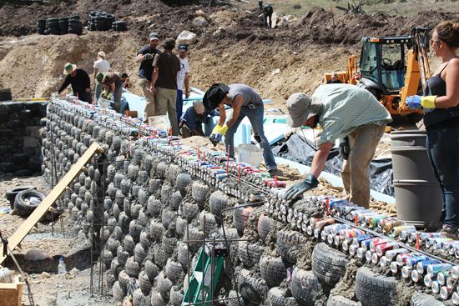](https://kids.britannica.com/students/article/sustainability/631791/media?assemblyId=239281)](https://kids.britannica.com/students/article/sustainability/631791/media?assemblyId=239281)

[Ingrid Pfau](https://kids.britannica.com/students/article/sustainability/631791/media?assemblyId=239281)Ingrid Pfau

Rising populations and unprecedented levels of consumption made sustainability an important topic in the late 20th and early 21st centuries. Sustainability refers to using resources in such a way that they will continue to be available in the future. Sustainability takes many different forms, but they all have some fundamental ideas in common. One is that the survival of humans depends on the natural [environment](https://kids.britannica.com/students/article/environment/609446). Another is that people must act with an awareness of the impact of their actions on the natural world. And a third is that people have a responsibility to balance the needs of the present day with those of future generations.

Sustainability has its roots in [environmentalism](https://kids.britannica.com/students/article/environmentalism/311166). However, it is a broad topic that has influenced many fields. [Agriculture](https://kids.britannica.com/students/article/agriculture/272753), [urban planning](https://kids.britannica.com/students/article/urban-planning/277519), [engineering](https://kids.britannica.com/students/article/engineering/274181), [building construction](https://kids.britannica.com/students/article/building-construction/273396), and energy production are just a few of the areas that deal with issues of sustainability.

**THE NEED FOR SUSTAINABILITY**

[[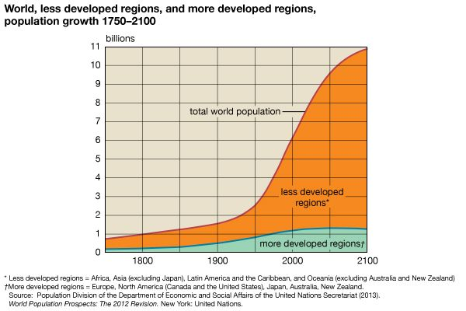](https://kids.britannica.com/students/article/sustainability/631791/media?assemblyId=171828)](https://kids.britannica.com/students/article/sustainability/631791/media?assemblyId=171828)

[Encyclopædia Britannica, Inc.](https://kids.britannica.com/students/article/sustainability/631791/media?assemblyId=171828)Encyclopædia Britannica, Inc.

Sustainability has become a more urgent issue as the world [population](https://kids.britannica.com/students/article/population/276507) has exploded. The world population did not reach 1 billion until 1804, but the second billion came just a little over a century later, in 1927. After that, the rate of growth accelerated rapidly. By the end of the 20th century the world population had tripled the 1927 total to surpass 6 billion. The 7-billion milestone came in 2011. The [United Nations](https://kids.britannica.com/students/article/United-Nations/277510) (UN) has projected that the total will exceed 11 billion by 2100. Growth has been highest in [developing countries](https://kids.britannica.com/students/article/less-economically-developed-countries/604088), and that pattern is expected to continue. Rising populations have already strained supplies of food and [natural resources](https://kids.britannica.com/students/article/natural-resource/599843) in some places, adding to long-standing problems of [poverty](https://kids.britannica.com/students/article/poverty/276526) and hunger.

As populations have grown, so has the consumption of resources. People have used more materials since 1960 than in all previous history. Consumption rates are expected to increase further as economies and incomes expand, especially in fast-growing developing countries in Asia and Africa. The [Organisation for Economic Co-operation and Development](https://kids.britannica.com/students/article/Organisation-for-Economic-Co-operation-and-Development/312829) (OECD) has projected that global use of materials—[metals](https://kids.britannica.com/students/article/metal/275805), [fossil fuels](https://kids.britannica.com/students/article/fossil-fuel/599853), [biomass](https://kids.britannica.com/students/article/biomass/317522), and nonmetallic [minerals](https://kids.britannica.com/students/article/mineral/275853)—will more than double between 2011 and 2060.

These patterns in population growth and consumption have led to greater awareness of the need for sustainability. At the 1992 UN conference known as the Earth Summit, most of the world’s countries committed themselves to pursuing economic development in ways that would protect the environment and natural resources. In the years that followed, more than 100 UN member countries adopted sustainable development strategies. In 2015 the UN adopted the 2030 Agenda, a new plan of action that included 17 sustainable development goals. The plan linked sustainable development to related priorities, such as ending poverty, promoting [human rights](https://kids.britannica.com/students/article/human-rights/274983), and protecting the environment.

**EXAMPLES OF SUSTAINABILITY**

Sustainability can be pursued in many ways, large and small, by governments, businesses, and individuals. In general, examples of sustainability take into account the economic, social, and environmental impact of a decision or action.

[[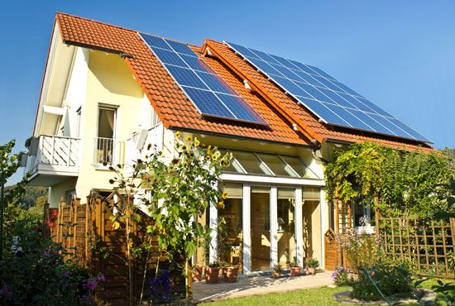](https://kids.britannica.com/students/article/sustainability/631791/media?assemblyId=108231)](https://kids.britannica.com/students/article/sustainability/631791/media?assemblyId=108231)

[© Andreas Weber/Dreamstime.com](https://kids.britannica.com/students/article/sustainability/631791/media?assemblyId=108231)© Andreas Weber/Dreamstime.com

[[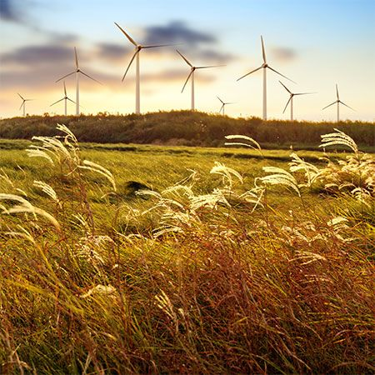](https://kids.britannica.com/students/article/sustainability/631791/media?assemblyId=239277)](https://kids.britannica.com/students/article/sustainability/631791/media?assemblyId=239277)

[gyn9038—iStock/Thinkstock](https://kids.britannica.com/students/article/sustainability/631791/media?assemblyId=239277)gyn9038—iStock/Thinkstock

Energy production has probably been the most prominent topic in discussions of sustainability. The use of [fossil fuels](https://kids.britannica.com/students/article/fossil-fuel/599853) to produce energy is unsustainable because coal, oil, and natural gas are [nonrenewable resources](https://kids.britannica.com/students/article/natural-resource/599843#323511-toc). This means that supplies are limited and will run out someday. In addition, the burning of fossil fuels is the main cause of [global warming](https://kids.britannica.com/students/article/global-warming/311438). Sustainable energy production involves the use of renewable resources, which cannot be used up and produce little pollution. Renewable, or [alternative](https://kids.britannica.com/students/article/alternative-energy/601164), energy sources include [solar power](https://kids.britannica.com/students/article/solar-energy/277128), [wind power](https://kids.britannica.com/students/article/wind-power/277764), and [waterpower](https://kids.britannica.com/students/article/waterpower/277668).

Another area with great potential for sustainable development is construction. The construction of [buildings](https://kids.britannica.com/students/article/building-construction/273396) and infrastructure, such as roads and bridges, requires enormous quantities of steel, concrete, wood, and other materials. In addition, the demolition of existing structures produces huge amounts of waste. Construction can be made more sustainable by using [recycled](https://kids.britannica.com/students/article/recycling/276669) materials, such as metals and concrete recovered from a demolished building. This practice has multiple benefits. It conserves the natural resources that would be required to produce new materials. It eliminates the [pollution](https://kids.britannica.com/students/article/environmental-pollution/276492) that would be produced in the process of extracting those resources. It also reduces the amount of waste going to landfills. Another way that builders can make construction more sustainable is by buying wood that was produced in well-managed [forests](https://kids.britannica.com/students/article/forest-and-forestry/274384).

Along with the wise management of materials, sustainable construction depends on site selection and building design. When choosing the site for a new building, the developer should consider the relationship of the building to the surrounding area. For example, will construction have a negative impact on the local [ecosystem](https://kids.britannica.com/students/article/ecosystem/384948)? Is the building located near public transportation, reducing the need for driving and the pollution it creates?

[[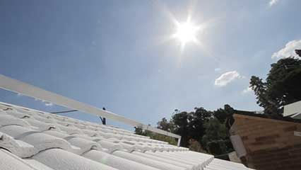](https://kids.britannica.com/students/article/sustainability/631791/media?assemblyId=239275)](https://kids.britannica.com/students/article/sustainability/631791/media?assemblyId=239275)

[© University of Melbourne, Victoria, Australia](https://kids.britannica.com/students/article/sustainability/631791/media?assemblyId=239275)© University of Melbourne, Victoria, Australia

Sustainable building design—also known as green architecture—typically focuses on maximizing the energy efficiency of the structure. An energy-efficient home requires less energy for heating, cooling, and other functions than does a less efficient home. Builders can make houses more energy efficient by properly [insulating](https://kids.britannica.com/students/article/insulation/275068) the structure and using windows and doors that minimize heat gain or loss. They can also install a so-called “cool roof.” A cool roof is usually made with highly reflective materials that absorb less heat than a traditional roof, keeping the building cooler during hot weather. A cool roof can also be made simply by painting a roof white.

[[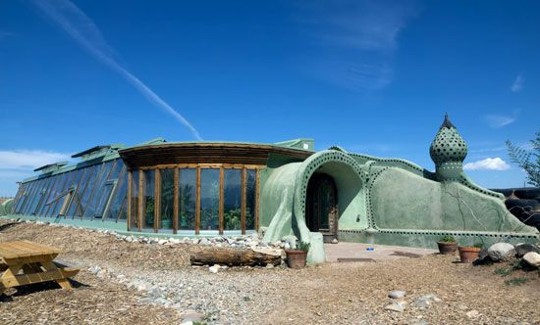](https://kids.britannica.com/students/article/sustainability/631791/media?assemblyId=239279)](https://kids.britannica.com/students/article/sustainability/631791/media?assemblyId=239279)

[© IrinaK/Shutterstock.com](https://kids.britannica.com/students/article/sustainability/631791/media?assemblyId=239279)© IrinaK/Shutterstock.com

Another approach to sustainable construction is the passive solar home. These homes are designed to collect and store energy from sunlight to use in heating the building. They typically have large windows oriented in such a way to receive the most sunlight. They also include materials to absorb heat from sunlight and release it as needed to warm the building during cold weather. These materials, such as concrete, brick, and stone, are known as thermal mass. During warm weather, thermal mass absorbs heat from warm air inside the building, reducing the energy needed for cooling.

[[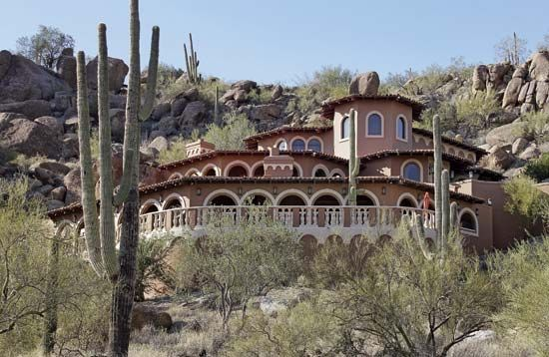](https://kids.britannica.com/students/article/sustainability/631791/media?assemblyId=157021)](https://kids.britannica.com/students/article/sustainability/631791/media?assemblyId=157021)

[© pics721/Shutterstock.com](https://kids.britannica.com/students/article/sustainability/631791/media?assemblyId=157021)© pics721/Shutterstock.com

[Water](https://kids.britannica.com/students/article/water/277663) conservation is another crucial aspect of sustainability. Hundreds of millions of people around the world lack access to safe drinking water. In the United States, 40 states expect to experience water shortages by the mid-2020s. Homeowners can reduce their water consumption by replacing existing plumbing fixtures with more efficient ones, such as composting toilets and low-flow shower heads. They can also buy appliances, such as washing machines and dishwashers, that are designed to reduce water usage. Builders can help conserve water by using efficient fixtures and by installing gray water systems. Gray water is wastewater from bathroom sinks, showers, bathtubs, and washing machines. It can be collected and reused for nondrinking purposes, such as [irrigation](https://kids.britannica.com/students/article/irrigation/275094). Builders can also choose landscaping that uses native plants and, especially in dry climates, drought-resistant varieties. This practice reduces the need for watering and for treatment with chemical [fertilizers](https://kids.britannica.com/students/article/fertilizer/274296) and herbicides, which benefits the soil and the environment.

[[](https://kids.britannica.com/students/article/sustainability/631791/media?assemblyId=239278)](https://kids.britannica.com/students/article/sustainability/631791/media?assemblyId=239278)

[© MichaelMajor/Fotolia](https://kids.britannica.com/students/article/sustainability/631791/media?assemblyId=239278)© MichaelMajor/Fotolia

Water conservation is especially important in [agriculture](https://kids.britannica.com/students/article/agriculture/272753), which consumes more water worldwide than any other activity by far. About 70 percent of the world’s fresh water is used for agriculture. One way that farmers can conserve water is by planting crops that are well suited to the climate. For example, they can avoid planting crops that require a lot of water, such as cotton and corn (maize), in dry areas. They can reduce their water use for irrigation by collecting rainwater or by switching to more efficient methods, such as drip irrigation.

Agricultural practices are also crucial to sustainable food production. Rising world populations mean that farmers will need to greatly increase production to feed billions more people in the coming decades. Researchers say that current methods of food production will not be adequate to meet future needs and are also not environmentally sustainable. Meat production is an especially inefficient way of feeding people. In the 2010s half of Earth’s ice-free land was used for raising livestock or growing grains to feed those animals. The need for more pasture and cropland has led to the clearing of [rainforests](https://kids.britannica.com/students/article/rainforest/275197), which contributes to [global warming](https://kids.britannica.com/students/article/global-warming/311438). In addition, cattle produce a lot of methane, which is a greenhouse gas. A shift away from livestock raising to the production of crops for human consumption would produce a more sustainable [food supply](https://kids.britannica.com/students/article/food-supply/274376) and be better for the environment. People can do their part by cutting back their meat consumption in favor of plant-based diets heavy on vegetables, fruits, legumes, and nuts.

Source: <https://kids.britannica.com/students/article/sustainability/631791>

**Grammatik**

Løs nedenstående opgaver på baggrund af nedenstående sætning:

Sustainability has become a more urgent issue as the world [population](https://kids.britannica.com/students/article/population/276507) has exploded.

1. Lav en syntaktisk analyse af sætningen.

|  |  |
| --- | --- |
| **Verbal** |  |
| **Subjekt** |  |
| **Subjektsprædikat** |  |
| **Direkte objekt** |  |
| **Indirekte objekt** |  |
| **Adverbial** |  |
| **Konjunktional** |  |

1. Lav en morfologisk analyse af sætningen.

|  |  |  |  |  |  |  |
| --- | --- | --- | --- | --- | --- | --- |
| **Sustainablility** | **has** | **become** | **a** | **more** | **urgent** | **issue** |
|  |  |  |  |  |  |  |

|  |  |  |  |  |  |
| --- | --- | --- | --- | --- | --- |
| **as** | **the** | **world** | **population** | **has** | **exploded.** |
|  |  |  |  |  |  |

1. Identificér verballeddenes tid i sætningen. Omskriv til pluskvamperfektum.