**Topic: How has Nike responded to the criticism?**

**Philip Knight’s opening remarks on 18 May 1998 in which he addresses the criticism of Nike.**

<https://www.c-span.org/video/?c4793533/user-clip-opening-nike-speech-1998-phil-knight>

1. Write down the most important points provided by Philip Knight in above video clip. Why has he chosen to publicly address the Nike scandals?

**Comic strips on Nike by Garry Trudeau (1997)**

1. Read the comic strips below and comment on the contents of each one. Which points are they trying to make? What is the intention/purpose?

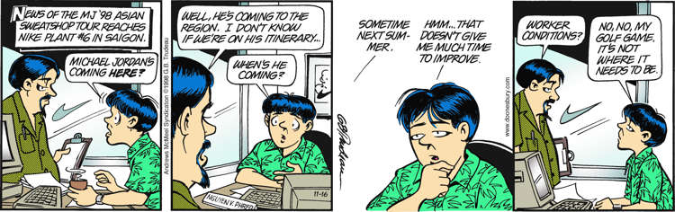

**Intention**:

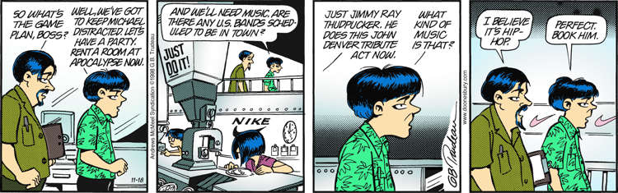

**Intention**:

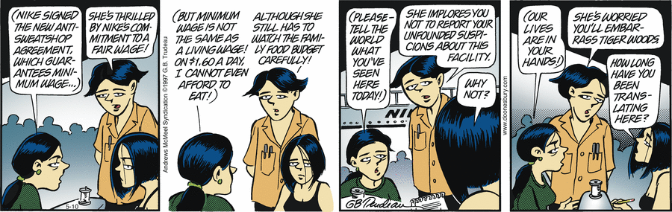

**Intention**:

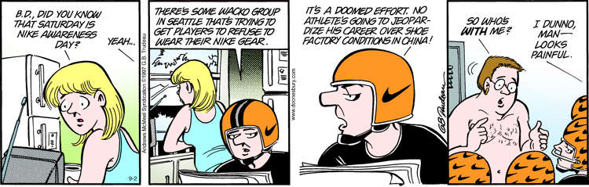

**Intention**:

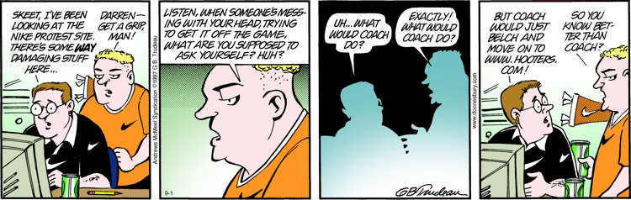

**Intention**:

1. Comment on using cartoons as means to create societal change. Any pros or cons?

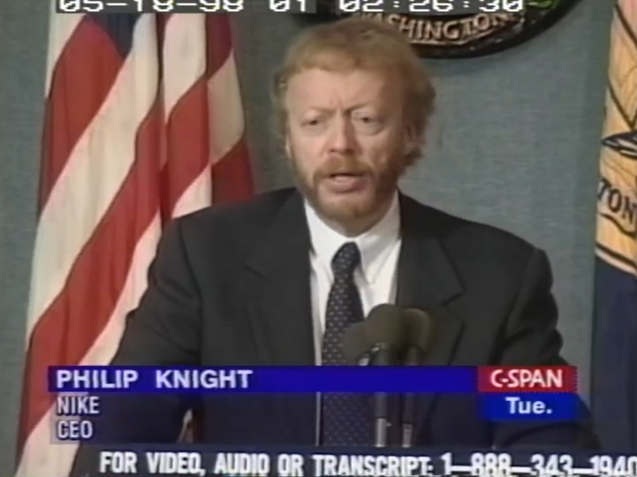<https://www.c-span.org/video/?c4665762/user-clip-phil-knight-1998-speech>

1. Watch the video clip above in which Philip Knight presents Nike’s initiatives towards rectifying the situation.
2. Which initiatives is Nike presenting here?

A message from the current President and CEO, John Donahue. <https://www.youtube.com/watch?v=qthqHLqtLNw>

1. Compare the communication situations that the two CEOs are navigating at the time of the two speeches. What effect does the communication situation have?
2. Go to: <https://about.nike.com/en/impact>. Choose one of the four focus areas (Diversity, Equity and Inclusion; Responsible Sourcing; Empowering Communities; Protecting the Planet). Write down some of the efforts that Nike is committing to within your chosen area.
3. Assess whether Nike operates according to the Three Pillars of Sustainability.