Introduction to Growing Up
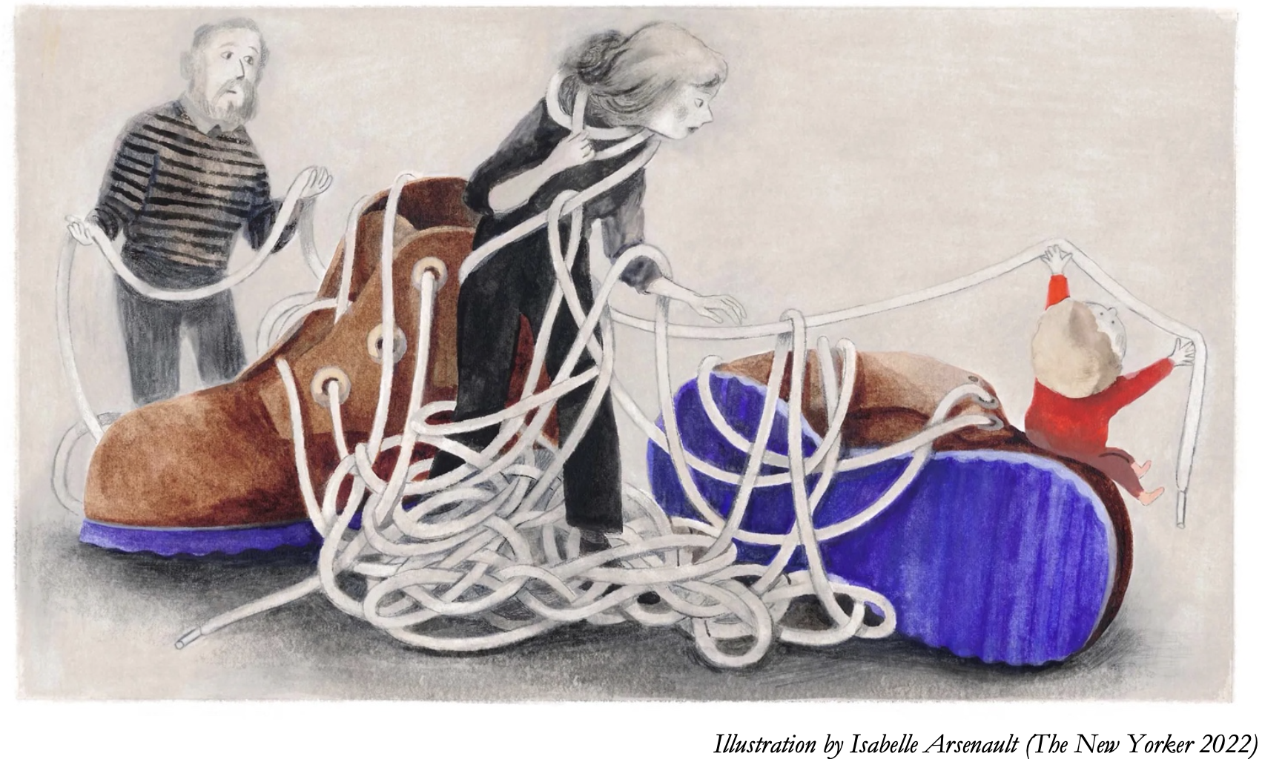

Task 1
Using the picture above, what do you expect from this theme? What could it be about?
- Write at least 3-4 sentences (with a study buddy)

1.
2.
3.
4.

Definition of ’Rite of Passage’: A rite of passage is a ceremony or ritual of the passage which occurs when an individual leaves one group to enter another. It involves a significant change of status in society. Source: Wikipedia
Task 2
Task: make a brainstorm list of formal and informal rites of passage:

Formal rites of passage: Informal rites of passage:
e.g birthdays e.g. first kiss

In groups of four decide on 2 formal and 2 informal examples (poster post-its)

Task 3. Where would you put the following on an age scale?
Look at the following words and translate them into Danish. Then connect them with the appropriate age.
https://www.oxfordlearnersdictionaries.com/

- adolescent ___________________________________________

- teenager _____________________________________________

- boy/girl ______________________________________________

- adult ________________________________________________

- old person____________________________________________

- toddler ______________________________________________

- Baby ________________________________________________

- man/woman__________________________________________

- middle-aged person_____________________________________

Task 4. Which of the following words do you associate with childhood, adolescence, adulthood and old age?

If you do not understand a word, look it up here for a Danish translation:
https://beta.ordbogen.com/en/
or here for a definition in English:
https://www.oxfordlearnersdictionaries.com

Depression Illusions Pressure
Boredom Despair Impulsiveness Problems
Bullying Disability Infirmity Reason
Cares Disillusionment Innocence Rebellion
(Un)certainty Egoism Isolation Recklessness
Challenge Expectations Loneliness Responsibility
Cheerfulness Experience Love (In)security
Childishness Fear Maturity Sex
Choice Foolishness Optimism Competition
Fun Patience Stress Confidence
Happiness Peace Understanding Curiosity
Pessimism Wisdom Hopelessness Play
(In)dependence Illness Pleasure Optimism

Childhood: | Adolescence: | Adulthood: | Old Age:

