Task 1
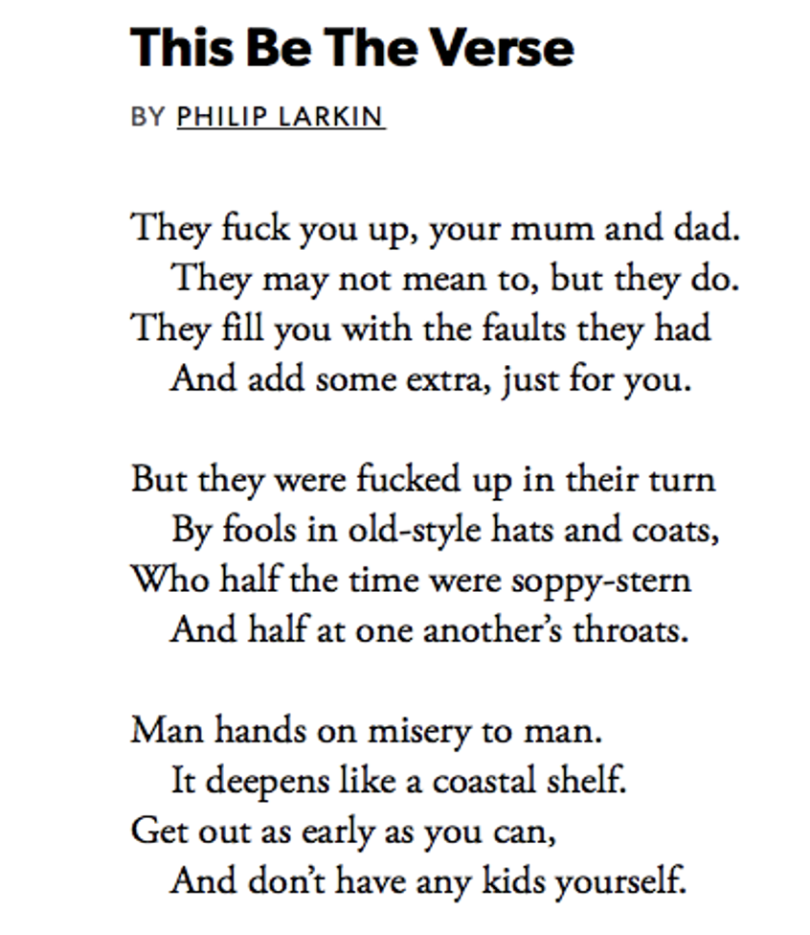

1974

- Try to express the meaning of the first stanza (strofe) in your own words.

- Who is speaking in the poem? (It is not always clear who is speaking. In that case, start by considering what situation or feeling the poem may have been written in, and continue with tone and subject matter.)
- What is this person’s background?
- From what situation or feeling is this person speaking?

- Who is the voice in the poem addressing (henvender sig til)? How can we tell?

- Why does the voice in the poem use as strong a word as "fuck"?

- Why do parents fuck up their children? Look for a reason in stanza two and add some extra reasons of your own.

- Does the voice of the poem have any advice (indirectly) to how a parent should behave? Does he understand/forgive parents for what they do?

- Compare this poem to "Indian Camp" and “Reunion” (or any other text/movie from the course). Are there any similarities? Explain.

Task 2
Relate (compare) this poem to “Reunion.” Are there any similarities? Explain below:

-
-
-

