Cinematic analysis – Skin (2018)

Framing
- What type of shots are used, i.e., how much of the characters and the surrounding do we see in each shot, and why?
  - Extreme close-up: Showing an object or facial feature in detail.
  - Close-up: Showing a person’s head and shoulders, or (parts of) an object. Can be used to capture the emotions of a character, give a sense of closeness and intimacy, draw attention to a specific thing.
  - Medium close-up: Showing a person from the chest up.
  - Medium shot: Showing a person from the waist (or knees) up.
  - Long shot: Showing a person’s entire body (head to toe).
  - Extreme long shot: Showing an object or person from a considerable distance.

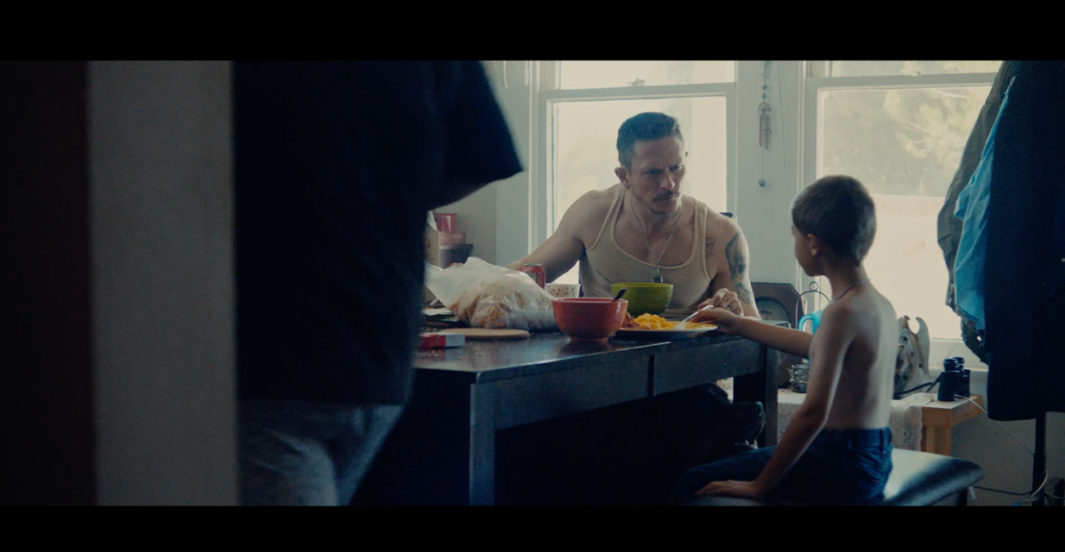
Framing:
Reason for this framing:

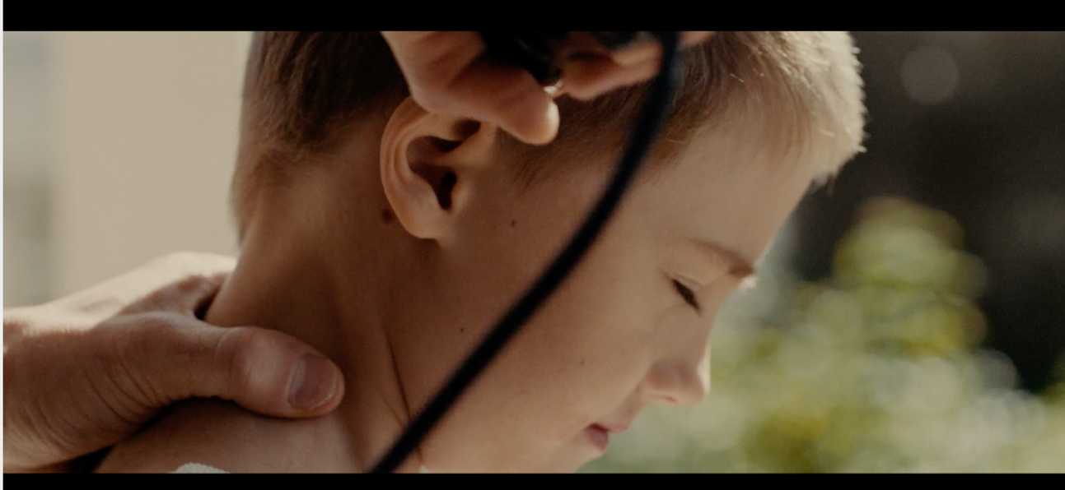
Framing:
Reason for this framing:
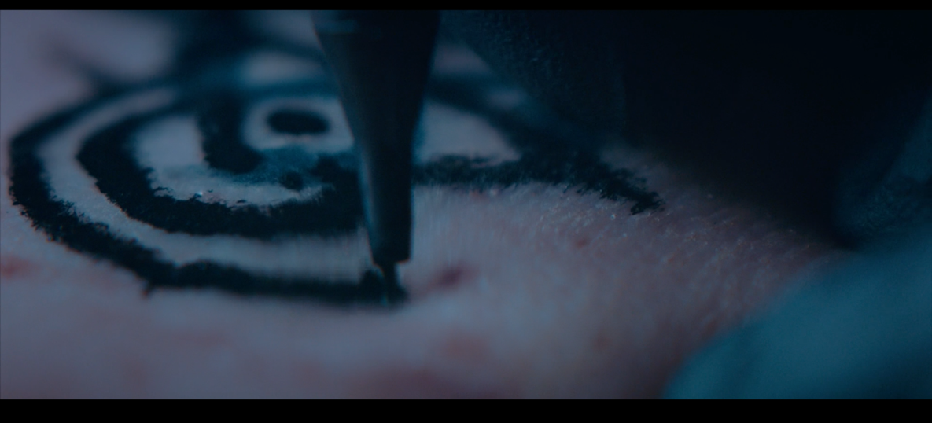
Framing:
Reason for this framing:

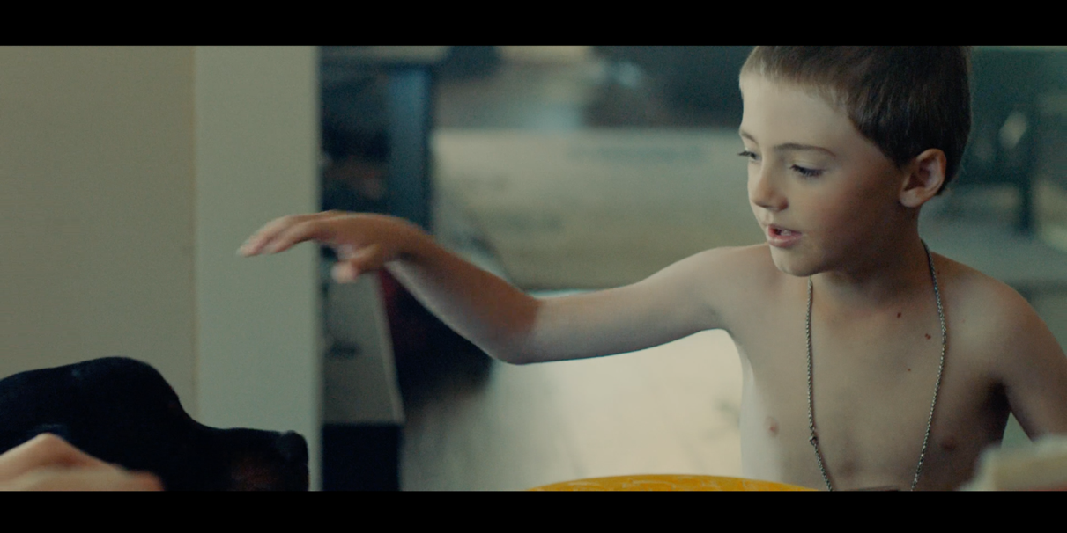
Framing:
Reason for this framing:

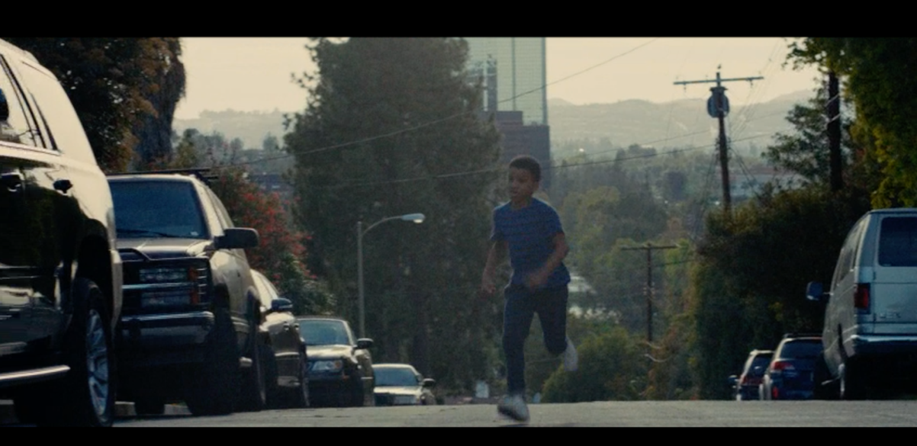
Framing:
Reason for this framing:

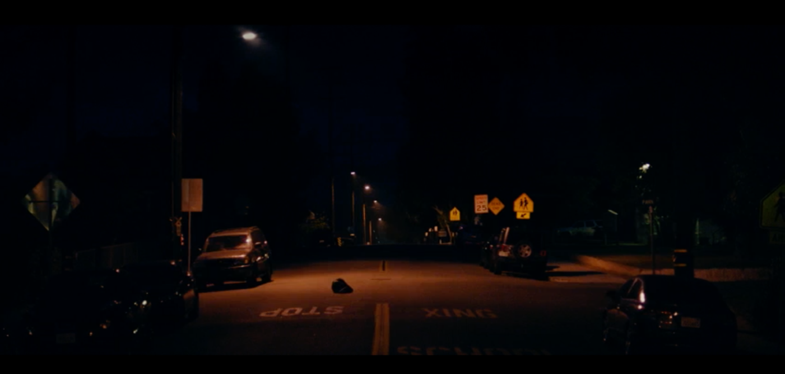
Framing:
Reason for this framing:

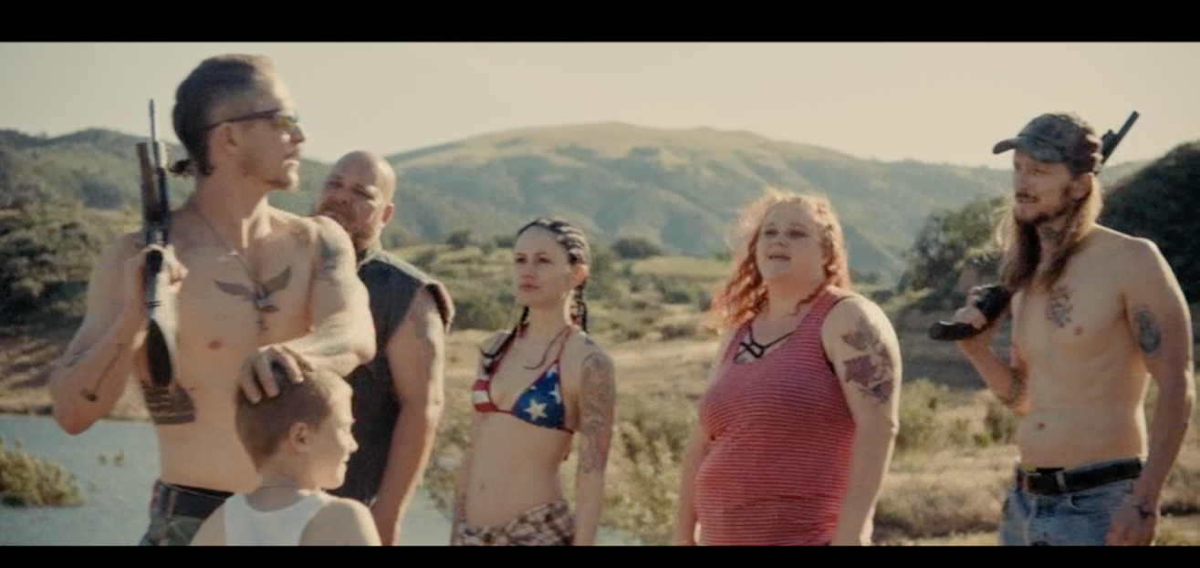
Framing:
Reason for this framing:

