The Flowers, By Alice Walker
Task 1 – read The Flowers aloud in small groups (pages 11-12 in your compendiums)
Task 2
Find på fem minutter alle de ordklasser, du kan. Prøv også at forklar, hvorfor du mener, at det er netop dén ordklasse.
The | air | held | a | keenness | that | made | her | nose | twitch

She | felt | light | and | good | in | the | warm | sun

She | skipped | lightly | from | hen house | to | pig pen

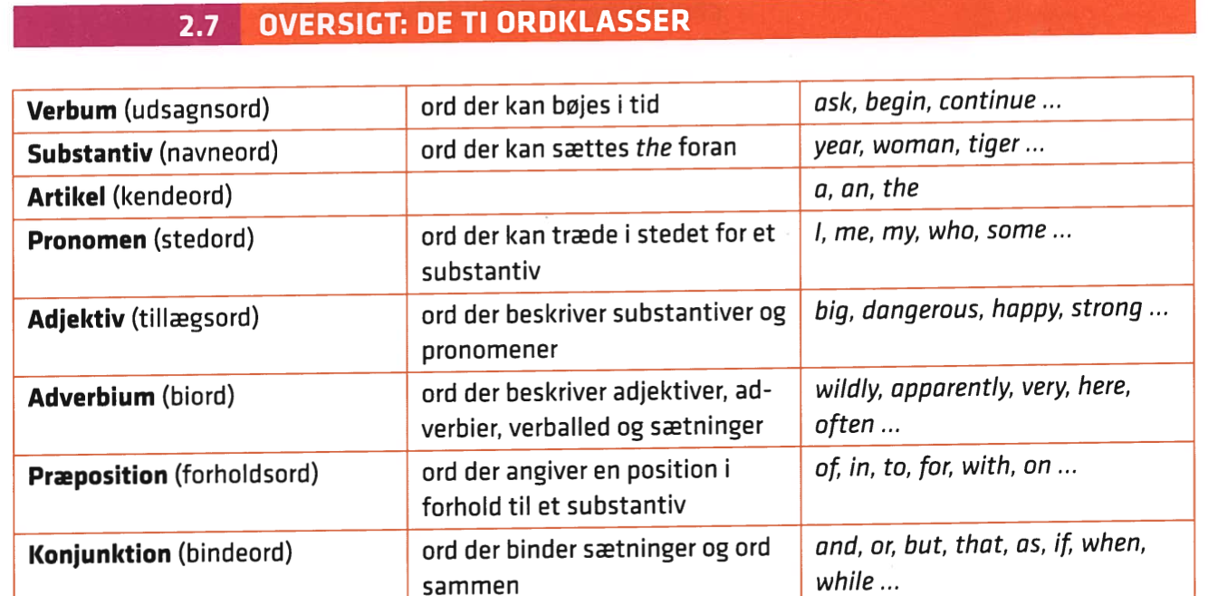
Task 3 – decide setting, mood and characterization (in the chart below the information boxes)
Setting and mood
Setting (Where and when do the events take place? And in which social environment? And how are these factors significant for the narrative?)
The mood is the atmosphere of the story. We can identify it by looking at the setting, characters, details, and word choices. By doing so, it will help us find meaning in the story and help us feel more connected to the writing.

Characterization:
- What are we told about the characters, and what can we conclude about them, e.g., in terms of age, looks, background, behaviour and personality?
- How does the author create the characters and their personalities? (through dialogue, thoughts, accent, actions, descriptions, appearance, lifestyle choices?
Note: it is called internal and external characteristics.
- Do the characters develop? If so, how, and why?
Also consider: are the characters
- Flat (two-dimensional) with only a few characteristics (like in fairytales)?
- Round (complex) like real people?
- How do the characters relate to each other?

 | Point (the story takes place in..) | Example (from the text) | Explain (why? Effect)
Setting
(Where is Myop?)

Mood
Based on the first two paragraphs (afsnit), what is the mood (stemning) of the story? What words or phrases in the text do you base it on?
Characterization
Who is our main character? What is your impression of Myop? What words would you use to describe her?

Task 4
Additional reading questions:

- Where is Myop by twelve o’clock? How has the mood changed?

- On p. 2, in the last paragraph it says, “It was then she stepped smack into his eyes”. What is happening? What has she found?

- Based on what she finds besides the man, how did this man likely die?

- How do you understand the last line of the short story: “And the summer was over”? What may be the symbolic meaning?

