How to write a summary!
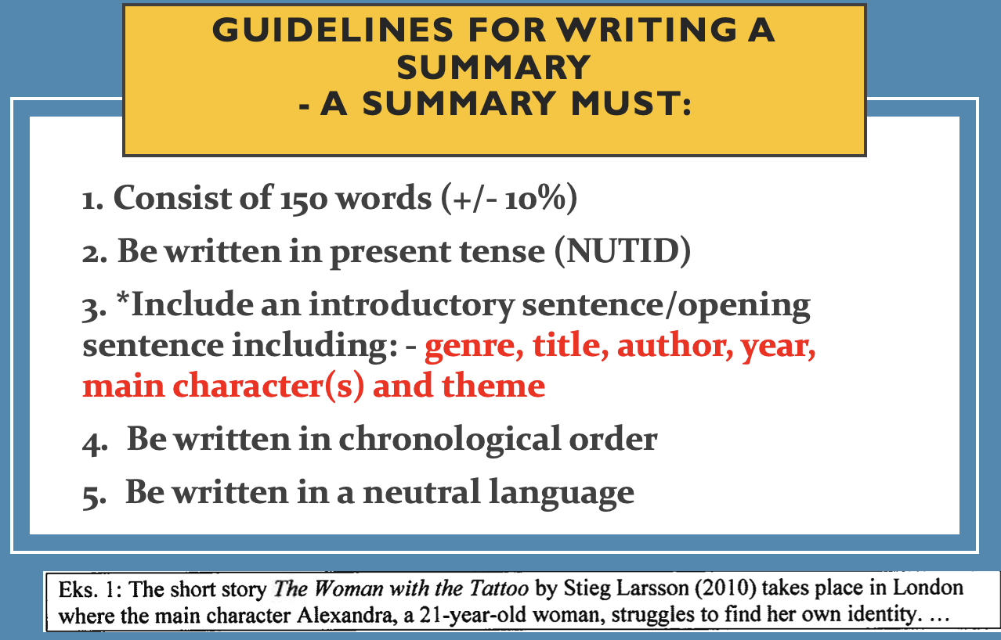

- Your summary starts here:

- Checklist
Did your summary include: | Yes/no
Consist of 150 words
Present tense (nutid) * (el. førnutid)
An opening sentence including:
-Title
-Genre
-Author/director
-Year
-Main character(s)
-Theme
Chronological order (including the ending?)
Neutral language (no analysis or own opinions)

*
