Analysis and interpretation of non-fiction

Always remember!
1) Why? What is the effect? For instance, what is the effect of the use of pathos?
2) Remember not everything is equally important in each text and each analysis.
3) Remember to always find it in the text (quotations) to substantiate your analytical points.
4) This handout is just an overview you might want to consult Tools or Angles Analysis (both on lectio) for more information.

Genre (what type of text is it? e.g., a speech, a letter, an, op-ed (kronik), an article?) (Consult Angles Analysis or Tools for more types of articles)

Rhetorical situation
- Topic/subject (what is the text about?)
- Sender/writer/speaker (who is behind the text? What do we know about the sender’s background, status, views, qualifications etc.? Is the background reflected in the style and/or content?)
- Receiver/audience/reader (who is meant to read the text? Who would be likely to be the receivers of the communication (age, sex, education, nationality, etc.)?)
- Medium (where did the text originally appear? i.e., what paper, book, website etc.?)
- Context/circumstance (under what circumstances (could be influenced by place, time, situation, culture) and for what occasion was the text written?)
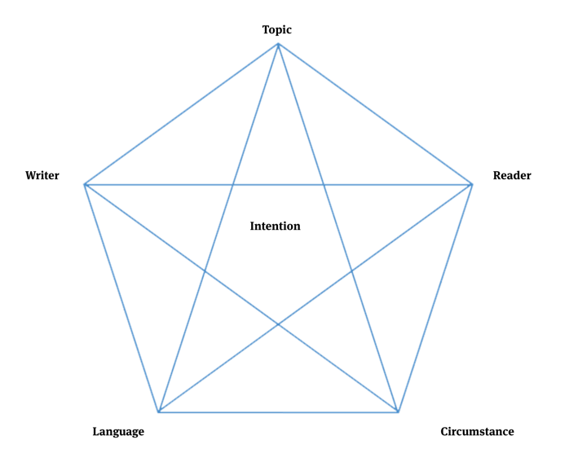
The rhetorical pentagon
The rhetorical pentagon can be used to analyse non-fiction. The lines indicate that all five elements in the corners of the pentagon are linked. If you change one of these elements, it will influence the others. In the centre of it all is the intention.

Intention (purpose)
Why has the text been written? (Feel free to add additional intentions/purposes)
- To inform?
- To persuade?
- To entertain?
- To discuss?
- To provoke? Or something else?

Rhetorical modes/modes of appeal/ modes of persuasion
How does the writer try to convince the reader?
- Logos (appeal to our sense of reason) by using facts, figures, statistics, surveys, logical arguments etc.
  - Academic arguments often rely on logos, and logos is often used to strengthen/establish ethos by supporting the trustworthiness of the speaker. Key elements include theoretical language, historical comparisons, definitions, factual data, statistics, and surveys.
- Pathos (appeal to our emotions), e.g., scare us, make us angry, stir our compassion etc.
  - It can be made in the form of a personal angle, a claim that the matter is unfair or unjust or something else. Key elements include emotional language, colourful descriptions, personal stories, and figurative language.
- Ethos (appeal to our trust) by building our confidence in her/him.
  - A sender’s ethos can be based on a person’s background, job, experience, merits, and education. When you analyse ethos, you find out whether the audience can trust the speaker (whether the speaker has high or low ethos). Key elements include: a special interest in and authority on the subject, experts, correct grammar, suitable vocabulary, and balanced presentation.
The three modes of appeal/modes of persuasion
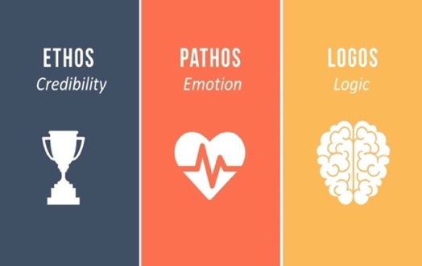

Language (what kind of language does the sender use?)
- Formal, informal (colloquial), slang, simple, complex, or descriptive?
- Does the author use many verbs/adjectives/adverbs, and what is the effect of this?
- Is the tone factual, humorous, aggressive, optimistic, friendly, hostile or something else?
- Use of rhetorical devices such as repetition, rhetorical questions, metaphors, rhymes, hyperbole, opposites, irony, and word plays. See on the following page.
- Use of quotations or references (could be to historical events/figures or to popular works of fiction)
- What characterizes the vocabulary? How have specific words been chosen and what are their connotations (‘associations’)? Do they target a specific audience? Do they establish a specific level of formality and mood?
- Anything interesting about the sentence structure or punctuation?
- Types of arguments – weak or strong?
- Is there any figurative language? such as: (some of these could also be seen as rhetorical devices)
  - Similes (comparisons using an image and words like as or like. E.g., she is like a rose).
  - Metaphors (comparisons using an image, but without as or like. E.g., she is a rose).
  - Personification (the attribution of a human characteristics to something non-human).
  - Symbols

Arguments
- What is the claim(s) (påstand)? What is the evidence (belæg) (ways of proving the claim is true)?
  - Do the arguments (argumenter) hold water? Why/why not?
  - For the more advanced student: What is the warrant (hjemmel) in the argument? Does the sender used a rebuttal (gendrivelse)? (Consult Angles Analysis or Tools for more on warrant)
  - What could be some of the counterarguments?

Message what is the message? Are we meant to learn something from the text? Do you suspect any hidden agendas or motives?

Relate the text to another/other text(s) from the theme.

Examples of rhetorical devices
A rhetorical device uses words in a certain way to convey meaning, to persuade, or to evoke certain emotions. Always consider the effect of the rhetorical device, why did the sender choose to employ this device?

- Alliteration – the recurrence of initial consonant sounds – Mary made magnificent muffins.
- Allusion – a reference to an event, literary work, or person – I can’t do that because I am not Superman.
- Amplification – repeats a word or expression for emphasis – Love, real love, takes time.
- Anaphora – repeats a word or phrase in successive phrase – It was the best of times, it was the worst of times, it was the age of wisdom, it was the age of foolishness, it was the epoch of belief, it was the epoch of incredulity.
- Antimetabole – repeats words or phrases in reverse order – Ask not what your country can do for you – ask what you can do for your country.
- Epistrophe – the repetition of a word at the end of successive clauses or sentences – I want the best, and we need the best, and we deserve the best.
- Euphemism – a word or expression used in place of one that is deemed offensive or suggests something unpleasant – ‘Senior citizen’ is a euphemism for ‘old person’.
- Hyperbole – an exaggeration – I have done this a thousand times.
- Hypophora – Hypophora is a figure of speech in which a writer raises a question, and then immediately provides an answer to that question – What should young people do with their lives today? Many things, obviously. But the most daring thing is to create stable communities …
- Idiom – a group of words in a fixed order that has a particular meaning that is different from the meanings of each word on its own – To ‘have bitten off more than you can chew’ is an idiom that means you have tried to do something which is too difficult for you.
- Intertextuality – the relationship between texts, especially literary ones (it could be an allusion).
- Metaphor – compares two things by stating one is the other – The eyes are the windows of the soul.
- Onomatopoeia – words that imitate the sound they describe – Miaow, slam, pow and bang.
- Oxymoron – a two-word paradox – a wise fool, cruel kindness.
- Personification – giving human qualities to something that is non-human – happy trees.
- Pun – a humorous use of a word or phrase that has several meanings or that sounds like another word – This is a well-known joke based on a pun: “What's black and white and red (= read) all over?” “A newspaper.”
- Rhetorical questions – a questions that does not need an answer, because the answer is implied – Are we winners or are we losers?
- Simile – compares one object to another – he smokes like a chimney.
- Tricolon (triplet, the rule of three) – series of three parallel words or phrases – Tell me and I forget. Teach me and I remember. Involve me and I learn.
- Understatement – makes an idea less important that it really is – the hurricane disrupted traffic.

