Substantiver (del 2)

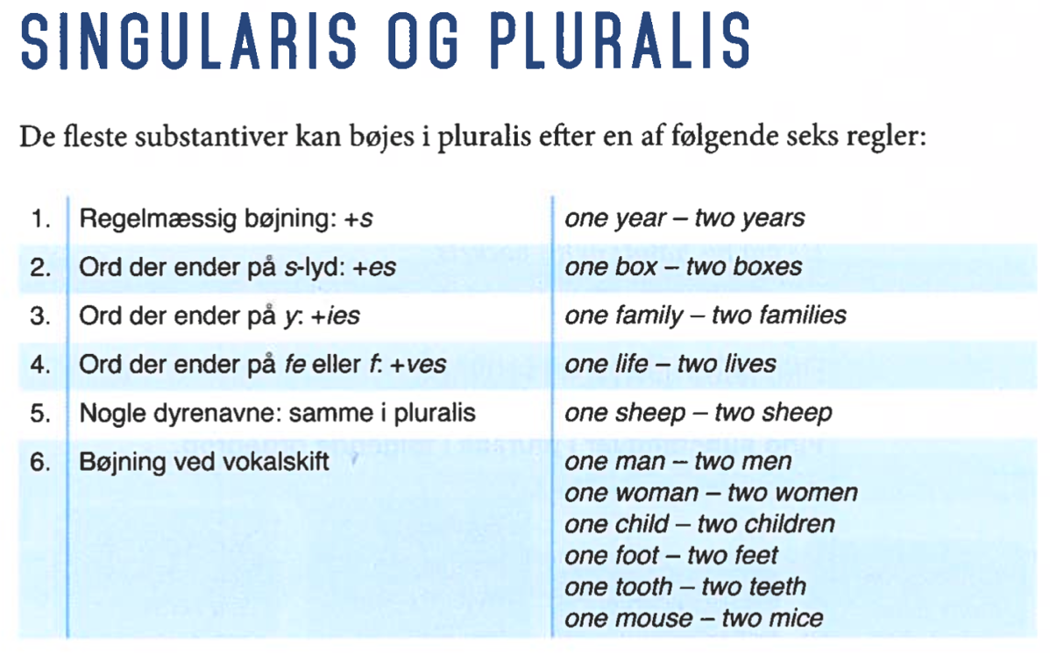
Mængdeord er substantiver, der henviser til noget, der ikke kan tælles, fordi det er
en mængde af noget og ikke et antal air,food, water, oil, energy, blood, knowiedge, stuif ice, rain, salt, dirt, research, cash
Mængdeord er utællelige. De kan ikke bøjes i pluralis, og man kan ikke sætte a
eller an foran dem.
Når mængdeord er subjekt i en sætning, skal verballeddet stå i singularis. (ental)
The water covers the floor.
x 0
The cash is in my wallet.
x 0

Substantiver, man skal være særligt opmærksom på:
Ental | advice, furniture, information, money,  news, progress | The latest news is that he has won Ohio.  The furniture you bought has arrived.
Flertal | people, police | eople are strange!  The police have asked for help from the  public

Logisk flertal/pluralis: På dansk kan flere mennesker (pluralis/flertal) godt miste livet (singularis/ental), og man kan stikke hænderne (pluralis/flertal) i lommen (singularis/ental).

På engelsk skal begge led sættes i pluralis/flertal. Det kaldes logisk pluralis.
They lost their lives.
He put his hands in his pockets.

OPG 2 FIND SUBSTANTIVER
Find alle substantiver i teksten. lnddel dem i singularis og pluralis.

lt is a period at civil war. Rebel space ships, striking from a hidden base, have
won their first victory against the evil galactic empire.
During the battle, rebel Spies managed to steal secret plans to the empire’s
ultimate weapon, the DEATH STAR, an arrnored space station with enough
5 power to destroy an entire planet.
Pursued by the empire’s sinister agents, Princess Leia races horne aboard
her starship, custodian of the stolen plans that can save her people and restore
freedom to the galaxy.

Singularis (ental) | Pluralis(flertal)
OPG 3 BØJ SUBSTANTIVER
1. Bøj substantiverne i pluralis (flertal)
2. Afgør for hvert substantiv, hvilken at de seks bøjningsregler (forsiden)
ordet bøjes efter.

Singularis | Pluralis | Regel nr. | singularis | pluralis | Regel nr.
world |  |  | leaf
country |  |  | baby
boss |  |  | steak
half |  |  | century
story |  |  | sheriff
job |  |  | self
business |  |  | foot
grandchild |  |  | loss
party |  |  | sheep
class |  |  | cliff
wife |  |  | army
church |  |  | knife
mouse |  |  | speech
activity |  |  | bridge
beach |  |  | address
deer |  |  | tooth
bus |  |  | city

OPG 6 FIND LOGISK PLURALIS
Find eksempler på logisk pluralis i sætningerne. Forklar for hver sætning,
hvorfor der er brugt pluralis.

1. A number of towns in Eastern Europe have changed their names in the past
30 years.

2. I work with some of the people who lost their homes in the earthquake.

3. It took us two and a half hours to get here.

4. The president and the prime minister smiled at the press and shook hands
warmly.

5. When they saw the big wave, they ran for their lives.

6. We took off our leather jackets and went to sit near the fire.

7. They seem to have a bt of things on their minds.

8. Modern houses often have very large and spacious kitchens.

9. Tweenies are children between the ages of nine and twelve.

10. Although they have been together for almost thirty years, they have very different tastes.

OPG 8 FIND, RET OG FORKLAR FEJL
I følgende sætninger er der 17 fejl i forbindelse med substantiver i singularis og pluralis. Find, ret og forklar fejlene.

1.The progress we have made in the past ten years are astonishing.

2. Today lots of shops and companys are online with informations about their
products.

3. Many men and woman in their sixtys and seventys have bad tooths.

4. Four people have lost their life in a major road accident this morning.

5. She was certain that the news were bad.

6. They were carrying all their luggages on their backs.
7. We stand to lose all our money, and my brother needs them for his education.

8. The police in Britain is arresting people who carries even small amounts of
cannabis.

9. The best advices I have ever received have come from childrens.

10. In order to get here, they had to change train three times.

